Reopening Plan for Charter Students

Families at each level have selected “In Person” or “Remote” learning options for when campuses open to Charter students. Families selecting In Person can return to Remote learning at any time. Families selecting Remote learning may change to In Person learning at limited entry points: (i) the day after Fall Break (Oct 19th); (ii) the day after Winter Break (Jan 4th); or (iii) the day after Spring Break (Mar 15th).

Charter Elementary – In Person learning returns week of September 28th
- Phase-in of In Person learners over Monday and Tuesday; all In Person learners return to campus on Wednesday. Monday, Sept 28 (last names A-M on campus; all others remote), Tuesday (last names N-Z on campus; all others remote); all In Person learners on campus starting Wednesday
- Any In Person learners scheduled to return on Monday who are observing the Jewish Holiday may elect to begin phasing in on Tuesday
- Remote learners may change to In Person on Oct. 19 or remain Remote
- All classroom lead teachers returning
- In Person and Remote learners track split; lead teachers focus on In Person learners; continue with a whole class meeting (In Person and Remote learners together) at beginning of the day, end of day and all students can participate in “lunch bunch”
- Remote team takes over math, ELA and cultural lessons for remote learners

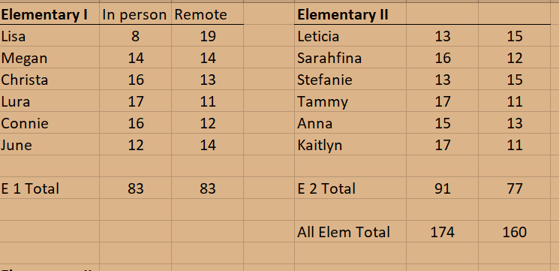

Charter Kindergarten – In Person learning returns September 28th
- 53 Charter Kindergarteners enrolled
- Anticipating 15 Ks on campus on Sept 28
- 11 others (Private Ks) are paying ½ tuition to hold private extended or all day spot; May elect to return to In Person on Oct 1st
- Remote learners may change to In Person on Oct. 19
- Remote learning team will continue to provide lessons to Remote learners

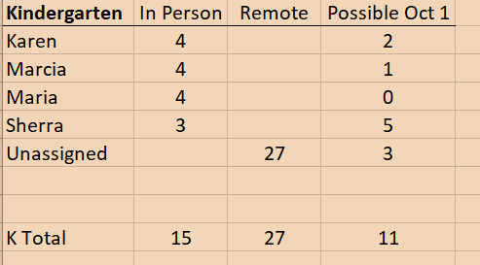

Primary Programs, all students:
- 57 students attending;
- 36 students paying ½ tuition to hold spot, may elect to return to campus on Oct 1st
- Currently, 20 student cap per classroom
- 4 Primary classrooms currently open; 5th classroom will likely open Oct. 1.
- The numbers below include Ks listed above

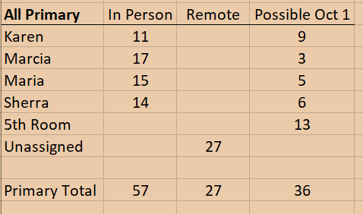

Middle School – In Person learning returns week of October 5th
- Phase-in of In Person learners over Monday, Oct 5th and Tuesday, Oct 6th in each community; all In Person learners return to campus on Wednesday.
- Remote learners may change to In Person on Oct. 19 or remain Remote
- All classroom lead teachers returning
- Lead teachers are providing all Remote learning; when In Person learning resumes teachers will continue to stream with remote learners

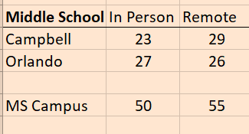

Other Private Programs – Continue in attendance. No changes on September 28th.
Infant – 6 enrolled
Toddler 1 – 5 enrolled
Toddler 2 – 14 enrolled

The Week of the 21st, Videos and Detailed Information Sent to Families Beginning In Person learning:
Expectations for students when on campus (hygiene, social distancing, mask use, etc.)
Drop off/pick up procedures for parents
Importance of proper mask wearing
Parents sign a pledge that student will not come to campus with COVID symptoms and agree to various other items (e.g., student will wear a mask at school, notify school of contact with any suspected/actual cases, taking actions designed to keep staff/teachers safe). Family Pledge will be included as email attachment

Key Daily Procedures:
Staggered drop off times/pick up times
Daily health checks (parents check symptoms at home, temperature taken at arrival)
Upon arrival, students go directly to their classrooms
Students enter classrooms through ODEs after washing hands
Each student will have a designated work space in the classroom
Extensive use of Plexi-glass
Students working in ODEs, some lessons given in outdoor spaces (the “slab”, Davis ODE, etc.)
Classes do not mix or co-mingle; specials delivered by classroom; recess by class
Isolation rooms set up for sick students awaiting pick up by parent
Parent pledges signed

Face Coverings
Face coverings are required for all students and staff
Acceptable face coverings are found here: https://www.maricopa.gov/ImageRepository/Document?documentID=62744

Air Purification/Ventilation
Air scrubbers added to several air conditioning units
Stand-alone devices purchased for classrooms with individual HVAC units
MERV-13 filters used throughout all campuses
Windows and doors opened as often as possible

Data Tracking
Absentee line:
Attendance staff check absentee line daily
Phone calls to parents to determine if absence is COVID related if that information was not provided
If absence is COVID related, attendance staff emails home isolation information to parent and student’s name is added to COVID related database maintained by Michele
School receptionist follows up with phone calls to any student absent due to COVID-like symptoms; adds that information to database
COVID-19 testing results are tracked on the database – MCHD is contacted if necessary
Michele tracks staff absentee/testing information on same database

Attendance taking:
Teachers take attendance several times throughout the day and record on attendance database
If student is absent for the day or absent from 2 or more periods in a day, attendance staff phones parents
If student is ill with COVID-like symptoms, that information is added to the COVID database and appropriate follow-up as listed above takes place

Symptoms at school:
Students who develop symptoms while at school are taken to a designated isolation room
Parents are called to immediately pick the student up
Student’s name added to COVID database
School staff calls parent later in the day to follow-up on student’s condition
Notification to class sent home

Home isolation/quarantine guidance is provided as appropriate – see AZDHS flowchart at
https://www.maricopa.gov/DocumentCenter/View/62154/Release-from-Isolation-Guidance-Flow-Chart

Testing results (if available) are added to database
If positive case, notification to class sent home; if close contacts are determined they are
individually notified

Same procedures followed for staff (staff leave campus immediately)

Reporting to Maricopa County Health Department
Individuals who report to us that they tested positive (students and staff) – this information added to our COVID database
Outbreaks within the school
Mandatory reporting within 24 hours of identification of outbreaks, defined as:
Two or more laboratory-confirmed COVID-19 cases
Onsets within a 14 day period of one another
Epidemiologically linked (had close contact in school-related settings)
Do not share a household or were not close contacts outside of school

Public health will reach out to us and review the situation
Provide guidance on excluding confirmed cases for duration of their isolation period
Identifying potentially exposed students/staff
Determining notification requirements for notifying student families and staff

Quarantine at home
Any close contact of a positive case (<6 feet for >10 minutes)
Household members of people with COVID-like illness do NOT need to quarantine unless that person ultimately tests positive

On-Going Monitoring of DHS Benchmarks
County benchmarks will continue to be monitored weekly
Weekly webinars with MCHD will continue for on-going guidance including if/when school may need to be closed

