2019 CARTA GRADUATE WORKSHOP
Southern Sun Mayfair Nairobi
February 11-16, 2019

PARTICIPANTS BIOS

Henry Zakumumpa
Institution: Makerere University
CARTA Cohort: Four
Year of graduation: 2018
Research interests: My broad interests revolve around health systems and services research. My PhD research focused on the sustainability of ART scale-up implementation in Uganda’s health system.
My academic background is in the social sciences. Hence, I seek to utilize social science frameworks in approaching research problems in the health systems of LMIC. I am particularly interested in understanding barriers to health services delivery and exploring constraints to the scale-up of public health interventions from an implementation science lens.
Oluwaseun Ireti Obasola
Institution: University of Ibadan
CARTA Cohort: Three
Year of graduation: 2017
Research interests: Focused on the use of information and communication technology to provide maternal and child health information, health information behaviour of different target groups.

Anitha Philbert  Institution: University of Dar es Salaam  CARTA Cohort: Three  Year of graduation: 2016  Research interests: human-wildlife interface in Tanzania. Zoonotic diseases are a strong impediment to the communities that interacts with animals. Several diseases are transmissible between human and animals (both domestic and wild). Mosquitoes in the Culex and Aedes genera are vectors of several globally important arboviruses. These vectors are also present in Tanzania making it potential for arboviral zooneses should an outbreak occur. Arboviral zooneses such as Yellow Fever (YF) and Rift Valley Fever (RVF) had previously occurred in Tanzania. Rift Valley Fever was reported for the first time in 1930 followed by periodic epidemics of 10-20 years in 1947, 1957 and in 1997 through 1998 following the El-Nino rainfalls. The most recent RVF outbreak occurred in the year 2006 to 2007; this particular outbreak claimed thousands of lives of people and livestock. It is therefore evident there are active viral activities maintained in unknown reservoirs during when there are no epidemics. We therefore propose to characterize arbovirus vectors and the specific viral strains they transmit, their viral infectivity rate and the seroprevalence of zoonotic viral infections in human and wild animals where these primates co-exist. |  |  |  |  |  |  |  |  |  |  |  | 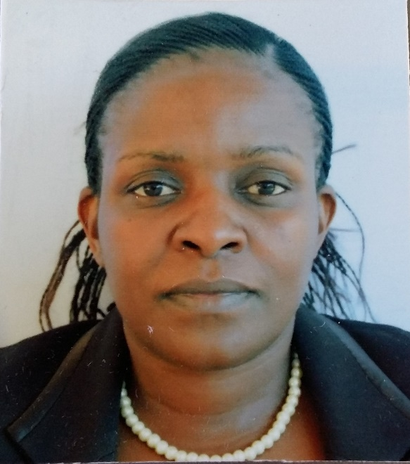
François Niragire
Institution: University of Rwanda
CARTA Cohort: One
Year of graduation: 2017
Research interests: My current research interest is embedded in my research agenda of “generating evidence based knowledge related to environmental and social determinants of health for policy and action”. In fact, environmental degradation and status of key social determinants of health are among the major impediments of global sustainable development. My current research interest is to investigate underlying factors of nutritional status among the under-five children in Rwanda, where child stunting has been persistent within both food-secure and food-insecure settings. For example, child stunting is unexpectedly lower than national rate in a district where majority of households are in extreme poverty
Felix Khuluza
Institution: University of Malawi
CARTA Cohort: Five
Year of graduation: 2018
Research interests: Feasibility study of low cost technologies in the identification of substandard and falsified medicines in Malawi and development of a mobile app reporting system.

Respicius Shumbusho Damian
Institution: University of Dar es Salaam
CARTA Cohort: Four
Year of graduation: 2018
Research interests: Health systems researcher with interest in community-level accountability for improving availability and access to primary health services in rural communities. A special interest has been on the implementation of community empowerment and community-level accountability policy interventions with the aim of understanding how the rural context affects the capacities and capabilities of community actors to play an effective oversight role for ensuring that available resources are properly used to deliver quality services. My research aims at making community-financed rural healthcare accountable as a means towards achieving universal coverage in under-resourced remote communities.
Fredrick Okoth Okaka  Institution: Moi University  CARTA Cohort: Three  Year of graduation: 2016  Research interests: My current research interests include: impacts of climate change and climate variability on population health with particular focus on urban areas, Health and well-being of the elderly people living in urban areas, Population studies, Urban Housing with emphasis on Gender Dynamics and Geography Education. |  |  |  |  |  |  |  |  |  |  |  | 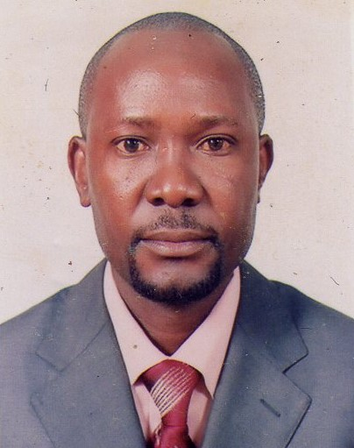
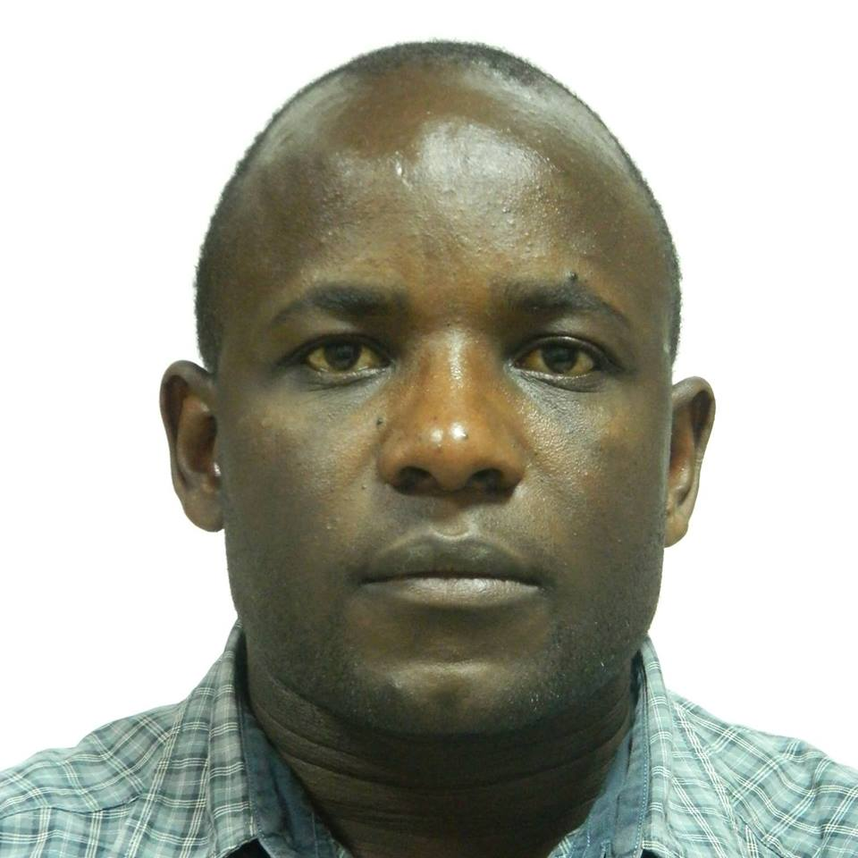 |  |  |  | Joel Karani Magutah  Institution: Moi University  CARTA Cohort: Four  Year of graduation: 2018  Research interests: cardiorespiratory fitness area. Specifically, I have interest in investigating (experimental, follow-up studies) exercise approaches that could appeal more for individuals at higher risk for diseases and syndromes associated with being sedentary, and that will demonstrate measurable positive effects in reducing the risk posed in these individuals, thereby preventing disease occurrence.
Celine Niwemahoro
Institution: University of Rwanda
CARTA Cohort: One
Year of graduation: 2017
Research interests: My previous study done on understanding health-seeking behavior among pregnant and unmarried girl has left me with a sympathy and curiosity to know more about them and their reproductive health. Adolescent women are much more vulnerable after delivery, with a high chance of getting repeated pregnancies. This time will be mainly dedicated on publishing and advocacy for the betterment of young people and on informing policy makers on the possible recommendation to accelerate the demographic transition in our region. If the opportunity is given, a postdoc position would provide me with more scientific experience I need to advance my career.
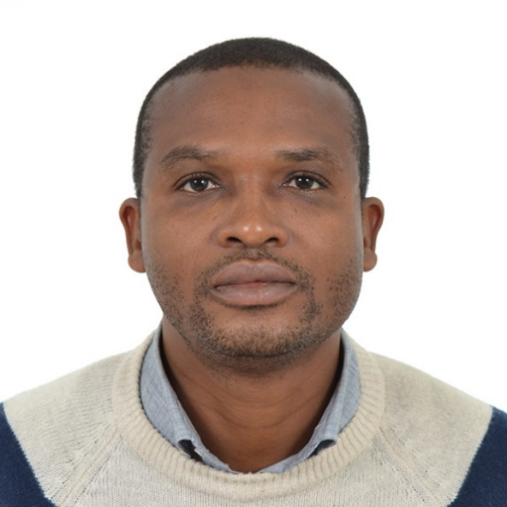 |  |  |  | Melvin Ojo Agunbiade  Institution: Obafemi Awolowo University  CARTA Cohort: Three  Year of graduation: 2016  Research interests: the broad field of Sociology of Health in Later Life. From his doctoral research to date, his research interests have revolved around the Ageing, the African traditional medical system, sexual and reproductive health, vulnerability and social protection in later life. Melvin has expertise and experience in mixed methods research and qualitative methodology. His epistemological position is that mixed methods are useful and closer to achieving valid knowledge production from diverse but critical positions.
Maurice Mutisya  Institution: African Population and Health Research Center  CARTA Cohort: Two  Year of graduation: 2018  Research interests: My research interest is to understand the linkages between maternal health, early childhood development, and cognitive development among the marginalized and poor populations and how this impacts on later life outcomes. These populations are characterized by high levels of stunting and face a number of challenges such as poor nutrition, and poor complementary feeding practices as well as food insecurity. Of interest are interventions that can be put in place to mitigate damages that may occur during early childhood development and the accrued benefits during post-childhood development including in education and health. |  |  |  |  |  |  |  |  | 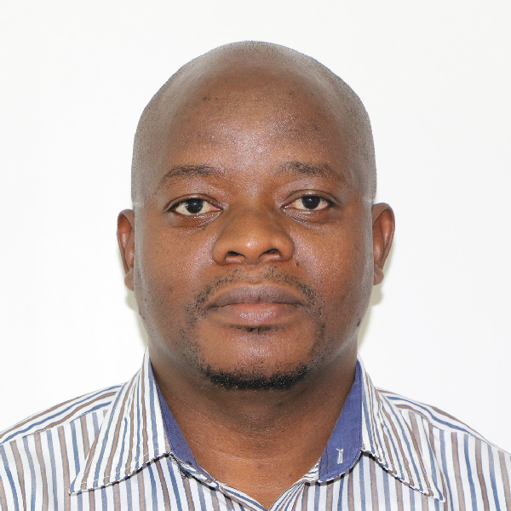
Adeyinka Adefolarin
Institution: University of Ibadan
CARTA Cohort: Three
Year of graduation: 2018
Research interests: Implementation research: Development and the integration of the use of technology device or app in African languages in the field of health promotion and education (school health, maternal child health, mental health, social health community health, training, reproductive and population health and nutritional health).
Joel Olayiwola Faronbi  Institution: Obafemi Awolowo University  CARTA Cohort: Three  Year of graduation: 2015  Research interests: My interest is to build a career in geriatrics/gerontology nursing. This is with the view of addressing prevailing problems among the geriatric population by conducting translational research. The population of the older adults is on the increase globally with a greater proportion residing in the developing countries which are characterized by poor human and capital resources. The old age is associated with increased chronic illness and other associated physical and social problems. Through research, I hope to identify and develop a sustainable solution to the growing problems of the elderly population. |  |  |  |  |  |  |  |  |  |  |  |  | 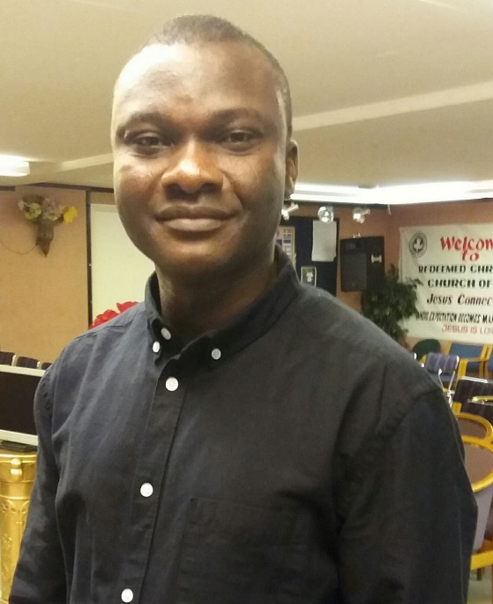
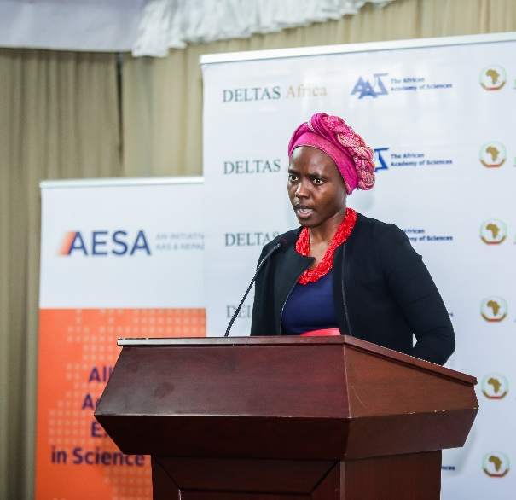 |  |  |  |  | Nomfundo Moroe  Institution: University of the Witwatersrand  CARTA Cohort: Six  Year of graduation: 2018  Research interests: Occupational and environmental noise and its impact on the quality of life; Early identification and management of occupational and environmental noise; Engineering controls in the management of occupational noise; Deafness - Culture; family dynamics, quality of life and family-centered intervention; Role of audiologists in various sectors.  Hearing loss at different stages of life; Auditory pathologies, particularly tinnitus; Advances and technology in Audiometry; Hearing children of Deaf parents and family dynamics; Health Advocacy.
Diana Menya  Institution: Moi University  CARTA Cohort: Two  Year of graduation: 2016  Research interests: Epidemiology of Cancer in western Kenya; Household Air Pollution; Malaria studies |  |  |  |  |  |  |  |  |  |  |  |  | 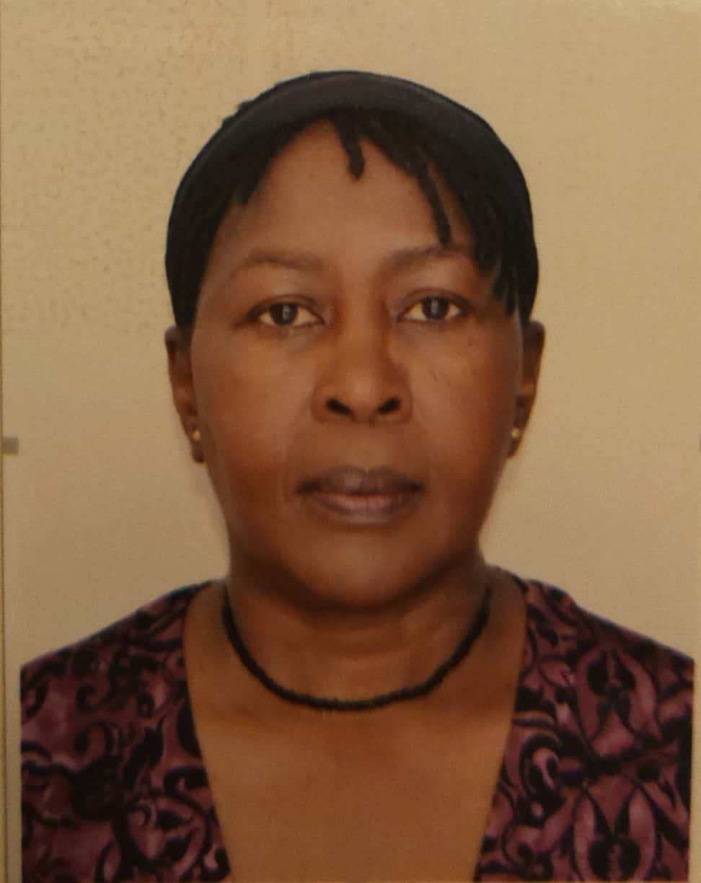
Sunday Joseph Ayamolowo
Institution: Obafemi Awolowo University, Nigeria
CARTA Cohort: Four
Year of graduation: 2018
Research interests: My major research interest is on Reproductive, Maternal, Newborn and Child Health (RMNCH). I am particularly interested in community midwifery studies that focus on key drivers of reproductive, maternal, newborn and child health care access, utilisation and outcomes in the health system. My minor research interest is eHealth, Open and Distance Learning (ODL) nursing education.

John Alonge Ayodele
Institution: University of Ibadan
CARTA Cohort: Four
Year of graduation: 2017
Research interests: Emerging technologies in Libraries, Digital Library, Health Information System, and Health Communication, new media, e- Library, e-Publishing, and Social media for communication
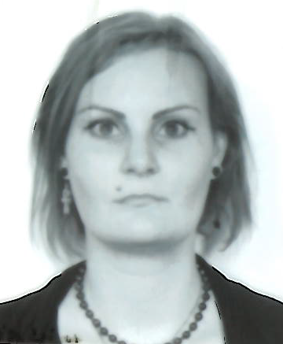 |  |  |  |  |  | Anna Levinsson  Institution: Université de Montréal  CARTA Cohort: N/A  Year of graduation: 2015  Research Interest: My main research interests are sex and gender differences in cardiovascular disease, social determinants of health, and epigenetics as sex- and gender-specific markers of exposure, all in both Western cultures and global health settings. In parallel I am also developing skills in health policy and knowledge transfer, by being a member of health policy working groups of several Canadian organizations.  Currently, I am finishing up my postdoc and applying for my first appointment as an independent researcher. I aim to join an inter-disciplinary department that encourages collaborations inside and outside the university as well as internationally.
Georges Danhoundo  Institution: University of Alberta  CARTA Cohort: N/A  Year of graduation: 2014  Research interests: West Africa (Benin, Burkina Faso) and rural Canada; HIV/AIDS and malaria in pregnancy; Social accountability interventions in maternal health service delivery; Factors associated with women’s access to antenatal visits; Quality of antenatal care and health systems; Maternal health program implementation; Social determinants of women’s and children’s health; Accountability processes in the health sector; Mental health of orphaned children; Longitudinal rural integrated community clerkships; Community impact of medical education; Community-based participatory research; Qualitative research methods. |  |  |  |  |  |  |  | 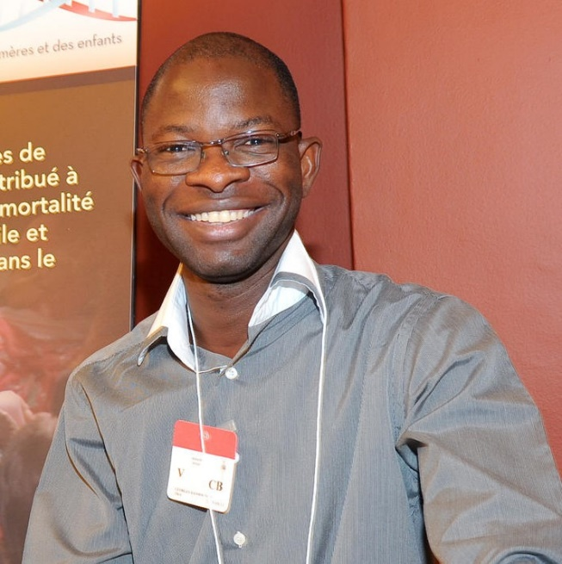
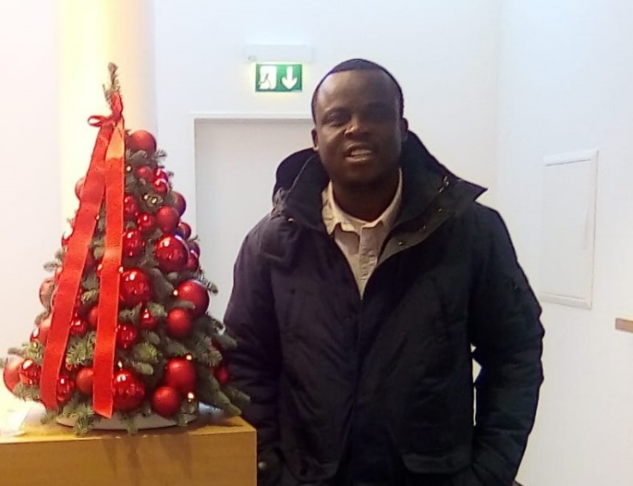 |  |  |  |  |  |  | Emmanuel Bakare  Institution: Swiss TPH  CARTA Cohort: N/A  Year of graduation: 2017  Area of interest: Biomathematics and Disease Modelling.

