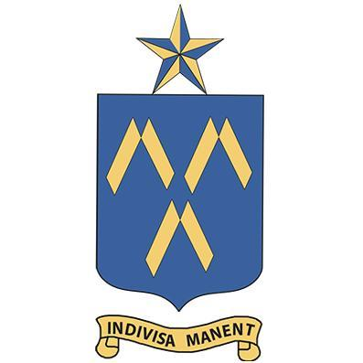
The Bethlehem University Foundation
Cordially invites you to a reception welcoming
Brother Peter Bray, F.S.C.
Vice Chancellor of Bethlehem University
Wednesday, the 16th of November, 2016
6:00-8:00 p.m.

The Archbishop Quigley Center
835 N. Rush St., Chicago, IL 60611-2030
Drinks and hors d’oeuvres
$150.00 per person
Proceeds to benefit
The Educational Mission of Bethlehem University

Please R.S.V.P. by Friday, the 11th of November, 2016
Contact atj@bufusa.org or (240) 241-4381 for additional information

Sponsorships available at www.bufusa.org/upcoming-events

