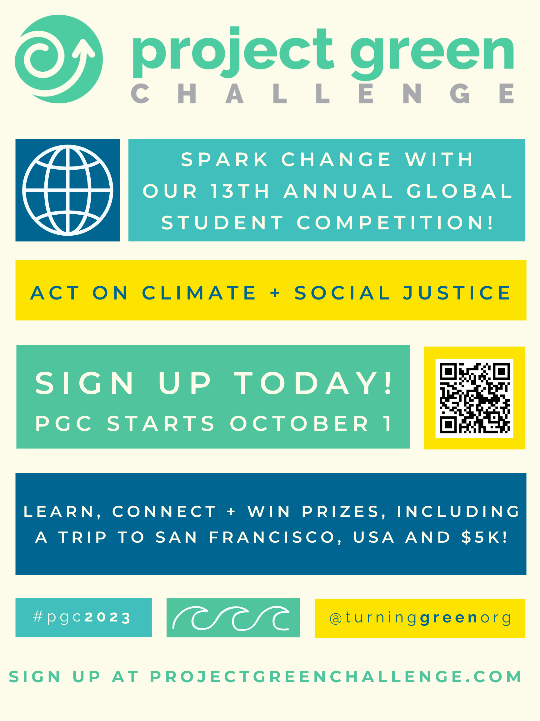

Dear Faculty,

This October, thousands of students from around the world will dive into a 30-day journey of sustainability, climate advocacy and environmental education. We’re reaching out to you in hopes that you’ll invite your students to participate in Turning Green’s 13th annual Project Green Challenge (PGC). The competition is free and offers students the opportunity to connect with like-minded peers, win prizes from our eco-friendly corporate sponsors, and learn how to become a visionary catalyst for environmental activism and advocacy.

What does PGC offer?
- Experiential education encompassing climate and social justice topics.
- Unique themes each day that form an intersectional environmental curriculum.
- The chance to join a global network of student environmentalists.
- Daily rewards for participants who upload exemplary challenge submissions.
- For up to 14 students, the chance to win an all-expenses paid trip to San Francisco for the PGC Finals in November.
- Guidance and mentorship to conduct a Climate Action Project.
- The opportunity to win a $5,000 grand prize.

What can you do?
- Invite college & graduate students to sign up at ProjectGreenChallenge.com!
- Encourage driven students to apply for a leadership position as a Campus Rep.
- Incorporate PGC into your October curriculum, lesson plans, and extracurricular activities.
- Share PGC with fellow educators in your network.
- Get in touch with our team with ideas for collaboration.

We are here and happy to support you in sharing PGC with students. Please reach out to us at info@turninggreen.org with any questions, ideas, or to set up a virtual meeting.

Our movement is propelled by educators like you.
Here's to #PGC2023!

With excitement and gratitude,
Emily

_______
Emily Yellen
Turning Green Intern
emily.yellen@turninggreen.org
631-478-4083

