CLIMATE & ENVIRONMENT

Column: Newsom’s appointees should stop delaying this great climate solution
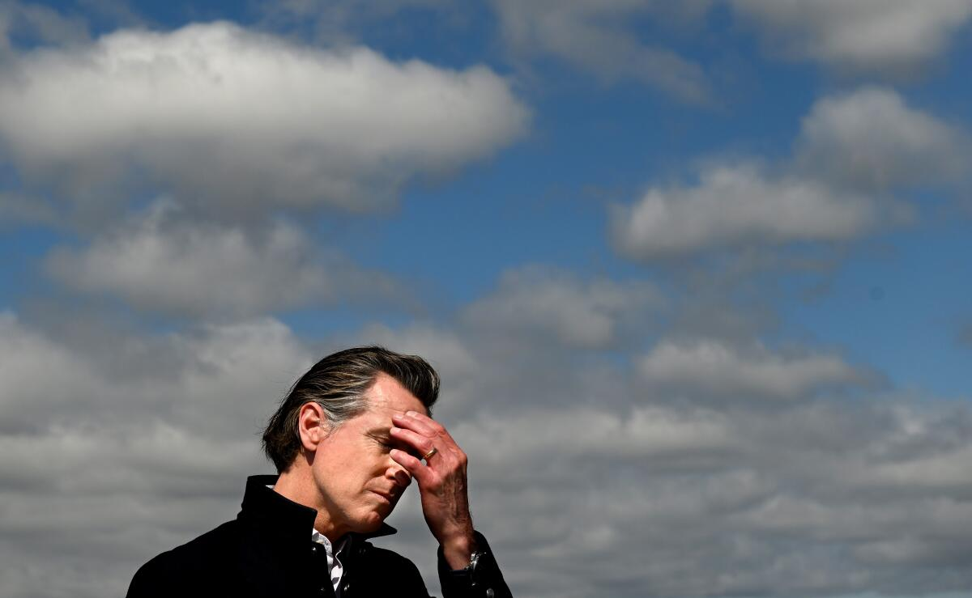
California Gov. Gavin Newsom speaks to the media as he stands next to a flooded strawberry field in the town of Pajaro in March 2023. (Wally Skalij / Los Angeles Times)
By Sammy Roth Climate Columnist, May 9, 2024 6 AM PT

We’ll have to wait a few more weeks to find out if Gov. Gavin Newsom is willing to push back against utility industry resistance to local solar power — or if the governor will follow the lead of electric monopoly Southern California Edison.
Newsom’s appointees to the California Public Utilities Commission had been scheduled to vote Thursday on an Edison-backed plan that critics say would throw up serious economic roadblocks to “community solar” projects — small neighborhood solar farms that can help renters and low-income families reduce their utility bills and stop relying on heat-trapping, lung-damaging fossil fuels. But on Wednesday the commission’s president, Alice Reynolds, delayed the vote until at least May 30.
The delay was the latest sign that Newsom may be working on a compromise.
The governor has faced pressure from across the political spectrum — and across the country — to not squash community solar. As I reported last week, Newsom and his team have heard from top energy officials in both the Biden and Trump administrations, and from New York Gov. Kathy Hochul, with all of them urging stronger support for community solar.
So it’s good that Reynolds and her fellow commissioners didn’t vote Thursday to adopt the Edison-backed plan.
But it’s frustrating that Newsom hasn’t instructed them to approve a far better proposal crafted by a coalition of community solar installers, environmental groups, consumer watchdogs and labor unions — many of whom don’t typically see eye to eye.
The Utility Reform Network, an influential consumer group, had previously sided with Edison, Pacific Gas & Electric and San Diego Gas & Electric in a successful campaign to persuade the Public Utilities Commission to slash “net metering” incentives for rooftop solar panels. TURN and the utility companies had argued that solar incentives are ultimately paid for by the vast majority of utility customers who don’t have solar, driving up monthly electric bills — an idea known as the cost shift.
The labor unions that represent many Edison, PG&E and SDG&E employees also played a key role in the rooftop solar fight.
Scott Wetch — a longtime lobbyist for Local 1245 of the International Brotherhood of Electrical Workers, which represents PG&E employees — is an especially powerful figure in Sacramento. And he’s put that power to use undermining rooftop solar.
“There’s not many legislative wins that have eluded us,” Wetch told me last week.
But when it came to community solar, IBEW Local 1245 and other utility unions got on board with the coalition proposal. So did TURN. It was only Edison that raised a stink, offering its own plan that that utilities commission staff largely endorsed.
Meanwhile, rooftop solar installers continue devastating layoffs, a year after Newsom’s commissioners gutted net metering.
What gives? With Earth just wrapping up its 11th-straight record-hot month, why is the Golden State’s climate champion governor refusing to move forward on a valuable clean energy solution? Why is he letting his commissioners fritter away three more weeks wringing their hands, while fossil fuel profiteers continue to pump carbon pollution into the atmosphere?
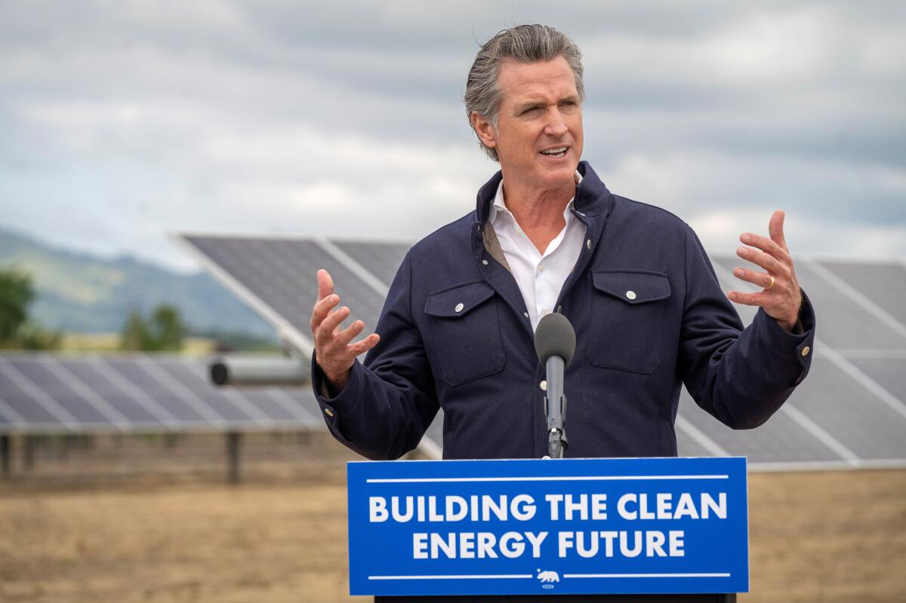
Gov. Gavin Newsom visits a solar energy and battery storage facility in Winters, Calif., in April. (Office of Gov. Gavin Newson)
When I asked Newsom spokesperson Alex Stack for comment last week on community solar, he called it “an open matter at the [Public Utilities Commission] which is currently moving through their public input and decision-making process.”
“California has more solar capacity than any other state in the country and is bringing on more and more solar every single year, and it’s critical that we continue bringing online more cost-effective renewable and zero-carbon energy,” he said in an email.
It’s true that we’ve got lots of solar power in California, and that we’re adding more all the time.
But even if California is doing a relatively good job of building large solar farms in the desert, that’s no excuse for blocking small-scale solar installations in cities — on rooftops, parking lots, warehouses, abandoned lots and elsewhere. We’ll need all the solar we can get to stem the increasingly deadly heat waves, wildfires, droughts, hurricanes and floods of the climate crisis.
That’s why, in my column last week, I pitched a political “grand bargain” to end California’s solar squabbling.
The basic idea was this: What if rooftop solar installers, utility companies, labor unions and other sparring parties could learn to stop fighting? What if environmentalists who prefer rooftop solar could grit their teeth and accept some large-scale solar farms that destroy wildlife habitat, as long as those solar farms aren’t built in the absolute worst spots? What if utility executives could accept a future in which they don’t profit off absolutely everything, and support increased rooftop solar incentives?
When I outlined the grand bargain concept to one of my longtime sources, he told me I was living in a fantasy.
“Maybe in an alternative version of our reality, in the metaverse, there is a place where people can carve out a deal that everyone can live with,” Matt Freedman said. “But in reality, there is no single table where we can all work out all our issues.”
“These are all being fought out issue by issue,” he added. “It’s basically trench warfare.”
Freedman, a longtime attorney for the Utility Reform Network, is right about the trench warfare. I’ve seen it again and again.
And yet, somehow, I still feel hopeful.
Maybe that’s because, even as the utilities and their union allies continue to steamroll legislation not to their liking, lawmakers continue to introduce bills that would support rooftop solar — and some of those bills haven’t been defeated.
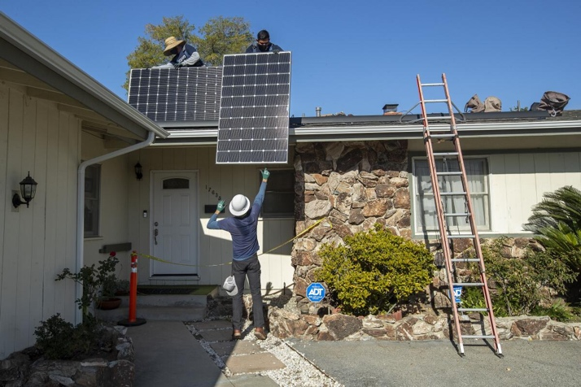
Sunrun employees install rooftop solar panels at a house in Granada Hills in 2020. (Mel Melcon / Los Angeles Times)
One recent example: State Senate Bill 1374 from Sen. Josh Becker (D-Menlo Park), which would undo another nonsensical decision by the Public Utilities Commission. Newsom’s appointees voted last year to make solar less affordable for schools, strip malls, farms and other non-residential properties served by Edison, PG&E and SDG&E. As a result of the vote, those entities now pay full retail rates for all the electricity they use — even during times of day when their solar panels are generating power.
In essence, they now pay the utilities full retail rate for electricity they generate themselves.
SB 1374 would give schools and other nonresidential customers with solar panels the same right to “self-consumption” enjoyed by single-family homes and apartments, allowing them to lower or cancel out their utility payments when the sun is shining. The bill cleared the Senate energy committee last month and is awaiting a vote in the Appropriations Committee.
In an interview, Becker told me he was incredulous over the Public Utilities Commission’s decision.
“We’re going to say to schools, ‘No, you can’t save $3 million with solar and shade cars [in the parking lot] because we’re worried it could have this small ripple effect down the road,’” he said. “To me, that is cutting off your nose to spite your face.”
Becker’s “small ripple effect” comment refers to the cost shift argument — the idea that almost any type of solar incentive paid for by utility ratepayers is inherently unfair, because homes without solar end up subsidizing homes with solar.
Edison cited the cost shift to explain its unpopular position on community solar. And although almost everyone else involved in the discussion disagrees with the company’s stance, the Public Utilities Commission’s internal ratepayer watchdog supports the Edison-backed proposal, describing it as “a positive step toward meeting the state’s clean energy and climate goals.”
Rising energy costs are a serious problem. Undermining community solar isn’t the right solution.
If Newsom shows some backbone and refuses to give Edison its desired outcome — by endorsing the coalition community solar proposal, not arranging some middle-ground compromise — the utility may be forced to reconsider its hard-nosed opposition to all things small-scale solar and find a new willingness to work with rooftop solar installers and advocacy groups.
I’d advise rooftop solar installers and advocates to find that same willingness to work with Edison.
Utilities and renewable energy developers have at times chosen disastrous spots to build sprawling solar fields, wind farms and power lines, attempting to pave over irreplaceable landscapes and wildlife migration corridors. But they’ve also struck deals with conservation groups, avoiding some of the most ecologically sensitive areas in exchange for regulatory certainty.
Just last month, Edison publicly joined with environmental activists and Native American tribes in urging President Biden to establish Chuckwalla National Monument in the California desert, as part of a compromise that ensures there’s room for solar energy and power lines on public lands. That could serve as a model for future dealmaking.

A dirt road leads into Painted Canyon, part of the proposed Chuckwalla National Monument in the California desert. (Tyrone Beason / Los Angeles Times)
And as much as Edison wants to build giant power lines to bring us electricity from far-off solar farms — that’s how the company makes money, by charging us for those lines, plus profits — it’s also exploring less infrastructure-heavy climate solutions.
Last month, Edison joined with PG&E and several state agencies to apply for a $2-billion federal grant that would help the utilities invest in technologies to route more energy through their existing wires. These “grid enhancing technologies” won’t eliminate the need to build new electric lines to move solar and wind energy from where it’s generated to where it’s consumed. But experts say they could accelerate transition from fossil fuels and reduce the costs of building out clean energy infrastructure.
Edison hopes to learn whether the technologies are cost effective, whether they’re safe and whether they perform as advertised, according to Erica Bowman, the company’s vice president of strategy, planning and performance.
“We are actively trying these new technologies because we see a real need for them in the future,” she said.
Won’t Edison make less money if it’s not building as many big power lines?
When I posed that question to Bowman, she basically said the company needs to be careful.
If electricity gets too expensive — spoiler alert, it’s already too expensive— Californians won’t want to drive electric cars or invest in electric heating and cooking. Edison’s growth plans, and California’s climate ambitions, are tied to “electrify everything.”
So, yes, Edison wants to build lots of big expensive infrastructure to make money — but not so much expensive infrastructure that utility bills go through the roof and there’s a political backlash against electrification. Hence grid enhancing technologies.
“This whole energy transition is not going to happen if costs of electricity are too high,” Bowman said.
Likewise, this whole energy transition is not going to happen unless we can find ways to start seeing the world through climate-colored goggles and be willing to put climate progress above whatever grievances we might have with the monopoly utilities, or the labor unions, or the rooftop solar installers that don’t employ union workers, or the conservationists in the desert.
Climate scientists tell us we’ve got six years to cut emissions more than 40%. Trench warfare isn’t going to work.
“I’m not defending the way things are,” Freedman said. “I’m just offering my observation.”
My observation: Community solar should be an easy starting point for Newsom to begin fixing this mess. No more delays.

This column is the latest edition of Boiling Point, an email newsletter about climate change and the environment in California and the American West. You can sign up for Boiling Point here. And for more climate and environment news, follow @Sammy_Roth on X.

