California Sues Giant Oil Companies, Citing Decades of Deception
Launching one of the most prominent climate lawsuits in the nation, the state claims Exxon, Shell, BP and others misled the public and seeks creation of a special fund to pay for recovery.
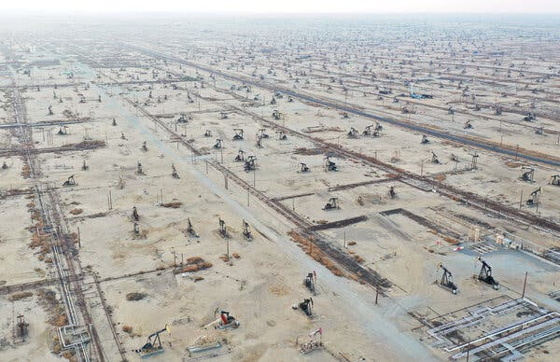
The Belridge oil field in California, a significant oil producing state. Credit...Mario Tama/Getty Images

By David Gelles, David Gelles writes the Climate Forward newsletter and reports on climate litigation., Sept. 15, 2023
The state of California sued several of the world’s biggest oil companies on Friday, claiming their actions have caused tens of billions of dollars in damage and that they deceived the public by downplaying the risks posed by fossil fuels.
The civil case, filed in superior court in San Francisco, is the latest and most significant lawsuit to target oil, gas and coal companies over their role in causing climate change. It seeks creation of an abatement fund to pay for the future damages caused by climate related disasters in the state.
The lawsuit targets five companies: Exxon Mobil, Shell, BP, ConocoPhillips, and Chevron, which is headquartered in San Ramon, Calif. The American Petroleum Institute, an industry trade group based in Washington, is also listed as a defendant.
Seven other states and dozens of municipalities have filed similar lawsuits in recent years. But the California lawsuit immediately becomes one of the most significant legal challenges facing the fossil fuel industry.
Beyond being the most populous state in the country, California is a major producer of oil and gas, and its attorney general’s office has a track record of bringing landmark cases that are emulated by smaller states. California is also on the front lines of climate-change-fueled extreme weather, with wildfires, floods, sea-level rise, searing heat and even tropical storms battering the state.
“California’s case is the most significant, decisive, and powerful climate action directed against the oil and gas industry in U.S. history,” said Richard Wiles, the president of the Center for Climate Integrity, a nonprofit organization that tracks climate litigation.

More on California
- Climate Disclosure Bill: Gov. Gavin Newsom said that he would sign a landmark climate bill requiring major companies to publicly disclose their greenhouse gas emissions, a move with national and global repercussions.
- Taking on Big Oil: California sued five of the world’s biggest oil companies, claiming that their actions have caused tens of billions of dollars in damage and that they deceived the public by downplaying the risks posed by fossil fuels.
- Marilyn Monroe’s Last Home: Sixty years after the actress’s death from an overdose, fans still leave flowers at the gate of her house in Brentwood. Now lawmakers and activists are fighting to save it from demolition.
- Salvation Mountain: The folk art monument in the desert near the Salton Sea in California is grappling with extreme weather, social-media-fueled tourism and its own tattering beauty.
Exxon, Chevron, Shell, BP and ConocoPhillips did not immediately reply to requests for comment.
In a statement, Ryan Meyers, general counsel of the American Petroleum Institute, said: “This ongoing, coordinated campaign to wage meritless, politicized lawsuits against a foundational American industry and its workers is nothing more than a distraction from important national conversations and an enormous waste of California taxpayer resources. Climate policy is for Congress to debate and decide, not the court system.”
The lawsuit, brought on behalf of the people of California by the state’s attorney general, Rob Bonta, was filed late on Friday. It claims that starting in the 1950s, the companies and their allies intentionally downplayed the risks posed by fossil fuels to the public, even though they understood that their products were likely to lead to significant global warming. It alleges that Exxon, Chevron and the other companies have continued to mislead the public about their commitment to reducing emissions in recent years, boasting about minor investments in alternative fuels while reaping record profits from the production of planet-warming fossil fuels.
“These folks had this information and lied to us, and we could have staved off some of the most significant consequences,” said Gov. Gavin Newsom of California. “It’s shameful. It’s sickens you to your core.”

California Attorney General Rob Bonta. Credit...Marcio Jose Sanchez/Associated Press
The lawsuit claims that the oil companies created a public nuisance, that they destroyed natural resources, and that they violated false-advertising and product-liability laws.
“Oil and gas company executives have known for decades that reliance on fossil fuels would cause these catastrophic results, but they suppressed that information from the public and policymakers by actively pushing out disinformation on the topic,” the complaint reads. “Their deception caused a delayed societal response to global warming. And their misconduct has resulted in tremendous costs to people, property, and natural resources, which continue to unfold each day.”
In a detailed 135-page complaint, the state makes the case that the companies and their trade group have known since the 1950s that emissions from their products would dangerously warm the planet. But rather than alert the public, seek to reduce their emissions or invest in cleaner technologies, they downplayed the dangers and promoted fossil fuels as safe.
The complaint claims that the companies’ greenwashing has continued up to the present day, with the oil companies promoting certain types of gasoline as environmentally friendly, and that the companies have recently walked back their commitments to reduce emissions.
The lawsuit also details the growing damage that climate change is inflicting on California in the form of record heat, drought and water shortages, wildfires, extreme storms, flooding, crop damage, coastal erosion and biodiversity loss.
“This last 10 years, it’s shook me to my core,” Mr. Newsom said. “These are things that we imagined we might be experiencing in 2040 and 2050, but that have been brought into the present moment, and the time for accountability is now.”
“What are the tipping points the world faces?”


Have Climate Questions? Get Answers Here.
What’s causing global warming? How can we fix it? This interactive F.A.Q. will tackle your climate questions big and small.
Oil, gas and coal companies are facing a wave of climate lawsuits. Cities and states around the country have sued, and are seeking billions of dollars in damages.
The fossil fuel companies tried to get many of the cases moved from state court to federal court, where they believed they would face better chances of winning. But earlier this year, the Supreme Court declined to hear an appeal on the matter, meaning the cases will stay in state court, where experts believe municipalities have a better chance of winning damages.
Two recent lawsuits against big oil companies, one in Puerto Rico and one in Hoboken, N.J., have brought charges under the state and federal versions of the Racketeer Influenced and Corrupt Organization Act. But the California lawsuit does not bring claims under the state’s RICO act.
The lawsuit also doesn’t seek damages from a specific weather event, a strategy used in the Puerto Rico case and a recent lawsuit from Multnomah County in Oregon.
Instead, Mr. Bonta is seeking the creation of a fund that would be used to pay for recovery from extreme weather events and mitigation and adaptation efforts across the state. The lawsuit claims that California has already spent tens of billions of dollars paying for climate disasters, and expects costs to rise significantly in the years ahead.
“This has been a multi-decade, ongoing campaign to seek endless profits at the expense of our planet, our people, and the greedy corporations and individuals need to be held accountable,” Mr. Bonta said in an interview. “That’s where we come in.”
There is a precedent for such a fund. Several California cities sued the makers of lead paint on similar grounds. After decades of litigation, the companies agreed to settle for $305 million, which was used to create an abatement fund.

David Gelles is a correspondent on the Climate desk, covering the intersection of public policy and the private sector. Follow him on LinkedIn and Twitter. More about David Gelles

