World is on brink of catastrophic warming, U.N. climate change report says

A dangerous climate threshold is near, but ‘it does not mean we are doomed’ if swift action is taken, scientists say
By Sarah Kaplan
Updated March 20, 2023 at 5:33 p.m. EDT| Published March 20, 2023 at 9:01 a.m. EDT
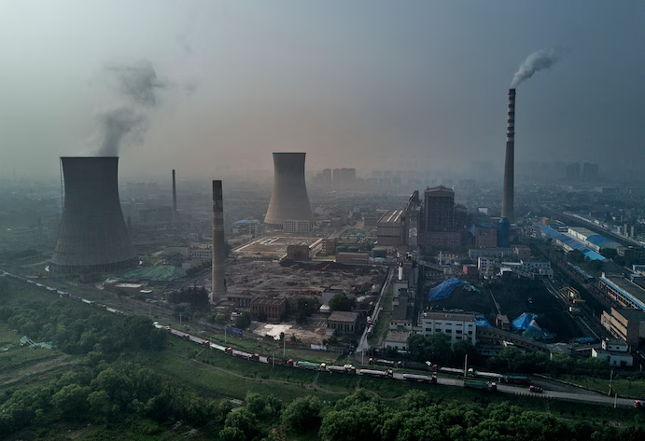
A Chinese state-owned coal-fired power plant is seen near a large floating solar farm project under construction in 2017 in Huainan, Anhui province, China. (Kevin Frayer/Getty Images)

The world is likely to pass a dangerous temperature threshold within the next 10 years, pushing the planet past the point of catastrophic warming — unless nations drastically transform their economies and immediately transition away from fossil fuels, according to one of the most definitive reports ever published about climate change.
The report released Monday by the U.N. Intergovernmental Panel on Climate Change (IPCC) found that the world is likely to surpass its most ambitious climate target — limiting warming to 1.5 degrees Celsius (2.7 degrees Fahrenheit) above preindustrial temperatures — by the early 2030s.
Beyond that threshold, scientists have found, climate disasters will become so extreme that people will not be able to adapt. Basic components of the Earth system will be fundamentally, irrevocably altered. Heat waves, famines and infectious diseases could claim millions of additional lives by century’s end.
- Global warming
At our current global pace of carbon emissions, the world will burn through its remaining “carbon budget” by 2030. Doing so would put the long-term goal of keeping global warming to 1.5 degrees Celsius (2.7 degrees Fahrenheit) irrevocably out of reach.
- Why the goal of 1.5 degrees Celsius?
Keeping warming below this threshold would help save the world’s coral reefs and preserve the Arctic’s protective sea ice layer. It could also stave off dramatic sea level rise by avoiding further destabilization in Antarctica and Greenland.
- So where do we stand now?
The world has already warmed more than 1.1 degrees Celsius (2 degrees Fahrenheit) above preindustrial temperatures. We charted over 1,200 different scenarios for climate changeover the coming century; of those, 230 pathways achieve the warming goal — although only 112 may be realistic.
- What can be done?
Not all hope is lost. Tackling global warming is an enormous feat, but there are many people, organizations and activists making bold strides. We’re tracking their stories in our Climate Solutions section.
Human activities have already transformed the planet at a pace and scale unmatched in recorded history, the IPCC said, causing irreversible damage to communities and ecosystems. Yet global emissions continue to rise, and current carbon-cutting efforts are wildly insufficient to ward off climate catastrophe.
Monday’s assessment synthesizes years of studies on the causes and consequences of rising temperatures, leading U.N. Secretary General António Guterres to demand that developed countries such as the United States eliminate carbon emissions by 2040 — a decade earlier than the rest of the world.
With few nations on track to fulfill their climate commitments and with the developing world already suffering disproportionately from climate disasters, he said, rich countries have a responsibility to act faster than their low-income counterparts.
The IPCC report shows humanity has reached a “critical moment in history,” IPCC Chair Hoesung Lee said. The world has all the knowledge, tools and financial resources needed to achieve its climate goals, but after decades of disregarding scientific warnings and delaying climate efforts, the window for action is rapidly closing.
Calling the report a “how-to guide to defuse the climate time-bomb,” Guterres announced on Monday an “acceleration agenda” that would speed up global actions on climate.
Emerging economies including China and India — which plan to reach net zero in 2060 and 2070, respectively — must hasten their emissions-cutting efforts alongside developed nations, Guterres said.
Both the U.N. chief and the IPCC also called for the world to phase out coal, oil and gas, which are responsible for more than three-quarters of global greenhouse gas emissions.
“This report offers hope, and it provides a warning,” Lee told reporters Monday. “The choices we make now and in the next few years will reverberate around the world for hundreds, even thousands, of years.”
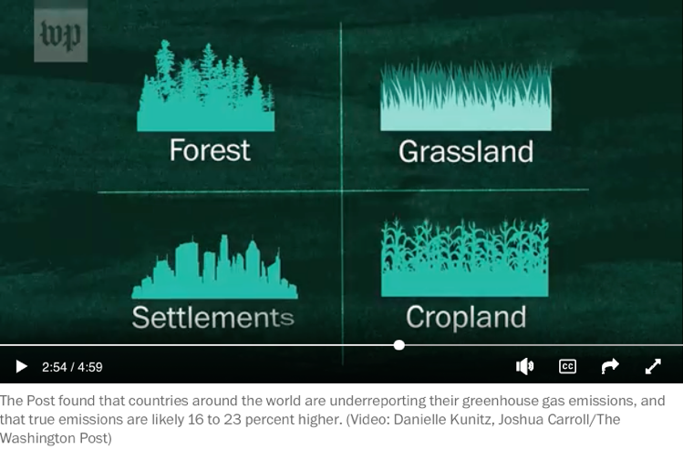
The Post found that countries around the world are underreporting their greenhouse gas emissions, and that true emissions are likely 16 to 23 percent higher. (Video: Danielle Kunitz, Joshua Carroll/The Washington Post)

A stark scientific outlook
Already, the IPCC’s synthesis report shows, humanity has fundamentally and irreversibly transformed the Earth system. Emissions from burning fossil fuels and other planet-warming activities have increased global average temperatures by at least 1.1 degrees Celsius (2 degrees Fahrenheit) since the start of the industrial era. The amount of carbon dioxide in the atmosphere hasn’t been this high since archaic humans carved the first stone tools.
These changes have caused irrevocable damage to communities and ecosystems, evidence shows: Fish populations are dwindling, farms are less productive, infectious diseases have multiplied, and weather disasters are escalating to unheard-of extremes. The risks from this relatively low level of warming are turning out to be greater than scientists anticipated — not because of any flaw in their research, but because human-built infrastructure, social networks and economic systems have proved exceptionally vulnerable to even small amounts of climate change, the report said.
The suffering is worst in the world’s poorest countries and low-lying island nations, which are home to roughly 1 billion people yet account for less than 1 percent of humanity’s total planet-warming pollution, the report says. But as climate disruption increases with rising temperatures, not even the wealthiest and most well-protected places will be immune.

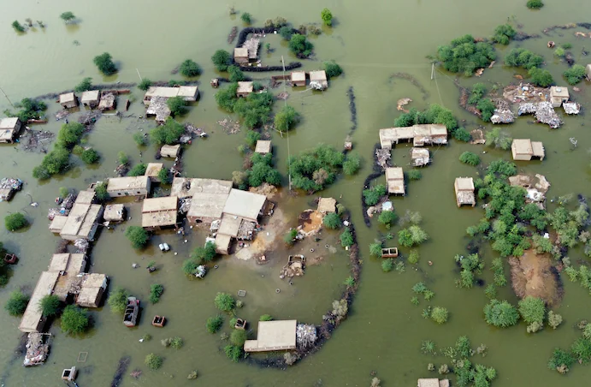
Homes in Pakistan's southwestern Baluchistan province were inundated in August. (Zahid Hussain/AP)
In 2018, the IPCC found that a 1.5C world would be overwhelmingly safer than one that is 2 degrees Celsius (3.6 degrees Fahrenheit) warmer than the preindustrial era. At the time, scientists said humanity would have to zero out carbon emissions by 2050 to meet the 1.5-degree target and by 2070 to avoid warming beyond 2 degrees.
Five years later, humanity isn’t anywhere close to reaching either goal. Unless nations adopt new environmental policies — and follow through on the ones already in place — global average temperatures could warm by 3.2 degrees Celsius (5.8 degrees Fahrenheit) by the end of the century, the synthesis report says. In that scenario, a child born today would live to see several feet of sea level rise, the extinction of hundreds of species and the migration of millions of people from places where they can no longer survive.
“We are not doing enough, and the poor and vulnerable are bearing the brunt of our collective failure to act,” said Madeleine Diouf Sarr, Senegal’s top climate official and the chair for a group of least-developed countries that negotiate together at the United Nations.
She pointed to the damage wrought by Cyclone Freddy, the longest-lasting and most energetic tropical storm on record, which has killed hundreds of people and displaced thousands more after bombarding southern Africa and Madagascar for more than a month. The report shows that higher temperatures make storms more powerful and sea level rise makes flooding from these storms more intense. Meanwhile, the report says, the death toll from these kinds of disasters is 15 times as high in vulnerable nations as it is in wealthier parts of the world.
If the world stays on its current warming track, the IPCC says, global flood damage will be as much as four times as high as it will be if people limit temperature rise to 1.5 degrees.
“The world cannot ignore the human cost of inaction,” Sarr said.

The price of delay
Though much of the synthesis report echoes warnings scientists have issued for decades, the assessment is notable for the blunt certainty of its rhetoric. The phrase “high confidence” appears nearly 200 times in the 36-page summary chapter. Humanity’s responsibility for all of the warming of the global climate system is described as an unassailable “fact.”
Yet the report also details how public officials, private investors and other powerful groups have repeatedly failed to heed those warnings. More than 40 percent of cumulative carbon emissions have occurred since 1990 — when the IPCC published its first study on the dangerous consequences of unchecked warming. Governments continue to subsidize fossil fuel use; banks and businesses invest far more in polluting industries than they do in climate solutions. The consumption habits of the wealthiest 10 percent of people generate three times as much pollution as those of the poorest 50 percent, the report said.
Decades of delay have denied the world any hope of an easy and gradual transition to a more sustainable economy, the panel says. Now, only “deep, rapid and … immediate” efforts across all aspects of society — combined with still-unproven technologies to pull carbon from the atmosphere — will be able to stave off catastrophe.
“It’s not just the way we produce and use energy,” said Christopher Trisos, director of the Climate Risk Lab in the African Climate and Development Initiative at the University of Cape Town and a member of the core writing team for the synthesis report. “It’s the way we consume food, the way we protect nature. It’s kind of like everything, everywhere, all at once.”
But few institutions are acting fast enough, the report said. November’s U.N. climate conference in Egypt ended without a resolution to phase down oil, gas and coal — a baseline requirement for curbing climate change. Last year, China approved its largest expansion of coal-fired power plants since 2015. Amid soaring profits, major oil companies are dialing back their clean-energy initiatives and deepening investments in fossil fuels.
Humanity is rapidly burning through our “carbon budget” — the amount of pollution the world can afford to emit and still meet its warming targets, the IPCC said, and it projected that emissions from existing fossil fuel infrastructure will make it impossible to avoid the 1.5-degree threshold.
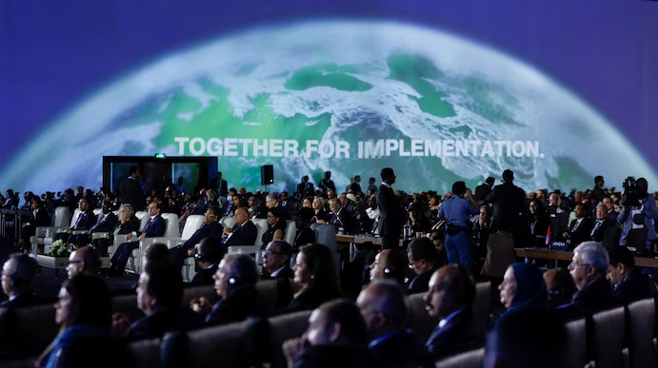
World leaders at November's COP27 summit in Egypt. (Mohammed Salem/Reuters)
Yet even as environmental ministers met in Switzerland last week to finalize the text of the IPCC report, the U.S. government approved a new Arctic drilling project that is expected to produce oil for the next 30 years, noted Hans-Otto Pörtner, a climatologist at Germany’s Alfred Wegener Institute and a co-author of a dozen IPCC reports, including the latest one.
“These decisions don’t match reality,” he said. “There is no more room for compromises.”
Failure to act now won’t only condemn humanity to a hotter planet, the IPCC says. It will also make it impossible for future generations to cope with their changed environment.
The report reveals thresholds in how much warming people and ecosystems can adapt to. Some are “soft” limits — determined by shortcomings in political and social systems. For example, a low-income community that can’t afford to build flood controls faces soft limits to dealing with sea level rise.
But beyond 1.5 degrees of warming, the IPCC says, humanity will run up against “hard limits” to adaptation. Temperatures will get too high to grow many staple crops. Droughts will become so severe that even the strongest water conservation measures can’t compensate. In a world that has warmed roughly 3 degrees Celsius (5.4 degrees Fahrenheit) — where humanity appears to be headed — the harsh physical realities of climate change will be deadly for countless plants, animals and people.
“It’s as if we’re traveling on a carbon-intensive superhighway and we’re in the fast lane,” Trisos said. Unless people immediately pump the brakes on carbon emissions, we will zoom past the off exit for 1.5 degrees of warming — and there will be no turning back.
Yet just like drivers who have missed their exit, humanity must strive to stay as close as possible to the 1.5-degree target, Trisos said. “We can still take the 1.6 exit, which will be better than 1.7.”
“With every increment of global warming, the danger will increase,” he added. “As we leave it later and take hotter and hotter exits, the fewer options we have to thrive.”

‘It does not mean we are doomed’
Despite its stark language and dire warnings, the IPCC report sends a message of possibility, said Friederike Otto, a climate scientist at Imperial College London and a member of the core writing team for the report.
“It’s not that we are depending on something that still needs to be invented,” she said. “We actually have all the knowledge we need. All the tools we need. We just need to implement it.”
In many regions, the report says, electricity from renewable sources such as solar and wind is now cheaper than power from fossil fuels. Several countries have significantly reduced their emissions in the past decade, even as their economies grew. New analyses show how efforts to fight climate change can benefit society in countless other ways, from improving air quality to enhancing ecosystems to boosting public health. These “co-benefits” well outweigh the costs of near-term emissions reductions, even without accounting for the long-term advantages of avoiding dangerous warming.
The IPCC also underscored that tackling climate change can help address global inequities — and vice versa. Stronger safety nets and policies that aid the poor can help foster support for the massive changes needed to help curb carbon emissions, the report says. Helping developing nations build renewable energy infrastructure will both avert emissions and alleviate the energy poverty that afflicts more than 700 million people worldwide, it said.
“It gives a goal to work toward, to a world that looks different,” Otto said of the report. “It does not mean we are doomed.”
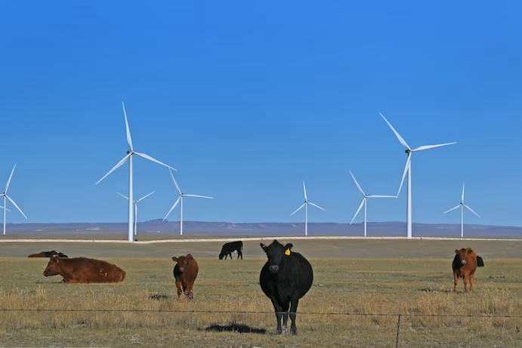
Carbon County, Wyo., is home to some of Wyoming’s most impressive wind farms, where herds of beef cattle graze beneath swooping turbines in 2021. (Katherine Frey/The Washington Post)
Report authors say the IPCC’s assessment comes at a pivotal moment. Beginning this year, nations are required to start updating the emissions-cutting pledges they made in Paris in 2015. Diplomats are also hashing out the details of a “loss and damage” fund established at least year’s climate talks, which would provide compensation to vulnerable countries suffering irreversible climate harms.
By the end of the COP28 climate conference in Dubai in December, Guterres said, the world’s leading economies should adopt climate plans in line with the IPCC’s findings.
The steep political stakes of the IPCC’s findings were evident during the report’s marathon approval session, with representatives from nearly 200 countries haggling over the document’s discussion of climate justice.
The science is indisputable, Lee said Monday: The world will not avoid catastrophic warming unless rich nations speed up their own carbon cuts and help poorer countries do the same.
What’s not yet clear is whether world leaders will follow through. When asked about Guterres’s call for developed countries to move faster toward net-zero emissions, a State Department spokesperson instead directed attention toward China, which is now the world’s largest annual producer of greenhouse gases.
But the planet can’t afford further delays or finger-pointing, the U.N. chief said.
“Demanding others move first only ensures humanity comes last,” he said. “We don’t have a moment to lose.”

