San Fernando Valley park is named for Cindy Montañez, CEO of TreePeople

San Fernando City Councilwoman and ex-legislator is honored for her life's work on environment, social justice.
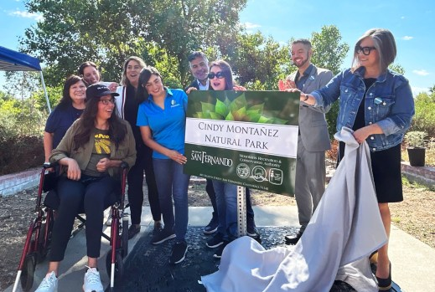
TreePeople CEO Cindy Montañez, a former state Assemblymember and current San Fernando City Council member (left) is joined by elected officials for the unveiling of a sign to commemorate the renaming of a park at 801 8th St. in San Fernando, Calif., after her. Joining her at the Saturday, Sept. 9, 2023, event were (from left): San Fernando Vice Mayor Mary Mendoza, Los Angeles Unified School District board member Kelly Gonez, state Sen. Caroline Menjivar, San Fernando Mayor Celeste Rodriguez, U.S. Rep. Tony Cardenas, Assemblymember Luz Rivas, San Fernando City Councilmember Joel Fajardo and L.A. Councilmember Monica Rodriguez. (Photo by Julie Duarte, City of San Fernando)
By LINH TAT | ltat@scng.com | PUBLISHED: September 12, 2023 at 1:41 p.m. | UPDATED: September 12, 2023 at 2:03 p.m.

Cindy Montañez, a former state Assemblymember, two-time San Fernando City Council member and current CEO of the environmental nonprofit TreePeople, continues to be recognized for her years of service with the renaming of a San Fernando Valley park in her honor.
More than 100 people attended the Saturday, Sept. 9, event in the city of San Fernando, where the Pacoima Wash Natural Park was renamed the Cindy Montañez Natural Park.
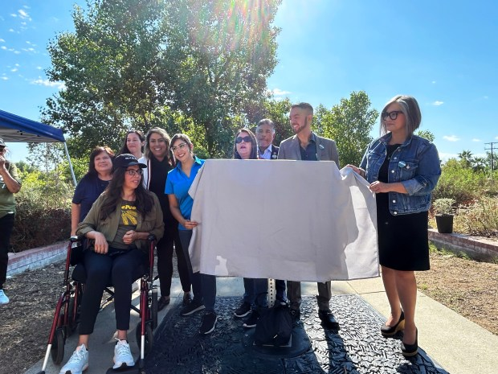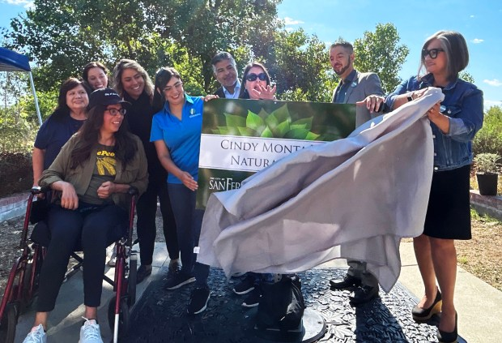
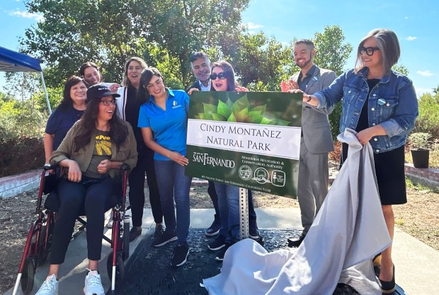
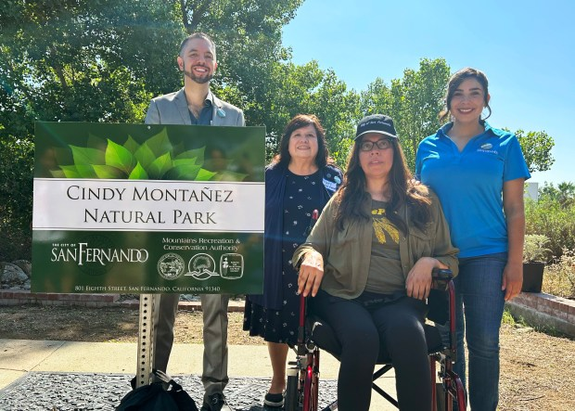

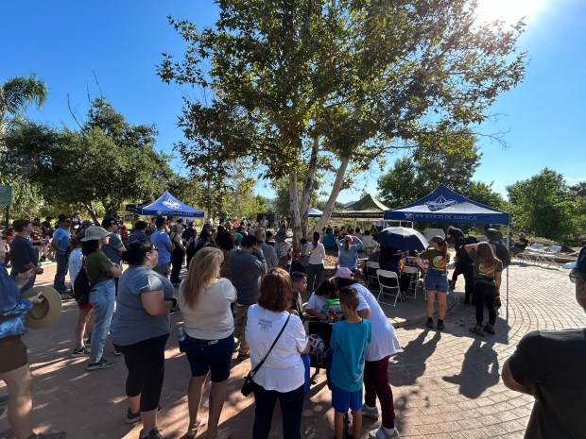 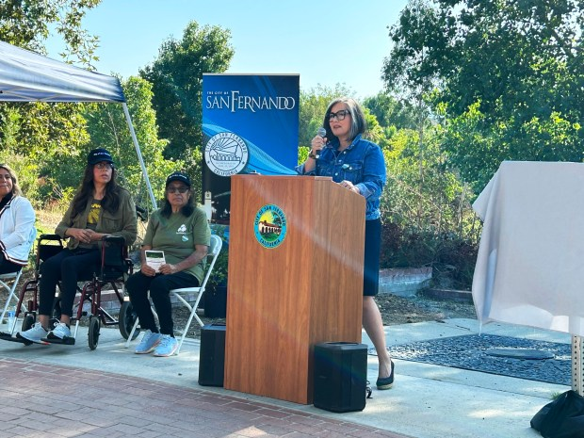
Members of the Aztec dance group Xipe Totec perform during a ceremony to rename the park at 801 8th St. in San Fernando, Calif., after TreePeople CEO Cindy Montañez, a former state Assemblymember and current San Fernando City Council member. The event, on Saturday, Sept. 9, 2023, also included a park cleanup and the planting of over 60 milkweed plants. (Photo by Julie Duarte, City of San Fernando)

The 49-year-old Montañez, who today is battling an aggressive form of terminal cancer, has long been an environmentalist and champion of green space. The 4.7-acre park at 801 8th St., which now bears her name, features walking trails, views of the Angeles Forest and a shady picnic area.
The park also features a stormwater capture system. Up to 371,000 gallons of water – enough to fill 8,800 bathtubs – can infiltrate into the San Fernando Groundwater Basin, decreasing the area’s need for imported water, according to San Fernando city officials.
At Saturday’s event, elected officials from northeastern San Fernando Valley joined Montañez, her family and other community members, for a park renaming ceremony and cleanup. The event included a ceremonial blessing performed by the Aztec dance group Xipe Totec, dedication of a coast live oak, and the planting of more than 60 milkweed plants — the only plant endangered monarch butterflies will use to lay eggs.
“This park wouldn’t be here without her and renaming it ensures we continue to honor Cindy’s work for generations to come,” San Fernando Mayor Celeste Rodriguez said in a statement.
Throughout her career in politics, Montañez has made history, first by becoming the youngest person ever elected to the San Fernando City Council in 1999 at age 25. She became the San Fernando mayor two years later. In 2002, at age 28, she became the youngest woman ever elected to the state legislature. At 30, she chaired the powerful Assembly Rules Committee — the youngest person, first Latina and first Democratic woman to hold the post.
Since 2016, Montañez has served as CEO of TreePeople, a nonprofit dedicated to planting and protecting trees. Under her leadership, the organization has expanded both in its mission and reach.
Montañez is also serving a second term on the San Fernando City Council, having been reelected in 2020.
When the San Fernando council voted to rename a park after her, Montañez requested that milkweed be planted to support a habitat for monarch butterflies.
During a recent interview, Montañez said she likes monarch butterflies because they migrate between the United States and Mexico and are bicultural.
“They fly without borders,” she said.
She said her wish is for everyone to stop and think about their loved ones when they see a monarch butterfly.
“And,” she added, chuckling, “if I’m on your list (of loved ones), think about me.”

