Date:
June 20, 2026

Contact:
Veronica Parsloe
Director of Community Engagement & Development, COMPASS
Veronica.parsloe@compassboston.org
(617) 721-8989

FOR IMMEDIATE RELEASE

Keir Araujo named Director of COMPASS School, serving students with special needs in Boston

(Boston, MA) – The Community Providers of Adolescent Services (COMPASS, Inc.) has named Keir Araujo the new Director of COMPASS School, effective July 1, 2026. Araujo joined COMPASS School in 2011 after earning her Masters in Counseling Psychology from Cambridge College and most recently served as the Director of Admissions and Family Engagement.

“My time with COMPASS School has been rewarding. This role is the next chapter in work I truly care about, and I approach it with commitment and dedication. My focus is on creating an environment where every student feels safe and supported, and ensuring our families know we are genuine partners in their child’s growth and well-being,” said Araujo.

COMPASS School, located in Dorchester serves, students ages 6-21 in grades 1-12 with a range of disabilities that require special education in an individualized therapeutic environment. The program integrates components to build resiliency by offering distinct services based on students’ age, cognitive levels, emotional needs and academic requirements.

As Director of COMPASS School, Araujo will report to the Executive Director and be responsible for the overall operation, quality of services, compliance, and culture of COMPASS School. In this senior leadership role, she will oversee all academic, clinical, behavioral, and family engagement services; ensure that programming across all grades is coherent, student-centered, and mission-driven; and maintain a safe, structured, equitable, and inclusive school community.

Araujo will lead the School Leadership Team in setting strategic priorities, guiding high-level conversations about the school’s health and direction, and promoting a positive milieu and healthy classrooms. Her responsibilities will include supervising the management team, leading recruitment and hiring, overseeing admissions and enrollment, ensuring trauma-informed practices, and maintaining compliance with all relevant educational, clinical, and regulatory standards, including IDEA and Department of Elementary and Secondary Education (DESE) requirements.

“Keir brings deep knowledge of the COMPASS School, strong clinical and program leadership experience, and an unwavering commitment to equity and culturally responsive practice,” said Laura Lajewski, Executive Director. “Her leadership will strengthen our capacity to deliver high-quality, therapeutic, and educational services to students with emotional and behavioral needs.”

In addition to the School, COMPASS offers community services to families throughout the entire state of Massachusetts, as a leading provider of both special education and human services. COMPASS’ mission is to equip those it serves with the skills to become self-sufficient, productive members of their communities and society, with a commitment to diversity, equity, and inclusion in all aspects of its work.

Follow COMPASS to learn more:
Facebook: https://www.facebook.com/COMPASSBoston/
LinkedIn: https://www.linkedin.com/company/10853959
Instagram: @compass_boston
Website: https://compassboston.org/

Partnership and sponsorship opportunities are available for corporations, small businesses and other local entities. Please contact Veronica Parsloe, Director of Community Engagement and Development at veronica.parsloe@compassboston.org for more information.

###

[Photographs attached]
Credit: Ebacher Photography

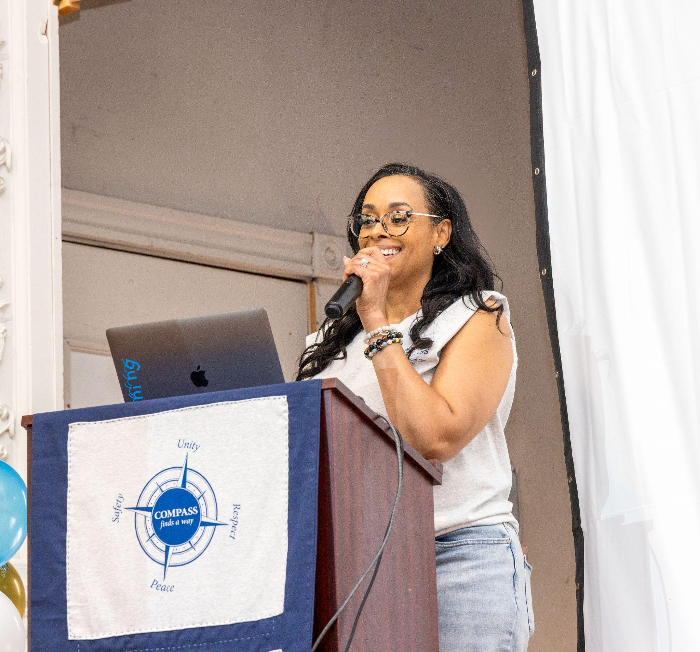
Keir Araujo addresses the audience at the 39th Annual Violence Prevention Day on May 27, 2026
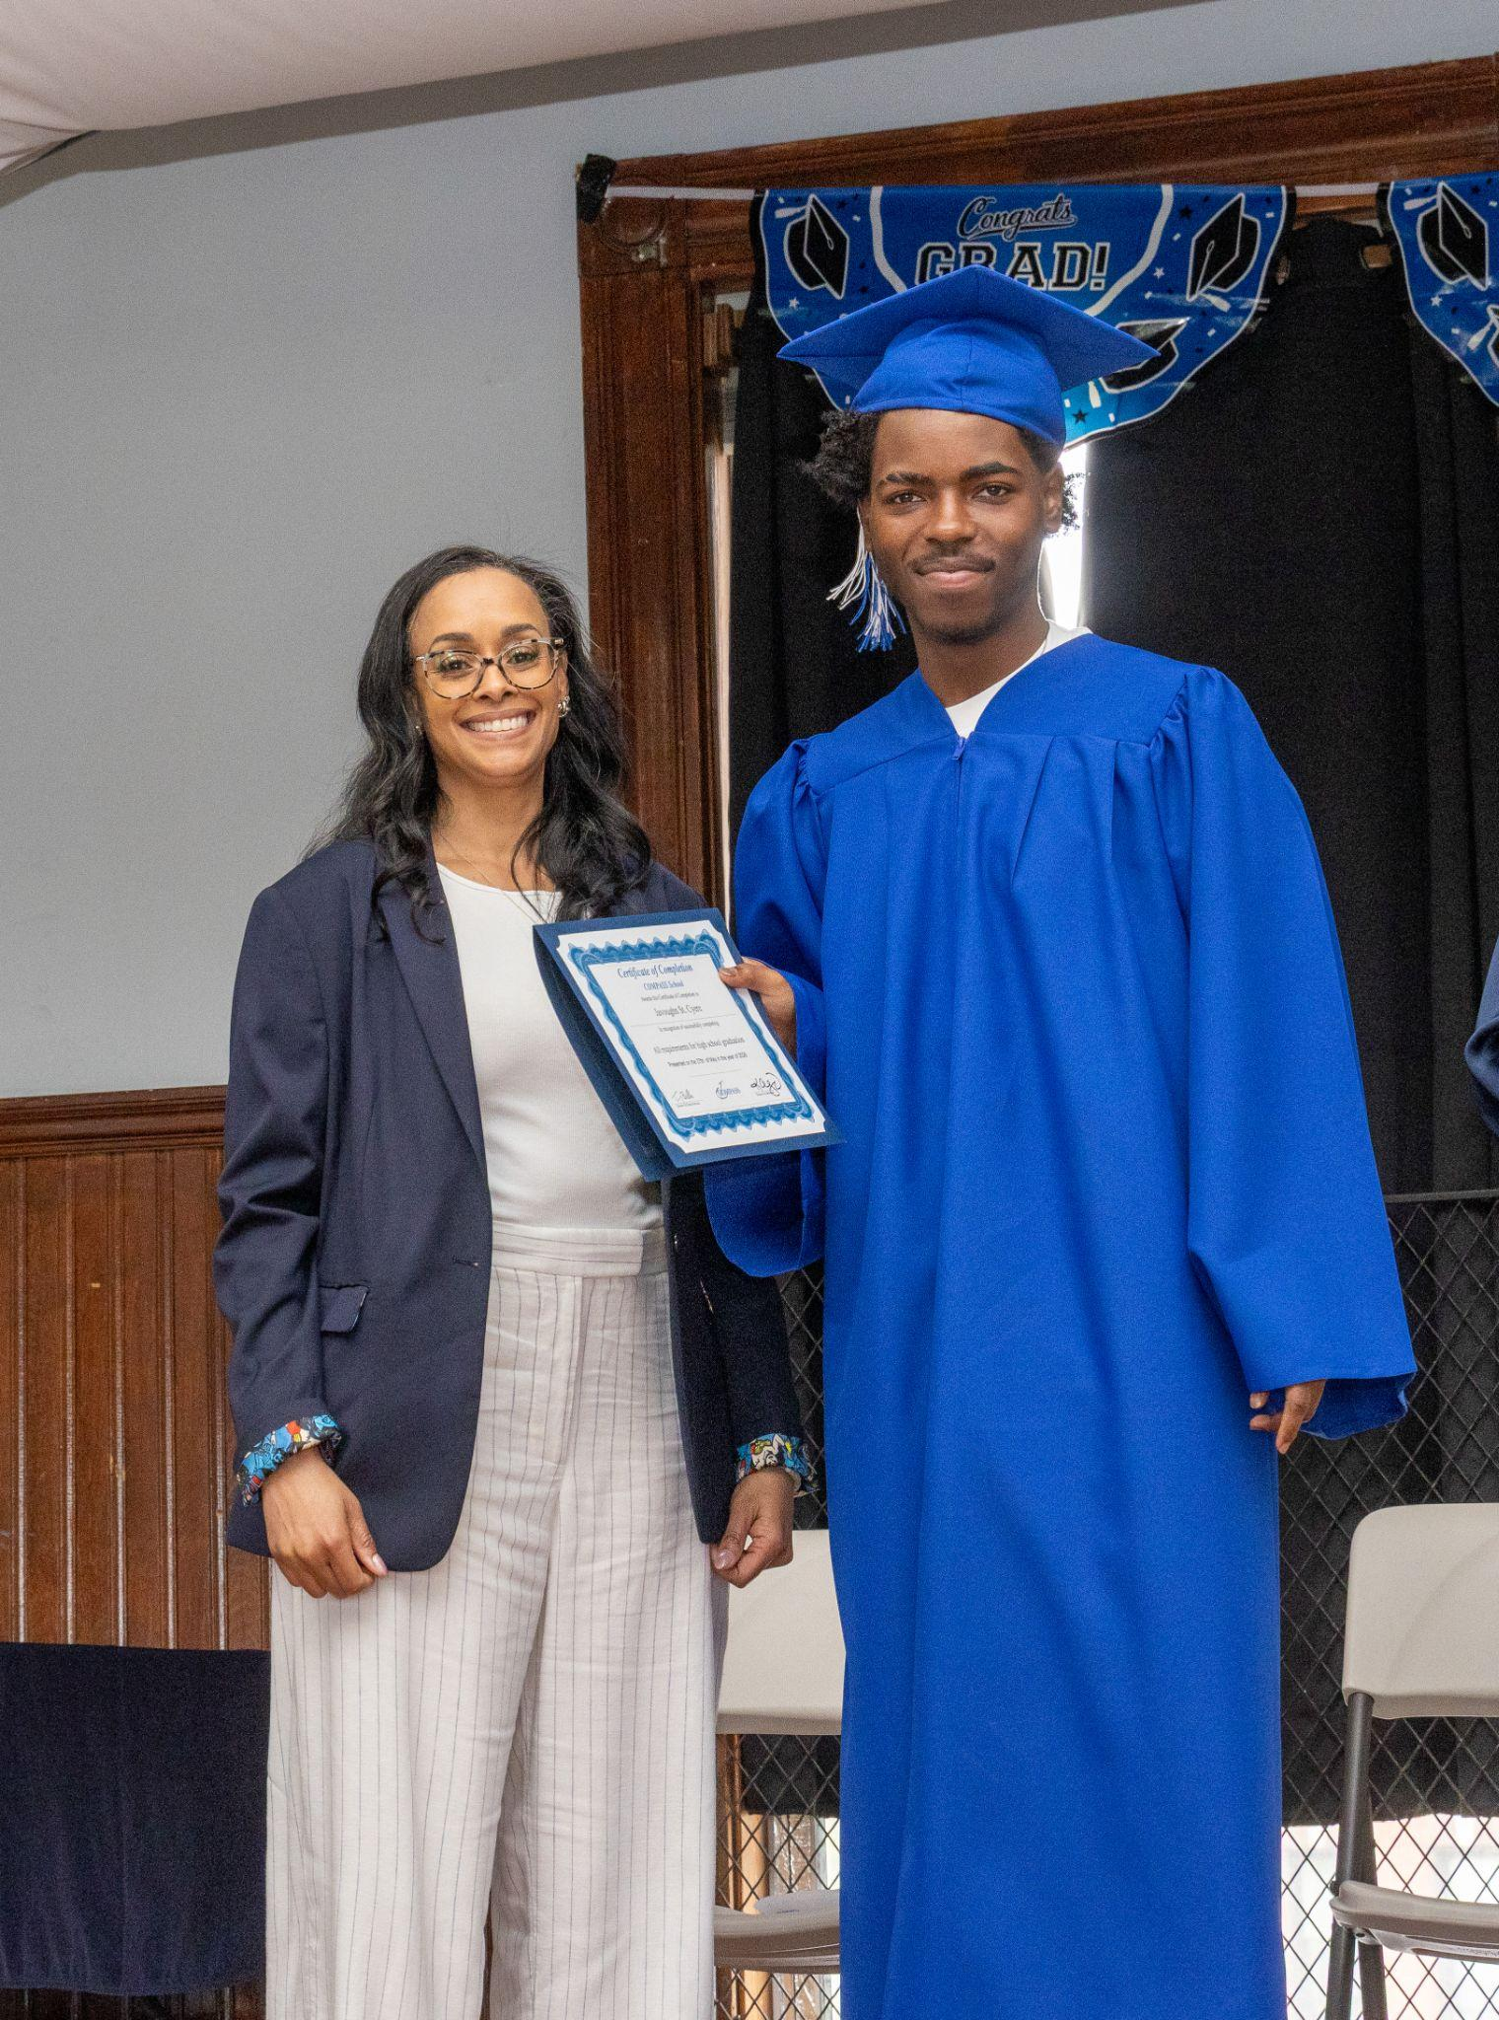
Keir Araujo hands a graduating student their high school diploma at COMPASS School Graduation on May 27, 2026



Keir Araujo provides a certificate to community partner Boston Fire Department honoring their support at the 39th Annual Violence Prevention Day on May 27, 2026

