PASTORAL LEADERSHIP DEVELOPMENT GROUPS

GRACE SCOTT FUND FOR PASTORAL CARE
New Hampshire Conference of the United Church of Christ administered by Pastoral Counseling Services

Pastoral Leadership Development Groups (PLDGs) will be offered in the fall of 2025 for ongoing professional support, personal growth as individuals in ministry, and building skills to sustain living out the call in these demanding times. These groups provide a safe setting to develop one’s identity and practice as a clergyperson.

PLDG facilitators are trained as pastoral psychotherapists, CPE supervisors, and/or specialists in systems theory as applied to the church. Groups will meet virtually, with an option to meet in person twice during the year, if participants decide. The groups are open to all Authorized Ministers of the NH Conference of the UCC. Tuition is $250, which covers ten meetings and is payable in full or in installments if needed (no tuition required for retirees).

In addition to three parish-based PLDGs, groups focused on three specialty areas are offered:
- Newly Called – for parish clergy who are new to ministry and/or new to the NH Conference
- Members In Discernment – for those discerning their call while in care of an Association of the NH Conference
- Retired Clergy – for those no longer serving in active ministry or will soon be entering retirement (two groups will be available this year).
- Licensed Pastors – a new group for the unique ministries of this group

Contact a designated facilitator listed below to be considered for the group in which you are
interested.
For general questions, contact David Reynolds, PLDG Administrator, at (603) 518 7751 or dbr@pcsnh.org.

PASTORAL LEADERSHIP DEVELOPMENT GROUPS
Facilitator Descriptions and Group Contacts

The Rev. Dr. Margaret B. Hess – (603) 930-3456 • meg@makegladness.com Parish Based Group B • 2nd Wednesday 1-3pm

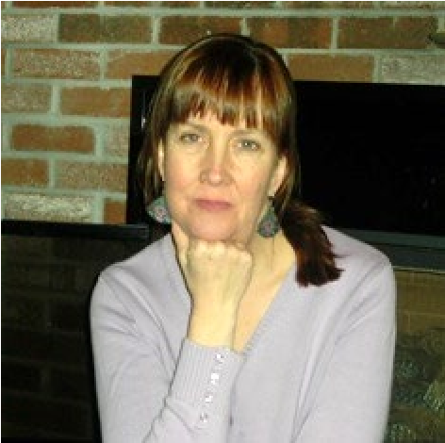
Meg is a NH Licensed Pastoral Psychotherapist practicing in Nashua, NH. An ordained American Baptist Minister, she served as Minister and Interim Minister to ABC/USA congregations in Massachusetts and New Hampshire for 25 years. Meg is on the faculty of Leadership in Ministry Workshops, which uses Bowen systems theory as a lens to explore leadership development in religious institutions. She was adjunct faculty in preaching at Andover Newton Theological School for over 30 years. Meg is a Professional Certified Coach with the International Coaching Federation and is on the faculty of the Mindfulness Coaching School. She returns for the eighteenth year as a facilitator for the PLDGs.
Meg’s groups will use Bowen family systems theory to explore pastoral leadership in congregations. The format will combine didactic sessions on Bowen theory, case study presentations, and family diagram (genogram) work by the participants.

The Rev. Rebecca Maccini – (603) 867-4604 • revrwm@myfairpoint.net
Parish Based Group C • 2nd Wednesday 10am–noon

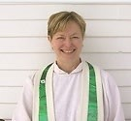
Rebecca has been in pastoral ministry for 35 years. She has served churches in northern New England and Scotland in these pastoral configurations: as an associate; co-pastor; bivocational/part-time; designated, transitional, and full-time. She also leads the Newly Called Group and a new group for Licensed ministers. Mentored by students of Murray Bowen and Edwin Friedman, Rebecca has been studying Bowen family systems theory for 25 years. She serves on the faculty of Leadership in Ministry (LIM) out of Columbia Theological Seminary, Decatur GA, that holds residential workshops and webinars to coach clergy how on integration Bowen Family Systems Theory in their settings of ministry.
Rebeca offers the lens of family systems, which includes understanding triangles, congregational history, anxiety and the pastor's familial history as a way to frame pastoral ministry and leadership in a congregational setting. Family systems theory provides a way of 'seeing' emotional process, and the opportunity for greater awareness of leadership skills in pastoral ministry. In addition, the key concept of boundaries will focus upon self-regulation and clarity about one's beliefs, and responsibilities in ministry. Bringing congregational case studies, doing family-of-origin work, utilizing genogram work, teaching the theory, and theological reflection will be part of the group work.

The Rev. Dr. David B. Reynolds – (603) 518 7751 • dbr@pcs-nh.org
Parish Based Group D • 3rd Wednesday 9-11 am

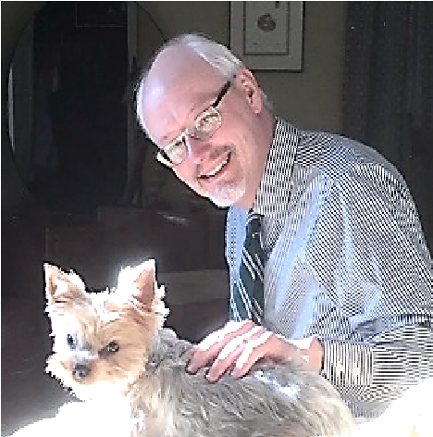
David is Senior Staff at Pastoral Counseling Services (PCS) in Manchester, NH, where he has worked for thirty-seven years. After stepping down from being Executive Director, he continues to provide spiritually integrated psychotherapy, spiritual direction and consultation. As an ordained minister in the Christian Church (Disciples of Christ), a NH Licensed Pastoral Psychotherapist, and a Clinical Member in the Association for Clinical Pastoral Education, he oversees the Clergy and Congregational Care Program at PCS, which provides psychotherapy, psychological testing, spiritual direction, and consultation for clergy and their families. David served eight years in the parish before working in pastoral psychotherapy. He returns for his sixteenth year in leading a PLDG and is administrator of the program.
The PLDG he leads has three components: spiritual centering; check-in on the pastoral self;
and case presentations by group members. Special attention is given to Murray Bowen’s concepts of anxiety, triangles, reactivity, self-differentiation, and emotional process in the context of the congregation. The group sometimes decides to read a book or an article together at the first gathering.

The Rev. Dr. Ron Dieter – (603) 731-7546 • rdieter463@gmail.com
Retired Clergy Group • meeting 3rd Friday • (Another group is in formation for those considering retirement or recently retired)

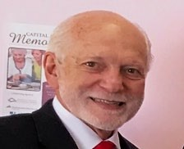
The Retired Clergy Groups of the PLDG program are facilitated by Ron who is in his fourth year.
He recently retired as a hospital Chaplain, following his 40 years of experience as a NH Licensed Pastoral Psychotherapist. His work provides an orientation toward the Spiritual process of healing and transformation, often during times of change, loss, and transition. Ron is specially trained in family therapy by the Kantor Family Institute. He is the former Director of Senior Enrichment Services, a pioneering mental health program for the aging in central New Hampshire.
Ron is an ordained American Baptist (ABC/USA) Minister. He values the spiritual resources of individuals to achieve healing of the whole person. In describing his style Ron states a common question that he asks is “Are you willing to bet on you?” It’s important for clergy (and others) to invest in themselves to grow and to realize the gifts within. Group time will focus on self-care of members, congregational case studies, theological reflection and what makes for renewal.

The Rev. Rebecca Maccini – (603) 867-4604 • revrwm@myfairpoint.net Newly Called Group • 2nd Thursday 10am–noon

The Newly Called Group is for those clergy newly called to ministry or to a UCC church in New Hampshire. This group generally meets by zoom once a month (Sept. - June) on the second Thursday at 10am.-noon. The group may meet physically if there is interest. Beginnings, endings and transitions are discussed along with the challenges and joys of becoming part of and leading a new congregation. The focus of the group is based upon the needs and interests of the participants. Short didactics about congregational emotional process, and other topics of interest that lead to deeper discussion and support ministerial leadership have been conducted. (See Rebecca’s bio above)

The Rev. Joel Eaton - (603) 545 -5505 • jeaton@hhhinfo.org
Members-In-Discernment Group • 2nd Wednesday 4:30-6:30pm

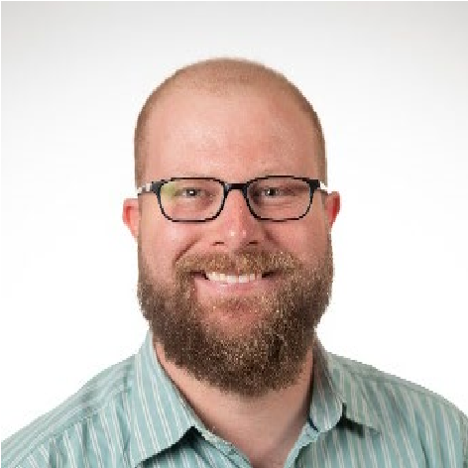
The PLDG program welcomes Joel to facilitate the MID group. He is a Board Certified Chaplain and CPE educator serving at Havenwood Heritage Heights, a continuing care retirement community in Concord, New Hampshire. Prior to becoming a chaplain, Joel served as a local church pastor. His own path to ordination was nontraditional, serving as a licensed pastor while completing seminary and ordination requirements. Ordained in the American Baptist Churches of Vermont and New Hampshire, Joel recently found a new ecclesial home for himself in the New Hampshire Conference of the UCC through a process for gaining standing that shared features of the MID process, including writing to the Marks of Faithful and Effective Authorized Ministers. He has an enthusiasm for reflective practice and is a skilled and empathetic facilitator of group processes. He will draw on his own experience of compassionately accompanying CPE interns on their unique journeys of vocational discernment and becoming.

The Rev. Rebecca Maccini – (603) 867-4604 • revrwm@myfairpoint.net Licensed Ministers Group TBD

Leading the newly formed Licensed Ministers Group, Rebecca will bring her wisdom to people in this unique calling. She has been in pastoral ministry for 35 years. She has served churches in northern New England and Scotland in these pastoral configurations: as an associate; co-pastor; bivocational/part-time; designated, transitional, and full-time. Mentored by students of Murray Bowen and Ed Friedman, Rebecca has been studying Bowen family systems theory for 25 years. She serves on the faculty of Leadership in Ministry (LIM) out of Columbia Theological Seminary, Decatur GA. LIM holds residential workshops and webinars that coach clergy how to integrate Bowen Family Systems Theory in their settings of ministry.
Rebeca offers the lens of family systems, which includes understanding triangles, congregational history, anxiety and the pastor's familial history as a way to frame pastoral ministry and leadership in a congregational setting. Family systems theory provides a way of 'seeing' emotional process, and the opportunity for greater awareness of leadership skills in pastoral ministry. In addition, the key concept of boundaries will be a focus upon self-regulation and clarity about one's beliefs, and responsibilities in ministry. Bringing congregational case studies, doing family-of-origin work, utilizing genogram work, teaching the theory, and theological reflection will be part of the group work.

