Make Room for Joy, Peace and Thanksgiving Concert

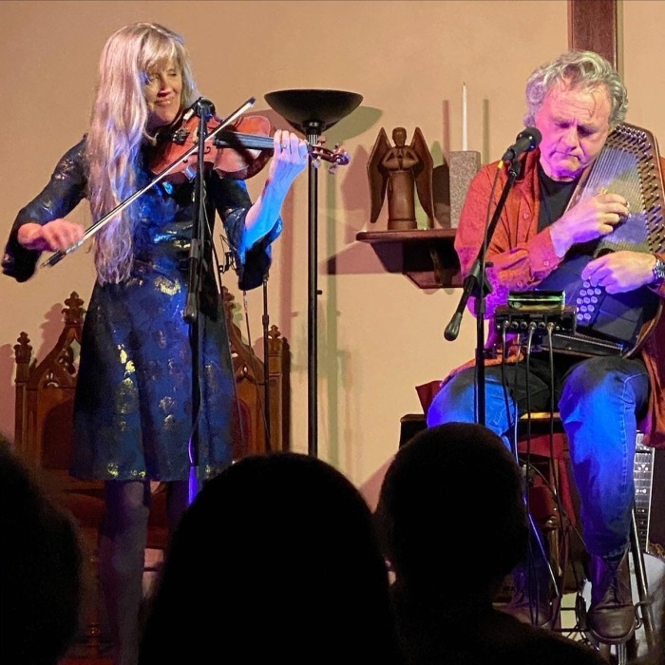
WHEN: November 24, 2024, the Sunday before Thanksgiving

WHERE: Northwood Congregational Church (in our Sanctuary) 881 First NH Turnpike, Route 4 East

TIME: 4:00 p.m. to 6:00 p.m.

Please join us and celebrate the holiday spirit by attending this joyous concert with nationally known songwriters and fiddler/guitar duo Joyce Andersen and Harvey Reid. They will perform a mix of wonderful, uplifting music and perhaps some holiday tunes as well.
Suggested donation is $20 per adult (accompanying children are free). We hope you will be able to join us!

