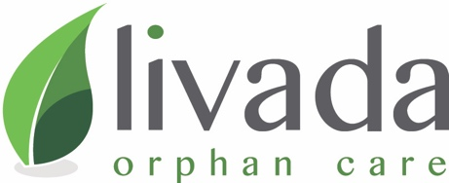

Year End 2024 URGENT Needs List
*Click on specific link to give to that project

- CHILD SPONSORS to join Sponsorship Teams
  - Orphan Outreach Club Sponsorships- $10/kid/month or $120/year
  - Private Foster Care Sponsorships- $400/kid/month or $4800/year
  - Livada Full Time Family-Style Group Home Sponsorships- $550/month or $6600/year
- COMMUNITY COUNSELING CENTER
  - Play Therapy Center finishings- $50,000
  - Counseling Offices finishings- $30,000
  - Aid Distribution Center finishings- $20,000
- GROUP HOME REBUILD/RENOVATION x 2
  - Building Repairs $60,000 each
  - Kitchen/Bathroom Renovations $30,000 each
- CHRISTMAS PARTIES & PRESENTS
  - $25/kid (One Time) for approximately 500 kids
  - $2000/month for new Follow Up Club Coordinator to reach all older children & teens in the Mures County child protection system
5. OPERATING FUNDS to cover the overall ministry daily admin, outreach, discipleship, humanitarian aid distribution, urgent care, Romanian staff costs, etc. $160,000 for remainder of 2024 and Q1 2025. ($40K/month)

IF you are in a place to give, please DONATE HERE
Livada Orphan Care is a registered 501c3 non-profit charity EIN number 01-0576849 and member of the ECFA: Evangelical Council for Financial Accountability. 2001 W. Plano Parkway Suite 3430 Plano, TX 75075 tel. 972-941-4416 info@livada.org

