CBCS Data Management and Analysis Core
CBCS Research Council Draft Proposal
Revised: April 25, 2023

Overview
The CBCS Data Management and Analysis Core (DMAC) is a centralized, shared resources hub that provides access to expertise and services relating to research requiring data management and monitoring, and statistical analysis. It provides expert technical and consultative services to investigators engaged in sponsored research and clinical trials. This core enhances investigators' capabilities, fosters collaboration, improves the quality of proposed and funded projects, and accelerates scientific discovery, dissemination, and translation.

Organization
A Director of the CBCS DMAC will devote a significant percentage of effort to developing and coordinating the CBCS Data Management and Analysis Core. The Director will establish consultation hours for brief conversations with faculty, for example, to discuss an upcoming proposal that may require a DMAC request. In addition to lending expert services, the Director will identify additional faculty and research faculty (within and outside of the college) with sufficient expertise to manage the services listed below and develop additional services as needs dictate. Those individuals will constitute a Leadership team within the Core and will work with the Director to match requests for services with expertise as efficiently as possible. The Director will need to discern the expertise and experience around different advanced statistical procedures, for example, to guide this process. In addition, DMAC will grow teams of research staff comprised of Data Managers and Data Analysts who will work under the direction of the Director, the Core leadership team, and PIs for funded projects. Data managers and analysts are necessary to ensure that the Leadership Team members can operate at their expert level by delegating work. This also can relieve budgeting expenses by sharing responsibilities with less expensive personnel. A proposed flowchart indicating tiers of DMAC Support can be found below.

Services
Services provided by the CBCS Data Management and Analysis Core are expected to meet high priority, immediate needs within the college initially. The data management team requires developers or coders who facilitate use of REDCap and other data collection technologies and who ensure documentation and data storage and compilation is compliant with applicable federal or other data management and sharing requirements. The statistical team will facilitate proposal preparation, power analyses, data cleaning, conducting analyses, interpreting results, and preparing reports, tables, and figures¹. As the Core gets established, the Director and Leadership team is expected to gradually expand those services based on demands and resources (e.g., increased indirect cost returns to the college).

Pre-award:
- Consulting and reviewing Data Management and Data Sharing plans for grant proposals/revisions
- Drafting Data Management and Data Sharing plans for grant proposals
- Consulting and reviewing Data Analysis plans and Power Analyses for grant proposals/revisions
- Drafting Study Design, Data Analysis plans, and Power Analyses for grant proposals

Post-award:
- Assisting with pre-registration of clinical trials and other studies (open science protocols)
- Planning for data collection and setting up data management protocols (e.g., REDCap) for funded projects
- Monitoring quality control over data (including randomization protocols) and assisting with compiling documentation
- Advising and assisting with the preparation of data for sharing through appropriate repositories
- Conducting statistical analyses and preparing reports for reports, presentations, and publications
- Ensuring secure storage and access for sensitive data (secondary data analysis, linking databases)

Service Request Process
Requests from PIs will initially be reviewed by the Director to determine if existing resources may be leveraged. The Data Management and Analysis Core will then assess the following criteria: Personnel and effort estimated for each project; project impact/trajectory; and ability and commitment to securing additional funding as needed to complete the project.
Requestors should expect to receive an initial communication about their request within two business days.
Examples of service request forms:
https://redcap.nubic.northwestern.edu/redcap/surveys/?s=JCCTRW3JWY
https://forms.cshs.org/biostatistics/

Funding
College RIA funds will be distributed to provide support for the Director effort and for some effort for the senior Leadership Team members for meetings and working on proposals.

Investigators are encouraged to write Data Management and Analysis Core services into their grant proposals. A document with standard language will be generated. Grant proposal budgets will be expected to support effort for a Leadership Team member or another expert and for data managers or analysts, adjusted for the scope and needs of individual projects. Research faculty may require some support to free up effort to work on grant proposals.

Ideas for Future Development
- Revise the prioritization of services based on needs and resources
- Expanded research methods (e.g., qualitative research, mixed methods, program evaluation, survey research, GIS, data visualization, measurement development, AI/machine learning)
- Broadening services to students or projects that are not externally funded
- Educational programming; workshops

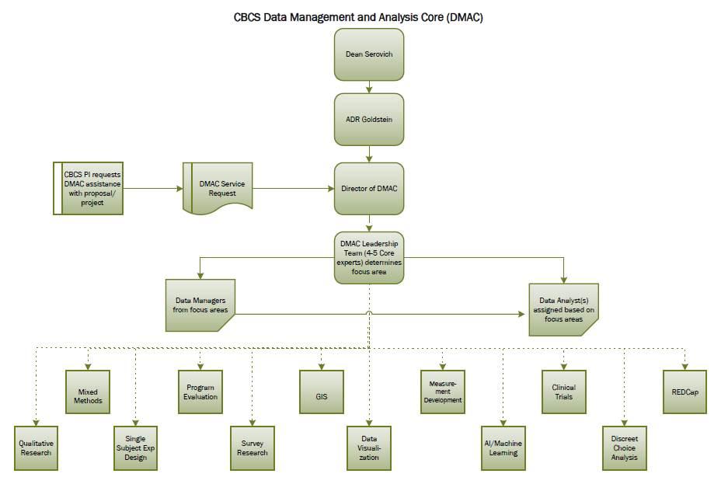

¹ In Rightpath, they have two teams: a statistician team (typically two master’s-level people) and a developer team (one senior dev, one grad student, and one undergrad). Typically, the developers handle REDCap and other data collection technologies.

