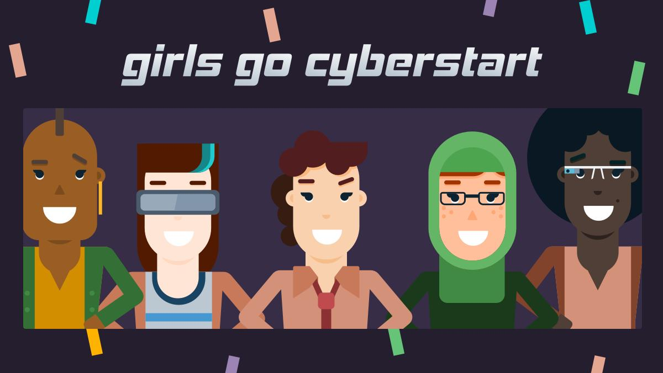

Girls Go CyberStart North Carolina

Advisor Resources

Advisor Resources

Informational Webinars with Mandy Galante, CyberStart Program Director

- December 18 – Each webinar will be 60 – 90 minutes and no experience is necessary to participate.

- Topics will include:
  - Basic program information how to’s, equipment, practice examples and resources for preparing for the competition, as well as a Q&A
  - Please invite anyone interested in learning more about the program and/or advising.
  - Dates and registration at https://forms.gle/ePBXPDtecKTnSzgo6

Important Websites

- NC Girls Go CyberStart Website – https://www.nc.gov/girlsgocyberstart
  - Stay up to date with information about the program in NC, as well as winners and prizes

- Girls Go CyberStart website – https://www.girlsgocyberstart.org/
  - Registration, general information, timelines, prizes, and details on the advisor role

- Girls Go CyberStart Advisor Resources – https://resources.girlsgocyberstart.org
  - Fliers, letters, posters, and videos for your clubs

- CyberStart US website – https://www.cyberstartus.org/
  - Information on the program, the Color the Map campaign, and testimonials

- CyberStart GO – https://go.girlsgocyberstart.org
  - Practice your skills with 15 sample challenges

- Mrs. G’s Tips blog – https://medium.com/girls-go-cyberstart/mrsgcyberstarttips/home
  - Mrs. G will update the blog regularly with practice challenges, tips and information on GGCS.

Social Media

Follow us on social media to keep up to date on the latest Girls go CyberStart news and let us know how your clubs are doing. Don’t forget to use #GGCyberStartNC in your posts!

- N.C. Department of Information Technology
  - Facebook: https://www.facebook.com/NCDIT/
  - Twitter: @NCDIT
  - YouTube: NC DIT
  - Flickr: NC DIT

- Girls Go CyberStart
  - Facebook: https://www.facebook.com/ggcyberstart/
  - Twitter: @GGCyberStart
  - Instagram: https://www.instagram.com/ggcyberstart/

