Region 6 Newsletter August 2016

San Lorenzo Unified School District Leadership Team spent a morning hard at work at one of the district’s schools. The idea came last spring as a planning team thought about ways to represent their commitment to leading the district by serving schools. With the hashtag #wearesanlorenzo 75 members of the management team in San Lorenzo showed up bright and early with gardening gloves and classroom decorating skills to help the teachers of the District Individualized Contracted Education (DICE) program move into their new facility. The school had previously been leased to a private school and when the lease ended it was designated to serve as a home for the more than 150 students who attend this program.
The morning began with a presentation by the Superintendent, Dr. Fred Brill about how this project represents the vision of the district which states that students will become creative, collaborative, compassionate, resilient, well-informed and socially responsible advocates for equity and social justice as a result of their education, experience and support from educators, families and the community. As District Leaders we are called to model these qualities and characteristics for our students.
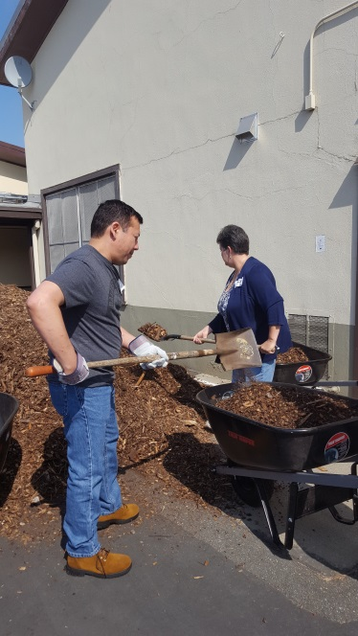
Dr. Ammar Saheli, the Director of Student Services shared information about the district DICE program. Students in the Independent Study program are seen one hour weekly during which time the teacher assigns and records work. After hearing about the success of the DICE program in San Lorenzo the 85 members of the District Leadership Team were assigned to various tasks that would help the teachers prepare for the opening of the school year. About half of the leaders went to work in the garden, preparing the soil for native plants that would be planted later in the year. While some were digging, others were shoveling mulch and then distributing it to the plant beds.
San Lorenzo USD Assistant Superintendents Julio Hernandez and Barbara DeBarger getting ready for the start of school at the District DICE Program site.
In addition to the garden work, other Leadership Team members helped teachers unload boxes in classrooms, put books away, filled supply closets, prepared bulletin boards and completed other tasks that helped the school to get closer to being prepared for the first day of school on August 29th. Teachers at the school site expressed their appreciation for the work of the management team and said that they felt much better about the start of school now that they had unpacked and created bulletin boards ready to share school information with families and students.
After a delicious lunch the management team reflected on their morning efforts and shared their observations about the ways that they met the goals of the district vision to support in our students to be creative, collaborative, compassionate, resilient, well-informed and socially responsible advocates for equity and social justice. Of course, the work doesn’t stop at the end of the day. Assistant Superintendent of Educational Services, Barb DeBarger, made sure that all District Office Managers were assigned to a specific school site for the first week of school to lend a hand as students and families return for a new school year.
As leaders in the educational community of San Lorenzo, the District Leadership Team is making every effort to serve the students and families that rely on them to provide, not only high quality academic education, but also a model of service that they can emulate throughout their lives.

