Continuation of the Interview with Jeanie Beyer

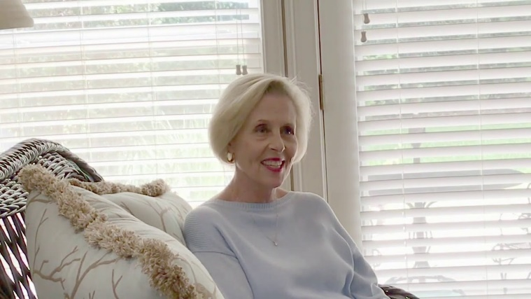

6. How long did you serve as Archdeacon and what was your job description?
Bishop Howard appointed me as Archdeacon in July 2010. I served in that capacity for almost 11 years. The Bishop and I agreed that I was to be a liaison between he and the Deacon Community. I offered Pastoral Care, guidance and listening to the deacons and built a stronger community among us. I traveled to speak to those discerning a call to the diaconate and tried to be an encourager. I attended The Annual National Archdeacon Conference to stay informed about the Discernment and Education of Deacons throughout the Country.

- What did you see as the needs of a strong diaconate when you started as Archdeacon? Has your perception of those needs/goals changed as you retire from the Archdeacon position?
My first impression was that the Deacon Community was small and spread out over the Diocese so there was a lack of collegiality. I worked to build community among us by keeping in touch and informing them about things going on in the Diocese. I tried to visit in person to build my relationship with our community.
I also saw the need for a richer and more though Academic and Experiential training program. With the help of The Rev. Dn. Marsha Holmes, we have worked to make annual improvements to our Diocesan Program. We are both proud that the training of Deacons in the Diocese of Florida meets all National Competencies for Vocational Deacons.

- What future do you pray for in the Diocese of Florida?
I believe the future for Deacons in our Diocese is exciting. I know that Archdeacon Mark and I both pray for the raising up of more truly called deacons. Mark plans to teach the Diocese more about the ministry of deacons and we would both encourage you to be looking for the deacons among us.

- Anything else you would like to share?
I want Bishop Howard to know how grateful I am for the trust he put in me. I was fairly new to the Diocese when he appointed me as Archdeacon. Not only did he appoint me as Archdeacon, but he appointed a Deacon as Archdeacon at a time when more than half of the Dioceses in the Country had Priests serving as Archdeacon. Thank you, Bishop Howard for the gift of a lifetime.

I would also like to thank the Mentors who so freely give of their time and talents training our Diaconal Students in Deacons’ School. Your generosity if a gift to the Diocese.

