JULY QUIZ ANSWERS

- William Jeffrey Allfriend
- “To tell of Thy Loving Kindness in the morning and of Thy truth in the night season.”
- National Register of Historic Places, 1978
- Francis Huger Rutledge
- Mary Meginniss Harris, 1968
- 1879
- Governor William Bloxham
- torreya, pine, cherry, walnut, magnolia, oak
- Achille Murat (Marquis de LaFayette), Catherine Willis Murat (George Washington). Prince Achille Murat was the eldest son of Joachim Murat, the brother-in-law of Napoleon who was appointed King of Naples.
- Church of the Holy Comforter, Tallahassee

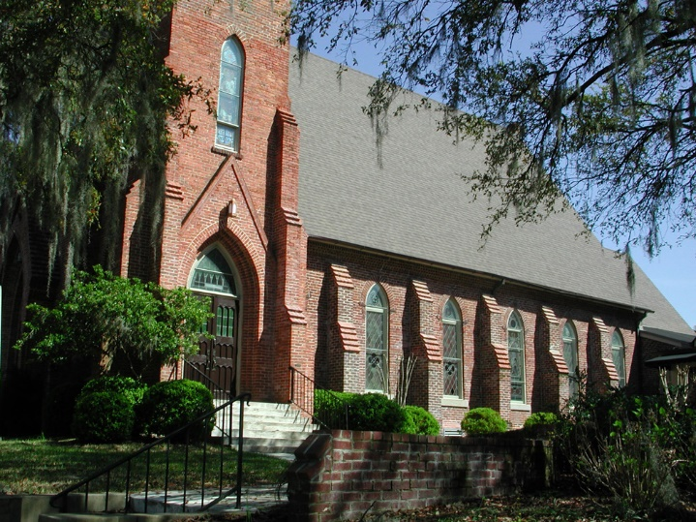
St John’s, Tallahassee

