ST LUKE’S, LIVE OAK, cont.

Have these outreach ministries had any really good news in recent months?

Lydia: We are excited to announce that The Greenville United Methodist Church will open our fourth location this month on September 24th. There are fourteen volunteers including two doctors, a nurse practitioner, and a pharmacist. Greenville is a small rural town of close to 1000 people in Madison County that has over the past several years has lost most of their essential to life resources including access to a medical professional. The Greenville UMC is located right downtown and this free health clinic will be a God send for so many who are most in need of medical care.

St. Luke’s just learned today that we were approved for a grant from the Florida Association of Free and Charitable Clinics for Electronic Patients’ Medical System hardware and to offset some of our patients’ lab fees.

How may all of us in the wider churches and Diocese of Florida support the work of your outreach ministries? What might we learn from them for our individual churches?

Lydia: There are two major ways that all of God’s children can assist St. Luke’s outreach ministries- The first way is absolutely to PRAY! We ask that everyone agree to Pray for good health, strength and perseverance for those whom we serve as well as for those of us who are serving. Pray also that we will be working with Athena Health now that we received approval for our FAFCC grant application for funding for an Electronic Patients’ Record System and hardware. This could possibly allow us to install a Telemedicine system.

The second way would be through a giving spirit of donations to the Food Pantry and to Shepherd’s Hands. The Food Pantry is financed totally through St. Luke’s parishioners and all whom God calls to help feed His people. Website- www.stlukesliveoak.org

Shepherd’s Hands is a 501 c 3 charitable organization. Our largest expense is for the lab fees we pay each month. Most of our patients cannot afford the cost of labs. Without these labs we would not be able to provide the quality of health care that our patients need and deserve.
Website – www.shepherdshandsclinic.org

In knowing that God is calling His people to serve in a food pantry or in a free health care ministry in these Covid Crazy times, please contact Deacon Lydia Bush if you have any questions or need more information. I would love to share what we at St. Luke’s have learned along the Way of Jesus!

The Rev. Lydia Bush

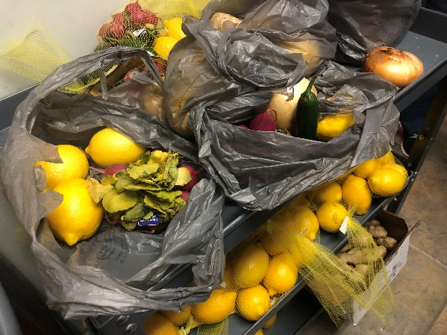

Fresh vegetables and fruit

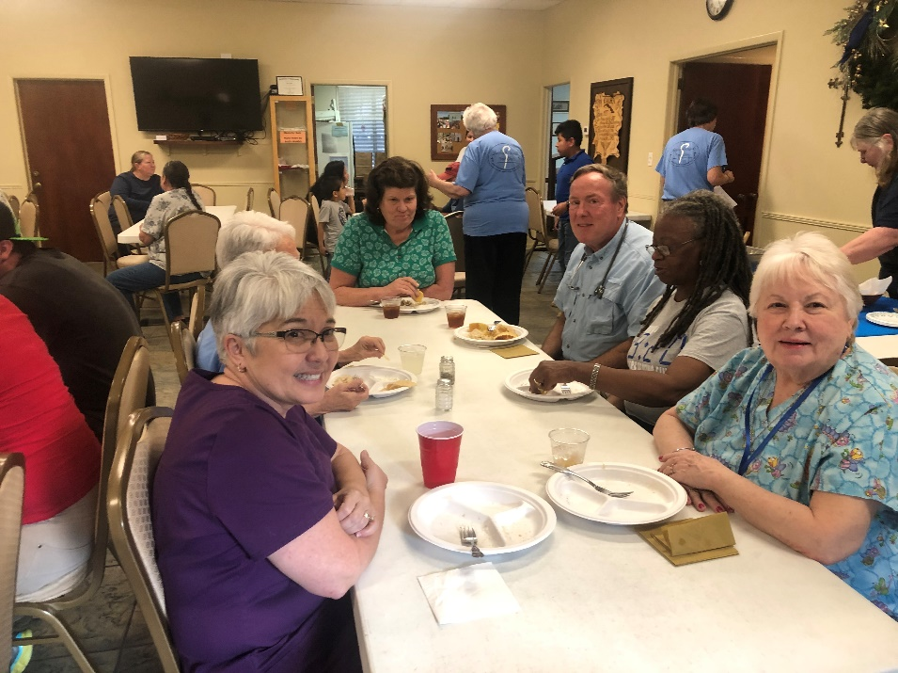

Shepherd’s Hands clinic (pre-Covid)

