**Interview with Camp Weed Director, cont.**

**Did the majority of Episcopal Church- related camps close across the country?**

**Thomas:** They did. In our Southeast area Kanuga, McDowell, Beckwith, and Day Springs all canceled summer camp this year.

**What did the summer camps that stayed open experience?**

**Thomas:** We continue to hear horror stories about overnight camps that tried to open but were quickly devastated by the virus. Some (mostly day camp) have operated successfully. These all had strict guidelines that changed the feel of camp.

**With hindsight, would they make the same decision to stay open?**

**Thomas:** I would have liked more time to prepare a safe and meaningful experience, but considering the factors and the lack of time, I would absolutely make the same decision.

**What impact did closing down programs in 2020 have on the Camp Weed staff?**

**Thomas**: It could not have been more serious as 95% of the staff workers had to be furloughed. The Diocese, with the Bishop leading, presented one of the CW employees some generous assistance as he and his family were all infected. The Government’s payroll PPP program via the Diocese was also helpful to Camp Weed.

**What work at the Camp has been consistent through these last six months?**

CWCC maintenance needs did not cease with the arrival of the virus. Keeping up with grass and grounds will always be a challenge during the summer months, and trees continue to fall. There is daily grounds work and it seems that for the last 4 months every conversation around here turn into a brainstorming session.

As for the physical estate, the deer and turkey have not been shy at all since the outbreak. We all miss the campers this summer, it is just not the same without them here.

Hurricane season is approaching. We have been meeting with the leadership and staff of Vicar’s Landing in Ponte Vedra to make plans for any necessary evacuation of their residents to CWCC if any big storms come their way this season.

**What would you like to see happen over the Fall and into the New Year as we pray things allow us to move about more and return to meeting and gathering in beloved places like Camp Weed?**

**Thomas:** I am optimistic that we can start hosting small groups. We have recently opened our cabins and hotel rooms up to guests and small groups from the Diocese.

**What can we do to support the mission of CWCC in addition to prayers and financial support through the Foundation Board and the Camp Weed Fund?**

This is a great time to get some fresh air and to do volunteer work at CWCC. Bob White has started putting a group together that will come out and take on a CWCC project. Bob is from St. Peter’s Church, Fernandina and has been the head of the Bishop’s Men who volunteer to assist with CWCC building projects. (The Bishop’s Men is the original name that now includes men and women!). Please contact me directly if you would like me to put you in touch with Bob to join a volunteer project or if you have a project that you/your group would like to take on. You can reach me by email: [thomas@campweed.org](mailto:thomas@campweed.org) or on 386-364-5250.

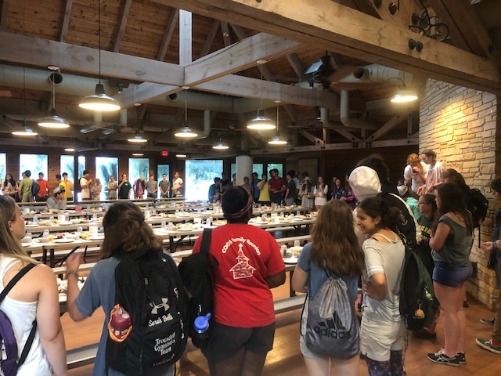

Happy days: a summer camp mealtime gathering in Juhan Hall, CWCC.

Photos with this article taken by the CWCC Director Thomas Frazer.