LES SINGLETON PROFILE, cont.

Les was born in Miami, Florida, the second of two children, and when he was nine years old, his parents proceeded to have four more children so he wound up as the second of seven.

Education
Les graduated from The University of Chicago. Class of 1964. He says hevaguely knew the kid from New York City named Bernie Sanders. He started off as a math major, and once he felt a call to ordained ministry, switched off to Psychology as a better preparation for seminary. He took classical Greek to fulfill my language requirement.

Les says the University of Chicago taught the students to be critical and independent thinkers. They were encouraged to ‘always drilled down to the root sources, as best we could’.The school had 2,000 undergrads and 3,000 graduate students, so a high intellectural standard was the expectation.

Call to ordained ministry

Les first felt a call to ministry when I was in high school. The timing was off. Had he planned on a ministerial path right out of high school, he would have let a conservative Methodist steer him to a petty narrow school. Instead he felt blessed to have heard the call when in the early years of college. The college chaplain steered me to Christ Church in Woodlawn, a ghetto. I taught Sunday School and ran the acolytes.
During this period Les met three priests who were speakers at the student ministry center ((Brent House)) who impressed him. One was in Christian social action, another had written a folk mass, but he forgot the credentials of the third. He thought ‘if God could use them, He could use me as well’.
Seabury-Western Seminary

Les attended the Seabury-Western Seminary. His wife at the time was a Chicago girl, and they knew there were good employment opportunities for her in the area. He says:

I was at Seabury in some golden years. Reginald Fuller in NT, and also Jules Lawrence Moreau, who also taught New Testament. We were a small class of about 12 or 15, and over the years to to know each other well. Probably about half of us were 22 as we entered seminary. Some of the others had been in the military, and some were coming in after a secular career in their mid to late 40's.

Les says seminary gave him a good coverage of the theological and scriptural basics. His tutor David Babin made the seminarians be prepared to preach every week (with a sermon closely tied to the lectionary of the 1928 BCP.) He said,

Just because you were called one week, did not mean you would not be called on the next. Every single week, we had to have another one, and that has been true most of my life...another one every week. Not so much the three years I was a curate. Very much the case the ten years I was a rector, and most of the years ever since.
Dedication to teaching (in his own words):

I like to teach. Also, a person learns the most when the know enough to teach others.

Mentoring others: [stems from when I] was I was a sales manager and I made a living by helping others make an even better living. Dale Carnegie is all about building self- confidence and helping people to live better with the gifts the good Lord gave them.

One of my favorite Bible chapters is Ephesians 4. We all have gifts! All of us. The priest can't do it all. One percent of the church membership are ordained, and 100 percent are baptized. The ninety-nine percent who are baptized (and not ordained) have very valuable work to do.

I want people to know Christ and make Him known. I want people to express their faith. To be able to talk their faith coherently; and able to live their faith consistently.

Any other advice to us all:

Enjoy life. Do something for yourself every day. Truly spend time with your loved ones. Find a way to love and serve the Lord. Remember the last and the least. Everyone is someone in God's eyes.
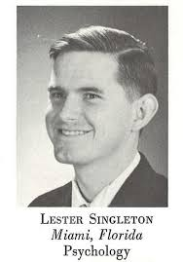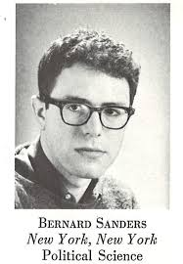
University of Chicago

