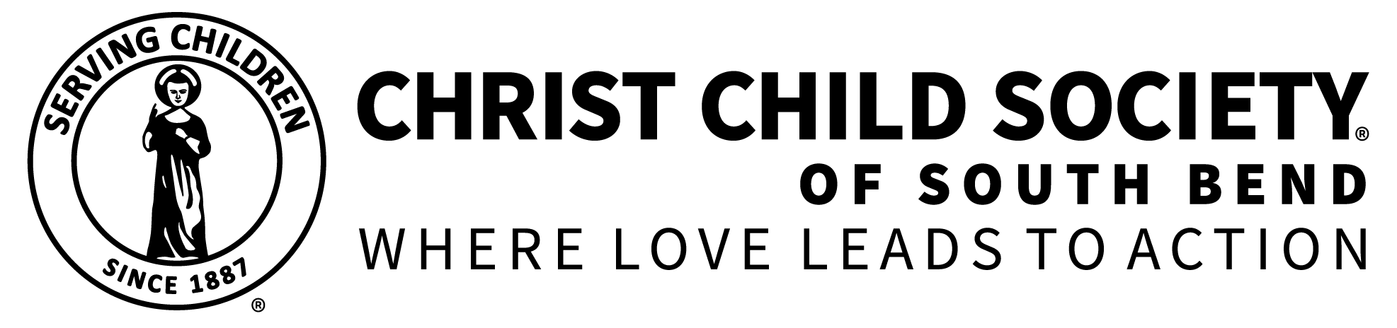

**Christ Child Society Referral Agencies 2020**

**All Elementary and Middle Schools in South Bend, Mishawaka,**

**Penn-Harris-Madison and Catholic Schools**

**Beacon Midwifery Centered Care**

621 Memorial Drive Suite 403

South Bend, IN 46601

647-3972

**Big Brothers Big Sisters**

218 West Washington Suite 710

South Bend, IN 46601

232-9958

**Catholic Charities**

1817 Miami Street

South Bend, IN 46613

234-3111

**Center for the Homeless**

813 South Michigan Street

South Bend, IN 46601

282-8700

**Department of Child Services**

300 North Dr. Martin Luther King Jr. Blvd Suite 230

South Bend, IN 46601

232-3042

**Division of Family Resources**

401 East Colfax Suite 375

South Bend, IN 46617

(800) 403-0864

**El Campito**

1024 Thomas Street

South Bend, IN 46601

232-5570

**Excel Center**

2721 Kenwood Ave

South Bend, IN 46628

314-5570

**Family Justice Center**

533 N Niles Avenue

South Bend, IN 46617

234-6900

**Goodwill**

1805 Western Avenue

South Bend, IN 46619

472-7300

**Hannah’s House/Bridge of Hope**

518 W Fourth St

Mishawka, IN 46544

254-5309

**Head Start Program**

245 North Lombardy

South Bend, IN 46619

283-8127

**HealthLinc Community Health Center**

420 W 4th Suite 100

Mishawka, IN 46544

307-7673

**Hope Ministries**

432 South Lafayette Blvd

South Bend, IN 46601

235-4150

**Indiana Health Centers**

765 South Michigan Street

South Bend, IN 46601

235-7990

**Keys Counseling**

300 S. Saint Louis Blvd, Suite 150

South Bend, IN 46617

235-5424

**La Casa de Amistad**

746 South Meade Street

South Bend, IN 46617

233-2120

**New Vision Christian Academy School & Church**

610 Logan Street

Mishawaka, IN 46545

257-0628

**Oaklawn**

415 East Madison

South Bend, IN 46617

349-9471

**Real Services**

1151 South Michigan Street

South Bend, IN 46601

284-7130

**Red Cross**

3220 East Jefferson Blvd

South Bend, IN 46615

234-0191

**Salvation Army/Kroc Center**

900 West Western Avenue

South Bend, IN 46601

233-9471

**Sister Maura Brannick, CSC, Health Center**

326 Chapin Street

South Bend, IN 46601

335-8222

**South Bend Housing Authority**

501 Alonzo Watson Drive

South Bend, IN 46601

235-9346

**St. Joseph Physicians Network**

707 Cedar St

South Bend, IN 46617

335-3968

**St. Margaret’s House**

117 North Lafayette Blvd

South Bend, IN 46601

234-7795

**St. Vincent de Paul Society**

520 Crescent Avenue

South Bend, IN 46617

234-6000

**Success Academy**

3408 Ardmore Trail

South Bend, IN 46628

288-5333

**WIC- Memorial Hospital**

615 North Michigan Street

South Bend, IN 46601

647-6614

**WIC – St. Joseph County**

201 Lincolnway West

Mishawaka, IN 46544

647-2175

**Women’s Care Center**

1935 North Ironwood Drive

South Bend, IN 46635

273-8986

360 North Notre Dame Avenue

South Bend, IN 46617

234-0363

234 Chapin Street

South Bend, IN 46601

234-0403

607 Lincolnway West

Mishawaka, IN 46544

252-3680

**YWCA**

1102 South Fellows Street

South Bend, IN 46601

233-9491