FREE Diabetes Classes
for ANYONE with or who knows someone with Diabetes
Take charge of your life by learning how to control your diabetes.
Sign Up Today!
Learn how to take better care of your diabetes.
Sign up for a Diabetes Self-Management Education class and learn how to take charge of your health.
In these classes you will learn how to live a healthier life with diabetes!!!
What to Expect:
A trained instructor leads the class, which meets several times. Your class will be small – probably no more than 20 people. You will have plenty of time to ask questions and learn more from others in your class. There will be an incentive for completing the program (all 6 classes)!!!!
To sign up, call the number listed below. Hurry because seats may be limited.
Choctaw Memorial Hospital Business Office @ 1405 E Kirk ST. Hugo, OK
10:00 a.m. to 11:30 or 12:00 p.m. Every Thursday –June 1, 2017 – July 6, 2017
Phone number to call to sign up: 580-372-0531 (Leave message)
Class to be presented by: Nora Testerman, Certified DEEP Educator
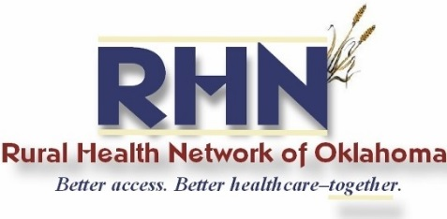
There is no fee for this class, it is totally FREE!!ss

www.rhnofoklahoma.org

This material was prepared by TMF Health Quality Institute, the Medicare Quality Innovation Network Quality Improvement Organization, under contract with the Centers for Medicare & Medicaid Services (CMS), an agency of the U.S. Department of Health and Human Services. The contents do not necessarily reflect CMS policy. 11SOW-QINQIO-B2-14-12.

