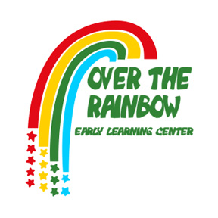
6765 Brint Road
Sylvania, Ohio
419-882-0734
otr0902@gmail.com

1809 N. McCord Road
Toledo, Ohio
419-867-0057
otr112015@gmail.com

About Over the Rainbow:
Over the Rainbow is an independent, locally owned and family operated company that currently has two locations. Over the Rainbow offers a safe, healthy, nurturing environment where education and communication creates the bridge for continuous growth and development. Enrollment is open for children beginning at 6 weeks and continues through Kindergarten age. Our environment provides a large, developmentally appropriate outdoor play area and classrooms are organized to meet individualized educational progress and personal independence. Our program utilizes Creative Curriculum by Teaching Strategies GOLD. This is a theory and research based curriculum. It is aligned with the Ohio Early Learning and Development Standards for Infants, Toddlers, Preschoolers and Pre-Kindergarteners. Children learn through a variety of methods, interest areas and purposeful play each day. All teachers participate in ongoing Professional Development classes provided by the Ohio Professional Development Network, meeting Step Up to Quality Standards. Over the Rainbow is currently a 3-Star rated program.

Currently hiring ECE Teachers:
Our SUTQ 3-Star educational child care facilities are rapidly growing and are looking for caring, compassionate teachers. We are committed to providing top quality care and education for children who are enrolled in our program. Our goal is to enhance the lives of every child that attends our facility. If you are a patient, caring professional, then this is the job for you!

Responsibilities:
Design and follow a full schedule of activities and discover suitable teaching material
Balance your teaching between logical and social exercises
Provide quality care
Use a wide range of teaching methods (stories, media, indoor or outdoor games, writing, intentional teaching) to enhance the child’s abilities in all domains
Evaluate children’s performance (utilizing Teaching Strategies Gold) to make sure they are on the right learning track
Remain in constant communication with parents and update them on the progress of their children
Observe children’s interactions
Collaborate with other colleagues
Adhere with teaching standards and safety regulations as established by the official sources

Requirements:
Knowledge of child development and up-to-date educational methods
Methodical and creative
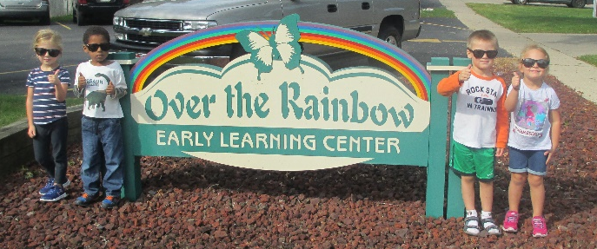
Patience, flexibility and love for children
Strong communication and time management skills
Certificate in first aid and CPR a plus not required
Degree in early childhood education preferred

Benefits:
Paid Vacation Medical, Vision and Dental
Paid Personal days Paid Planning
Paid Holidays Utilization of tablets for child development

