Right Path Riding Academy, Drumright, OK
Right Path, a Premier Accredited Center, was founded in 1996 by physical therapist Leslie Kirkland who is a PATH registered instructor in riding and driving.
Today, Mike and Joshalyn Ocker serve as Operations Managers at Right Path along with their 15 children. The riding program is now called “William’s Walk” to honor the memory of William Ocker who loved riding until he passed away last year at age 8. The center is also home to “Hooves on the Ground,” a Veteran’s program, a large Literacy Program and a Youth Enhancement Program.
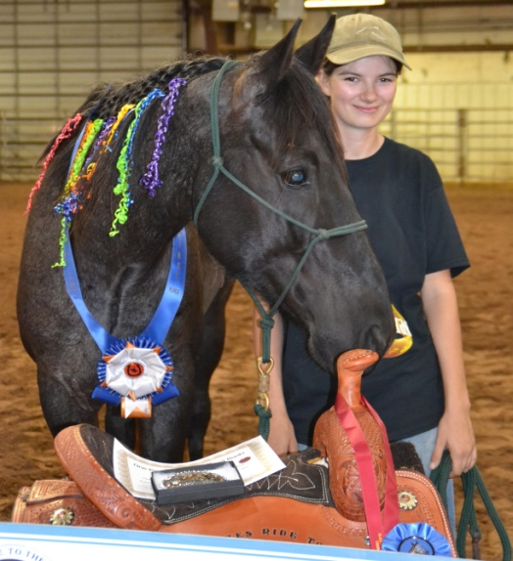
Abby Ocker serves as Herd Manager at Right Path, providing schooling for the unique needs of the therapy, veterans and mini horses at the Center. And for the past two years she’s proved her winning ways with horses at the annual Blaze’s Tribute Equine Rescue Challenge.
In January, Abby joined other qualifying trainers for "Pick Up Day." Trainers are randomly drawn to pick a horse from the group chosen by Blaze's to be in the competition. Horses are generally halter broke but not broke to saddle. Trainers then have 120 days to work with their horse before showing what they've been able to accomplish at the Challenge. At the end of the Challenge, the horses are sold at auction.
Last year, Abby won the youth division with a young palomino mare named Prancer. This year Abby chose a 6 year old blue roan quarter horse gelding named Hooey and together they won the adult division. Abby is the first trainer to win 2 years in a row. Abby fell in love with Hooey and the best part of the competition for her was getting to take him home afterwards. She renamed him Obi-Wan and today they are working equitation partners. And Abby is working to become a therapeutic riding instructor. She has her IT letter and plans to test later this summer.
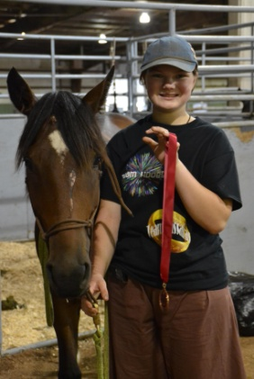
The way with horses runs in the family. This year, Abby’s younger sister, Sherrod who is the Barn Manager at Right Path entered the Blaze’s Tribute youth division for the first time. It was Sherrod’s first time to start a horse independently. She chose a 3year old bay quarter horse mare named Sassafras and they took 5th place. Sherrod is looking forward to entering the Challenge again next year.
By the way, Abby and Sherrod’s sister, Sarah, is the office manager at Right Path and oversees the website and social media. Sydnee Ocker is the Herd assistant.

Oklahoma State Meeting
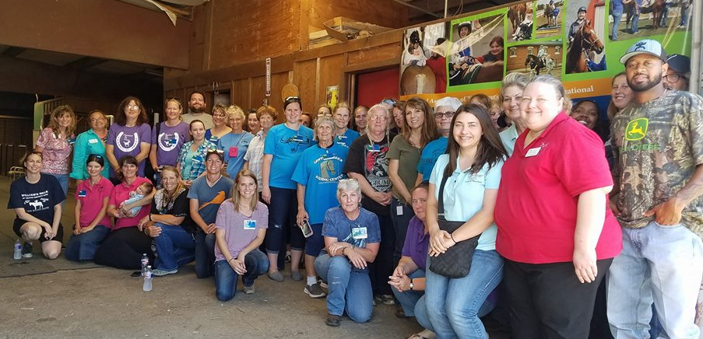
The Oklahoma state meeting was held June 10, 2017 – returning to the Right Path Academy in Drumright. This year the line up of speakers provided four hours of disability CEU’s and one general CEU plus lunch for $10. Not surprisingly, the event attracted nearly 50 instructors, center staffers and board members from Oklahoma, Texas and Kansas. Twelve centers were represented. Attendance was up 50% from last year. And Oklahoma was particularly proud to host Region 8 Rep Shannon Middleton of ROCK in Georgetown, Tx and LSTEN President Jen Donahue of Equest in Dallas.
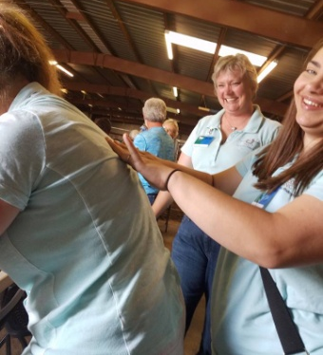
The first speaker, Leisa Persaurd, a board member at Right Path and a physical therapist, spoke on the benefits of kinesio taping for riders with physical disabilities. She spent the first hour discussing how taping can benefit riders by assisting to retrain or support muscles. Then everyone got a roll of tape and practiced taping each other. Several attendees reported immediate pain relief!
The second presentation featured Special Education Instructor Susan Ledgerwood of the Drumright Public School system. She discussed the complicated and time-consuming trek to qualify a student for an individual education portfolio and disability related resources through the school system. Her bell curve illustrations really clarified the fine line between “our” students and those who do not receive services.
At lunch, the entire group voted to offer to host the 2018 Region 8/LSTEN Conference. And Savannah Station TRC volunteered to host with the enthusiastic support of their board and their landlords at Redlands Community College in El Reno.
After lunch, attendees heard another disability presentation from the University of Oklahoma’s Zarrow Center representatives Andrea Suk and Melarie Deardorff. Melarie is also a PATH registered instructor. They talked about value-added opportunities for therapeutic riding centers to integrate federally required Transition goals into lesson plans and build stronger ties to teachers.
The day wrapped up with riding instructor, ESMHL, Judy Smith, sharing real solutions to successful grantsmanship for therapeutic riding centers.
Oklahoma State Rep Cathryn Christiansen, who planned the 2017 state meeting, also proposed utilizing the Oklahoma State University's Horse Owner's Workshop as another venue to provide instructors disability CEUs.
The annual Horse Owner’sWorkshop by the College of Veterinary Medicine and the Department of Animal Science and covers feed, forage, confirmation, and other equine health issues. In March of 2018, the Oklahoma Coordinators hope to "piggy back" on that workshop by provide two more hours with a speaker on disability issues over dinner at a nearby restaurant. The CEU’s will be free. Attendees will buy their own dinner

Coffee Creek Riding Center, Edmond, Ok
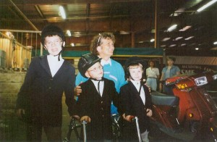
On April 9, 2017, Oklahoma’s longest running therapeutic riding center marked the beginning of its 40th year! Coffee Creek Riding Center has been providing FREE therapeutic riding opportunities to the disabled community since 1977. Executive Director and Master Instructor Joy Milligan says “Jesus has been faithful to provide and raised up things like Centennial Horse Show, United Way partnership, Junior League, Edmond Women's club and so many
businesses and organizations and touched the hearts of so many individuals to give over the years to make this possible.”
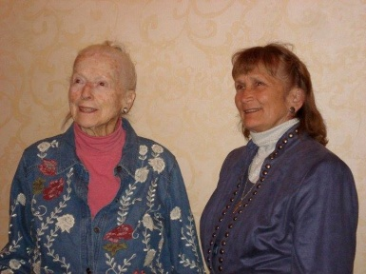
Coffee Creek provides therapeutic riding to approximately 280 students each year with a staff of around 190 volunteers. Started by Joy and her mom, Fancy, the center has grown to be an integral part of Edmond, OK and therapeutic riding in Oklahoma. In their 40 years, they have not only helped thousands of children but they continue to mentor therapeutic riding instructors and centers around the state.
People often ask Joy Milligian, “Why do you provide the program Free?” she says, “For most families, a child with a disability is a long term situation. The costs of special care, equipment, physicians, surgeries and therapy are extremely expensive. Our program is a gift from Jesus to each family, to help them in their quest to find the highest level of ability , mobility, freedom and joy possible for their child and family.”
Here is Milligan's story on how this came in being: “Somehow, God impressed on me from the beginning that he wanted the program to be free. And He wanted me to trust Him to provide the finances. Now, if that sounds a little odd to you, it was a whole new way of thinking for me! Here’s how it happened. In 1976, at age 28, I had just left my tenured position at Rose State College in radiologic technology. I intended to move to Denver and marry, but I soon moved back to Oklahoma instead.
My mother had wanted to do therapeutic riding for years, but was too busy, so now she shared her dream with me. I thought maybe I should just start it for her (while I looked for another teaching position) and that was 40 years ago. God moved with lightening speed and suddenly we had a fulltime program with 50 students.
Through the years we have had so many fun miracles of provision and timely gifts of funds exactly when the need was the greatest. When we are invited to, we send a grant to an organization or foundation for equipment items. Now when we built the indoor facility, I thought of course God would need my help with such a large project – so I wrote matching grants – but never accumulated enough funds. God let me try that for 3 years, then He did it His way instead.
Could all the circumstances that have made our program possible for nearly a half century just be coincidences? No way guys, not day after day, and year after year. But, as we have shared Jesus’ faithfulness to meet our every need; we find that others have been encouraged to trust Him for things in their life. If you have a need in your life, I encourage you to share it with Jesus!
Joy and long time Assistant Director Linda Cloud feed almost 40 horses daily and divide teaching duties at Coffee Creek. Joy’s mom, Fancy, still lives on the property.

The Longhorn Center, Stonewall, Ok
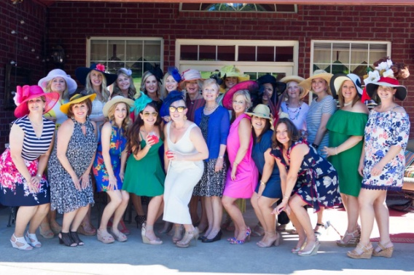
The Longhorn Center for Equine Therapy hosted a Derby Party on Derby Saturday called "Talk Derby to Me." The fundraiser was decked out with traditional decorations of roses and trophies, food, beverages, and HATS! The event showcased some fabulous Derby Hats raising over $4500 for the TLC.
TLC Equine Therapy was originally started at Stonewall Schools in 2009 by PATh instructor Amy Cusak and her husband. Since then, the program has grown to service the surrounding communities. The program is designed to service children and adults with physical, cognitive, and/or emotional disabilities.
This year, TLC also celebrated the start of a veteran's program - one of a very few in the state of Oklahoma. Located close to a major military base in Lawton, TLC has a large number of potential riders but intends to offer the veteran’s services at no charge to the servicemen nor their families.
TLC is also one of a growing number of therapeutic riding centers in Oklahoma who participate in the Horse Tales Literacy Program. Presented in April to 200 first graders from Hayes Elementary, the program is designed to promote children's literacy and reading at an early age. The center received a Beacon Grant from the Elks Lodge to provide funding for the program and to provide a book for each child to keep, often the first book they have ever owned. TLC has already been notified that they have received the grant again and will be expanding to the Ada Boys and Girls Club and the Ada Library this summer.

Turning Point Ranch, Stillwater, OK
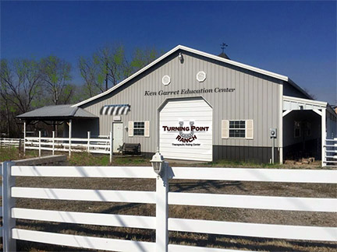
Turning Point, a Premier Accredited Center founded in 2000 will have a new home this Fall! Turning Point had rented facilities at Starr Valley Stables outside Stillwater for the past 11 years while searching for a permanent home within the school district’s busing limits.
This Spring, the PERFECT location became available and a donor stepped forward with funds to make an offer. There was a verbal agreement on a contract when the sellers changed their minds! They decided to DONATE the property to Turning Point. The program hopes to take possession by July 1. The 21 acre property is less than 10 minutes from the Oklahoma State University campus and has an existing barn. Turning Point was just awarded a grant from Rotary International to build a sensory trail at the new location and is raising funds for a covered arena and renovation of the barn into a classroom, unmounted activity and office center named for the original owner.
Turning Point has a contract with the Stillwater Public School system and numerous partnerships with Oklahoma State University including the Center for Veterinary Medicine and academic programs from Animal Science to Education which award academic credit to volunteers who earn service learning hours at TPR. Turning Point has nine registered instructors affiliated with the center and current Program Coordinator, Rachel Royston is scheduled to present at both the Region 8 Conference this summer and the PATH International Conference in November.

Mini’s on the Move
Turning Point has just acquired its first mini to give the program outreach capabilities during construction at the new facility. Baxter Black made his first trip to Atwood’s where he was shopping for an ORANGE halter and getting sensitivity training on automatic doors and indoor spaces with lots of people. He loved the treat aisle and the other shoppers loved him. Actually, he loved the trip in the back seat of our herd manager’s truck. Note: his window was closed on the highway! He is equally happy to join passengers in the back of Natalea’s mini van.
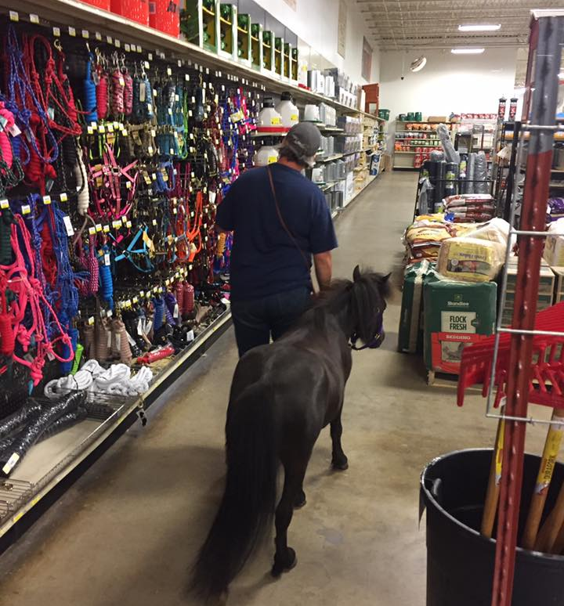
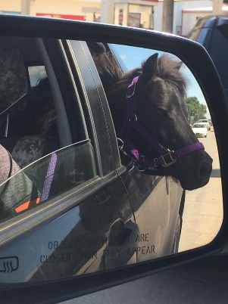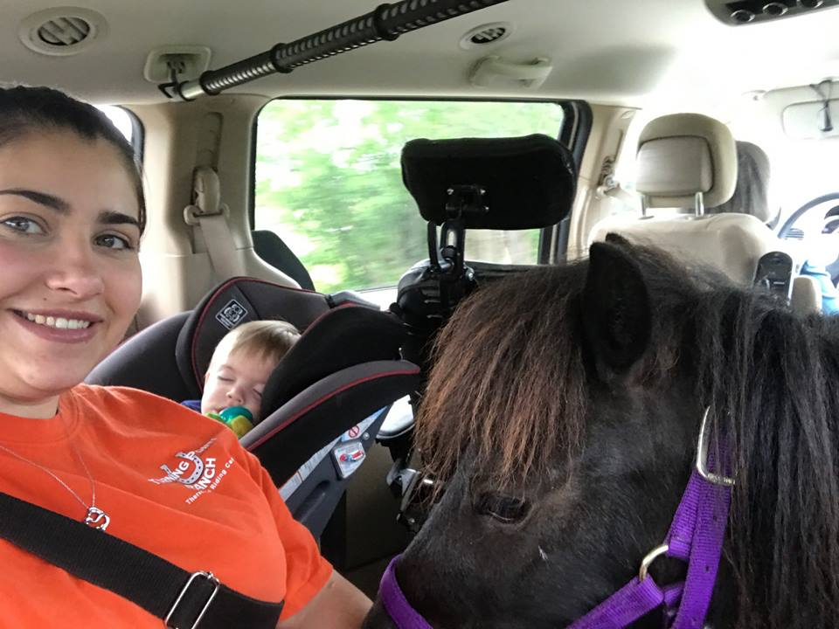

Meanwhile Right Path Academy’s experienced mini, Velvet, has just made MORE friends at the Little Lighthouse in Tulsa – a school for children with a variety of disabilities. Velvet makes visits to hospitals and nursing homes as well.
