Texas News

Healing With Horses Ranch, a PATH Intl. Member Center, in Manor, Texas reports that they are making significant progress toward building their new covered arena. As of June 17, the piers were about to be poured! Congratulations!
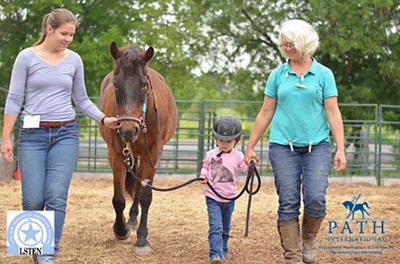

SIRE, a PATH Intl Premier Accredited Center with 3 locations in the Houston, Texas area, celebrated their Volunteers during Volunteer Week April 23rd-28th. Each year SIRE volunteers give over 33,000 hours of service!
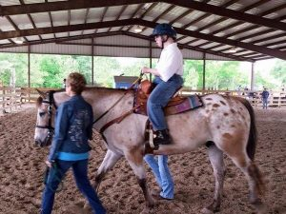

ROCK, Ride On Center for Kids in Georgetown, Texas recently received the Commitment Level award from the Quality Texas Foundation. Quality Texas helps businesses, hospitals, schools, government agencies and non-profits improve performance through education, training, assessing, providing feedback and recognizing organizations committed to a journey of excellence and continuous improvement. ROCK is a PATH Intl. Premier Accredited Center.
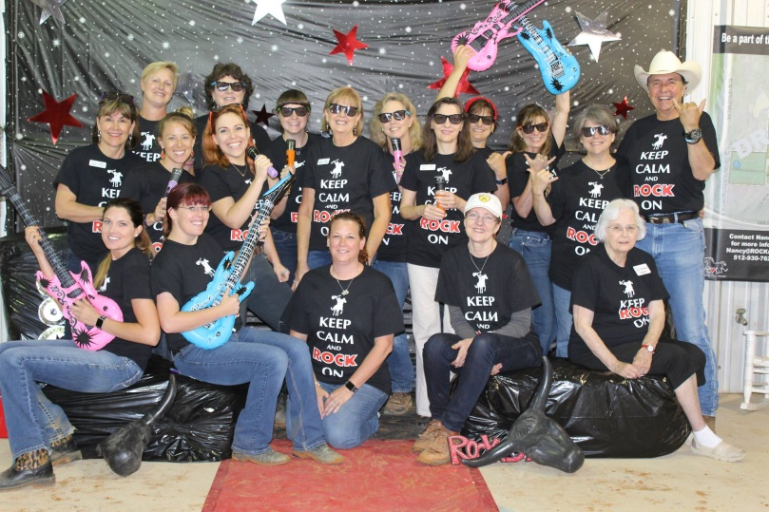

Divine Equine Therapeutic Riding Center, a PATH Intl Member Center in Sherman, Texas, was recently highlighted on the KXIII News, a Fox affiliated station. Volunteer Mary Jacobs told how the impact of therapeutic horsemanship goes beyond the participant to touch the parents as well. She was quoted, "And all of a sudden you see a connection between him and the horse or him and the instructor and the words may not be clear, but you'll see tears come out of the parent's eyes when the child is doing something they never thought they could do."
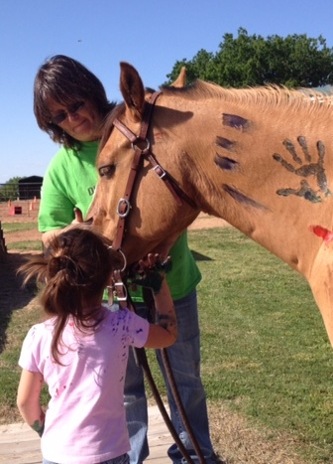
H.E.L.P. Center of Austin, a PATH Intl. Member Center, located in Manor, Texas recently partnered with Dover Saddlery of Austin to raise awareness of helmet safety during Helmet Awareness Week. Through this partnership, H.E.L.P. was able to receive 19 new helmets for their riders!

Hopeful Hearts Therapeutic Riding, a PATH Intl. Member Center in Leander, Texas, was recently awarded $5000 for their Veterans’ program from the Texas Stars Foundation. The Texas Stars, an affiliate of the Dallas Stars, is an American Hockey League team.
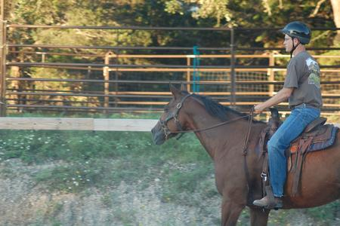

From Texas to China . . .
Priscilla Lightsey, a PATH Intl. Registered Instructor, Doctor of Physical Therapy, and Hippotherapy Clinical Specialist from Texas, moved to Beijing, China in 2006 temporarily due to her husband’s job. Never one to stay idle, Priscila started a therapeutic riding center. Today, with the help of over 200 volunteers and one full time staff member, HOPE (Horses Offering People Enrichment) continues to enrich the lives of children who have physical, cognitive, social and emotional impairments and is the only functioning therapeutic horsemanship program in Beijing. (www.hopebeijing.org)
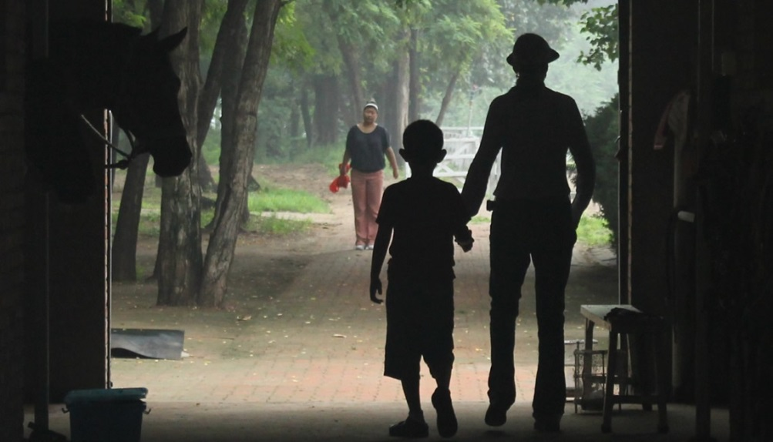
The HOPE story truly began in 2006 when Priscilla established the first HPOT program in mainland China at the China Rehabilitation Research Center (CRRC) where she trained a team of medical professionals. CRRC is considered the largest public rehabilitation hospital in the country. Sadly, the program was discontinued in 2008.
In 2009, following the closure of the CRRC program, Priscilla was practicing traditional physical therapy at a Beijing orphanage and felt compelled to introduce the benefits of EAT to the children. She requested, and received, a small grant from her church in Beijing to purchase necessary equipment and lease a horse. That spring HOPE worked with two orphanages and expanded their services to the expatriate and local Chinese communities. Their mission became very clear: partner with the horse to enrich the lives of children with special needs and create awareness of the healing properties of the horse.
Shortly after the organization’s founding, Priscilla received an invaluable donation in the form of a horse named Snipper! In addition, Sara Jenner and Zhao Yanbo, both experienced equestrians, joined the HOPE team. When Remy Lepore began volunteering the team was complete! The original team members have moved from Beijing, but HOPE continues to serve children with special needs including residents of Bethel Foster Home (an orphanage), local Chinese and expatriate children.
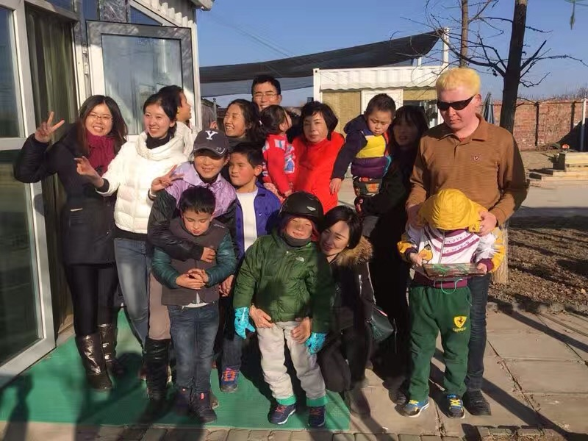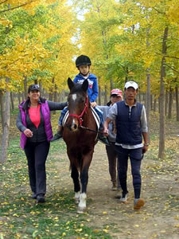
HOPE has received vital support from its community. It has grown through the help of its volunteers, gracious donations, and their partnership with Bethel Foster Home and stable owner Liang Haiming. Presently, HOPE operates out of Grasse Town Stable with a team of three ponies.

Mu'er participating in arts and crafts.

