Liliana Radulovacki Stevoff
1934 – 2021
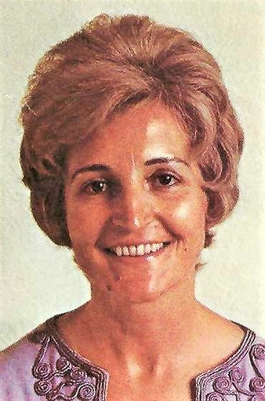
Liliana Radulovacki Stevoff, passed away on February 26, 2021 at Bridges Senior Living in Norwalk, Connecticut. She is the loving mother of Brad and Branko Radulovacki and proud grandmother of Grant, Katie, Reid and Ryan. She was born on October 9, 1934 in Brza Palanka, a small town on the Danube River in Serbia. She spent her high school years in the Serbian capital of Belgrade and went on to earn a DDS degree from the University of Belgrade Dental School. She met her future husband, Dr. Prof Miodrag (Misha) Radulovacki, during her dental school studies. Liliana, her husband and their two young boys spent three years in Khartoum, Sudan before emigrating to the United States in 1970 and settling in Evanston, Illinois. Before the age of 40, Liliana had passed the dental exam and practiced dentistry in three countries on three continents. As one of the few female dentists in Chicago at the time, she gained the trust and confidence of her patients through her conscientious attitude and skilled service. She ran a successful dental practice on the north side of Chicago for over 30 years. Liliana’s first marriage ended in divorce after twenty nine years. She met her second husband, Nicholas Stevoff, through her tennis group and they were married in 2001. She was preceded in death by both husbands. She is survived by her two sons and four grandchildren. Liliana was an avid tennis player who passed on her love of the sport to her children. She saved the lives of a father and son from drowning by rowing to their rescue, with a friend, during an outing at Turkey Run National Park. Liliana loved her life in Evanston. She found happiness within the Rookwood Gardens co-op community, located just a block from Northwestern University, where she lived for over 20 years. She also enjoyed the many strong friendships that she had created during her 49 years in Evanston. She was involved with the Unitarian Church, enjoyed concerts at Northwestern’s Pick-Staiger Hall, and reading at the Evanston Library. In January of 2019, she moved to Connecticut to be closer her son, Brad Radulovacki, and his family, who reside in Greenwich. Liliana will be remembered for her indomitable spirit, her sincere desire to connect with people, her utmost honesty and the courage with which she took on life’s challenges.
A memorial service will be held for her at 11am, Saturday, March 13th at The First Presbyterian Church of Greenwich, One West Putnam Avenue, Greenwich, CT. In lieu of flowers, memorial contributions may be made to the Unitarian Church of Evanston or a charity of your choice.

