
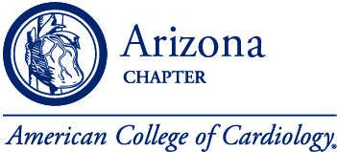

2024 Valley of the Sun & AZ ACC Annual Meeting
February 2-3, 2024
Commitment Form

Please use this form alongside our online registration to sign up for sponsorship.

** Online registration is up to date with the latest availability **
https://lp.constantcontactpages.com/ev/reg/5ejqwwm/lp/6588c011-7ee5-4b36-bd5a-97e5ef1dec54
All items are sold online on a first come basis.

Organization Name: ____________________________________________________________
Event Sponsor $15,000
Registration/Lanyard Sponsor $10,000
0
WiFi Sponsor $5,000
0
Breakfast Sponsor $6,000
- 0
Lunch Sponsor $7,500
- 0
WIC Dinner Sponsor $6,000
- 0
Coffee Break Sponsor $3,000
- 0
Exhibit Display $4,000
Billing Information
Contact Name: _____________________________________________________________________
Billing Address: ____________________________________________________________________
Phone Number: ____________________________________________________________________
Email: ____________________________________________________________________________
- 0
Once you process your online registration, complete this form, and send along with payment to:

American College of Cardiology, Arizona Chapter PMB 308 3849 E. Broadway Blvd. Tucson, AZ 85716
Phone: 1-877-460-5880 Email: lianna@aminc.org

