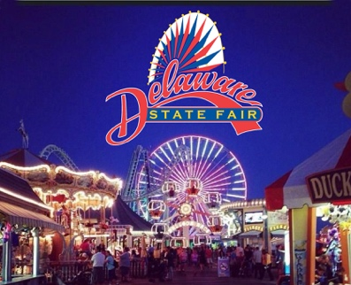
Delaware Foundation for Science and Mathematics Education
“STEM Is Everywhere at the STATE FAIR” Contest
Student Name / Contest Participant:

Student’s Grade / School / Contact’s Email Address / Contact’s Phone Number

Submission: Photo, Short Essay, Poster, Illustration, Creation (multiple entries acceptable)

How does your Submission relate to STEM? (Science, Technology, Engineering, Math)

Cash Prizes: $250 First Place / $100 Second Place / $50 Third Place
Winning Submissions will be published in DFSME August 2024 issue of DFSME News.
Email your Submission along with this entry form to:
dkidd@dtcc.edu with the subject line “State Fair STEM” by Aug 1, 2024.

Sponsored by Delaware Foundation for Science and Mathematics Education (DFSME)
100 W. 10th Street, Suite 612 • Wilmington, DE 19801 • 302-397-0034 • dfsme.org

