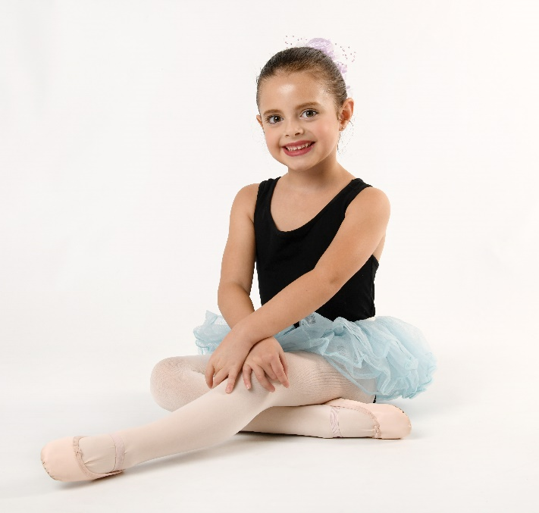
TIPS for a great photo session

Picture Day – Sunday, October 13th
1:00-6:00pm
Here at the Academy studios

Sign up Now!!

To make the day run smoother please note the following:
- Be ready on time. Come early to prepare your child for the shoot. Kim will take each dancer as they are ready. We will run as close to schedule as possible but be aware that you should give yourself an hour from when you come to prepare to when you leave. Hair may be up in a bun or worn the style you prefer. Note: Dance photos look best with hair in a dance style and not down. Make sure you have clean tights and shoes and do not wear underwear under your tights. They will show.

- Each dancer will get 3-5 poses (a headshot, 1-2 dance shots and a natural shot). Older dancers should prepare poses beforehand.

- Parents of younger dancers need to be aware that your child may not smile. It is OK. Kim will work to get the best possible photo and sometimes the most charming pictures are of children with an “attitude”. If your child is totally uncooperative you are not obligated to have the photo taken.

- Please come completely ready with your hair/makeup and dance clothes. There will be headpieces and tutus/skirts for your dancer to put on over their regular dance clothes. You may also choose to come dressed in an outfit of your own choice.

- Money and order form is due on Picture Day. Make checks payable to “Kim Garcia Photography”. Remember a portion of the profits from these photos are donated by Miss Garcia to the Ballet Yuma scholarship fund.

This will be the ONLY day for Academy Dance Portraits and there are no re-takes.

