Ballet Yuma’s Nutcracker 2018
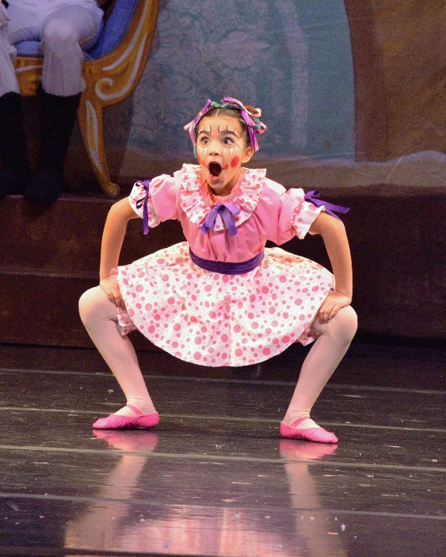
Performances: December 7-9th
Casting Calls for children’s roles
Saturday September 8th
Yuma Ballet Academy studios - 3942 S Ave 4 ½ E
Group B: 52”-55” tall 3:45-4:30pm
Group C: 47”-51” tall 4:15-5:00pm
Group D: 46” and under 4:45-5:30pm
Monday September 10th
Yuma Ballet Academy studios - 3942 S Ave 4 ½ E
Group A: 56” and over 7:30-8:00pm
Dancers coming to the casting call must have filled out the participation form and paid the performance fee ($85) BEFORE attending the casting call. Please make sure you read the information/guidelines/requirements before signing up your dancer for this exciting performance opportunity. Note: All children received parts if they meet the criteria.
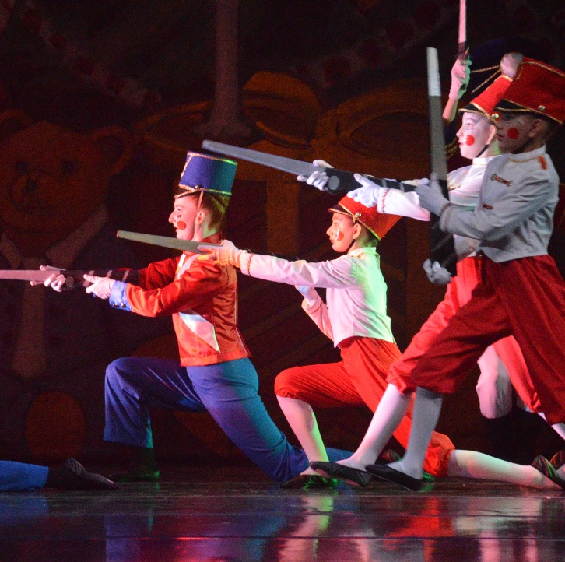
QUESTIONS?
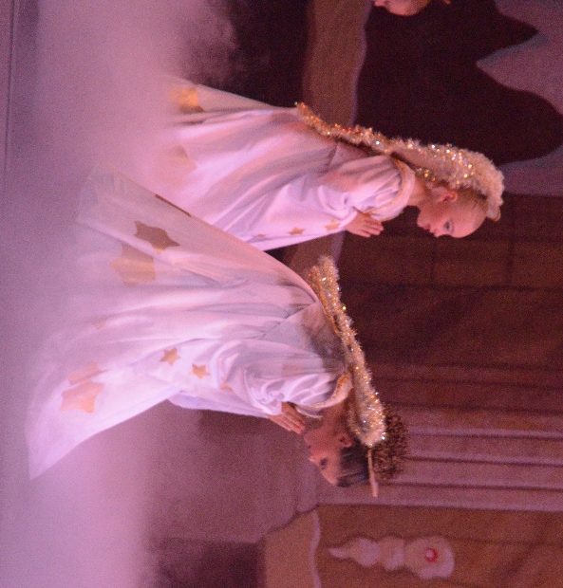
Email us at balletyuma1@gmail.com or call 928-314-4762

First rehearsals for most roles will take place on Saturday September 22nd

