RESOURCES FOR PARENTS AND YOUTH

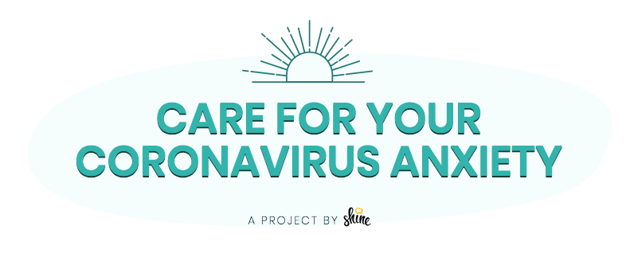

1. MDE MEMO: Compliance Requirements of the Individuals with Disabilities Education Act (IDEA) Part C during a Public Health Emergency
2. COVID-19 ("Coronavirus") Information and Resources for Schools and School Personnel
3.CDC Guidance for School and Childcare Plan, Prepare, and Respond to Coronavirus Disease 2019 (COVID-19)
4. The CDC Mental Health and Coping During COVID-19
5. The Child Mind Institute's Talking to Kids About the Coronavirus. Students may experience hunger, abuse, or lack of healthcare in their homes and with their families. Know local resources and be prepared to help.
6. Anxiety and Depression Association of America Psychologist Jelena Kecmanovic's 7 Science-Based Strategies to Cope With Coronavirus Anxiety
7. The Jed Foundation's Tips for Self-Care and Managing Stress
8. National Association of School Psychologists' Talking to Children About COVID-19: A Parent Resource
9. SAMSHA's Taking Care of Your Behavioral Health: Tips for Social Distancing, Quarantine, and Isolation During an Infectious Disease Outbreak

10. SAMHA's Coping With Stress During Infectious Disease Outbreaks
11. The Center for the Study of Traumatic Stress: Coronavirus and Emerging Infectious Disease Outbreaks Response
12. Internet AT&T offers a discount for those who qualify for SNAP
Comcast offers free internet for 2 months effective Monday, March 16, 2020
13. PBS KIDS Daily Newsletter new for duration of school closures.
14. Article "How to talk to your kids about the coronovirus"

