Advent

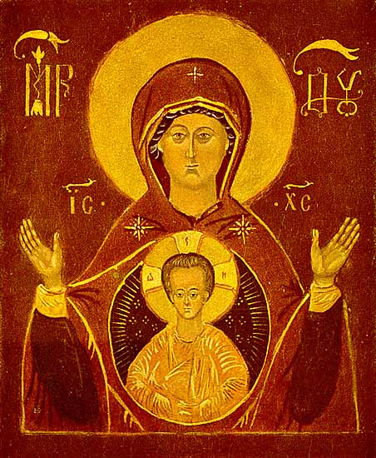

Advent is a time of hope, expectation,
and preparation.
It is a time of darkness, cold, and angst.
It calls us into the womb of paradox
where polarities fold into the other.
It is hard work and it is waiting.
And there is beauty in the waiting.

A Bidding Prayer

Dear People of God: In the season of Advent, it is our responsibility and joy to prepare ourselves to hear once more the message of the Angels, to go to Bethlehem and see the Son of God lying in a manger.

Let us recall the story of God’s loving purpose from the time of our rebellion against him until the glorious redemption brought to us by his holy Child Jesus, and let us look forward to the yearly remembrance of his birth with hymns and songs of praise.

But first, let us pray for the needs of his whole world, for peace and justice on earth, for the unity and mission of the Church for which he died, and especially for his Church in our country and in this city.

And because he particularly loves them, let us remember in his name the poor and helpless, the cold, the hungry and the oppressed, the sick and those who mourn, the lonely and unloved, the aged and little children, as well as all those who do not know and love the Lord Jesus Christ.

Finally, let us remember before God his pure and lowly Mother, and that whole multitude which no one can number, whose hope was in the Word made flesh, and with whom, in Jesus, we are one for evermore.

The Almighty God bless us with his grace; Christ give us the joys of everlasting life; and to the fellowship of the citizens above may the King of Angels bring us all. Amen.

Advent Reflections

The Overshadow
by Luci Shaw

“…. the power of the Most High will overshadow you… “ -Gospel of Luke

When we think of God, and
angels, and the Angel,
we suppose ineffable light.

So there is surprise in the air
when we see him bring to Mary,
in her lit room, a gift of darkness.

What is happening under that
huge wing of shade? In that mystery
what in-breaking wildness fills her?

She is astonished and afraid; even in
that secret twilight she bends her head,
hiding her face behind the curtain

Of her hair; she knows that
the rest of her life will mirror
this blaze, this sudden midnight.

Excerpted from “East Coker”, Four Quartets – TS Elliot

I said to my soul, be still, and wait without hope for hope
would be hope for the wrong thing; wait without love
For love would be love of the wrong thing; there is yet faith
But the faith and the love and the hope are all in the waiting.
Wait without thought, for you are not ready for thought:
So the darkness shall be the light, and the stillness the dancing.

The Risk of Birth (Christmas, 1973) by Madeleine L’Engle

This is no time for a child to be born,
With the earth betrayed by war & hate
And a comet slashing the sky to warnThat time runs out & the sun burns late.
That was no time for a child to be born,
In a land in the crushing grip of Rome;
Honour & truth were trampled by scorn-
Yet here did the Saviour make his home.

When is the time for love to be born?
The inn is full on the planet earth,
And by a comet the sky is torn-
Yet Love still takes the risk of birth.

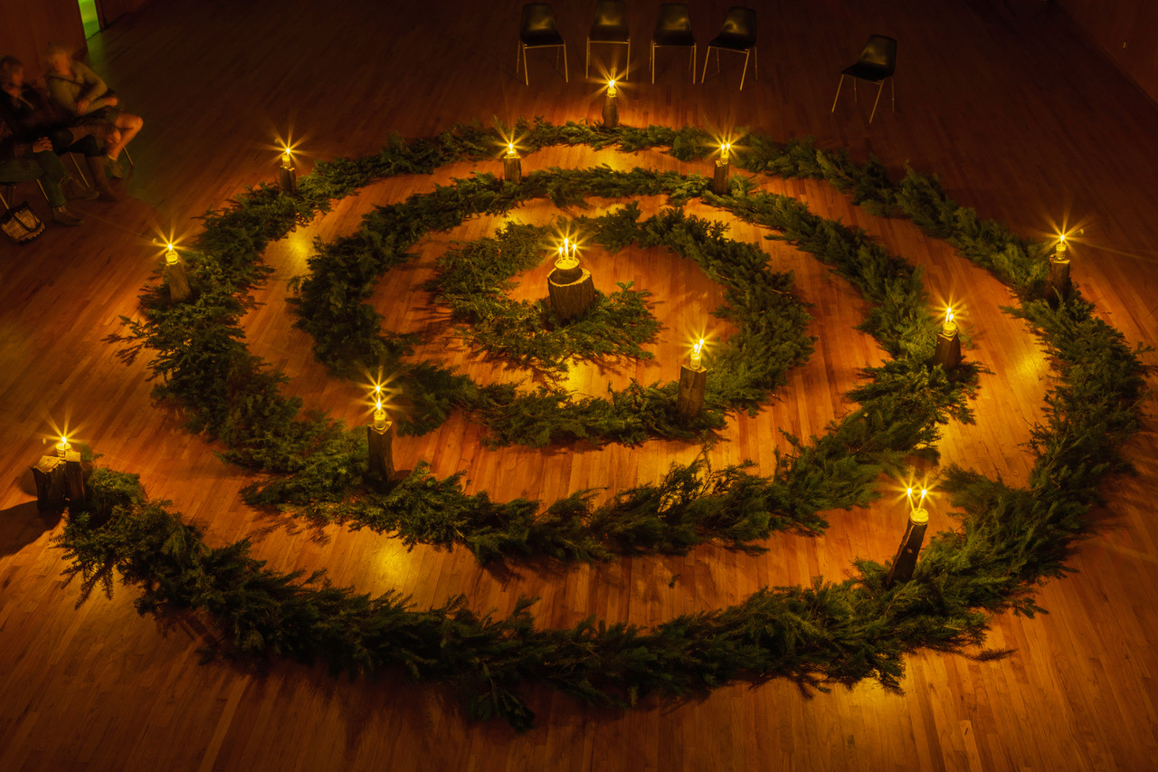

Advent is a time when we prepare ourselves for the coming of Christ. It is meant to be a time of reflection and a time set aside to renew our connection to Christ. This booklet provides prayers and resources to support the daily observance of Advent in your home.

The Blessing of the Advent Candle:

Leader: Our help is in the name of the Lord.
All: Who made heaven and earth.
Leader: O God, by whose Word all things are sanctified, pour forth Your blessing upon this wreath and grant that we who use it may prepare our hearts for the coming of Christ and may receive from You abundant graces. We ask this through Christ our Lord.
All: Amen.

Weekly Prayers To Use When Lighting the Advent Candle:
Each evening before dinner, designated one person to say the prayers and various members of the family to light the candles. Family members can also take turns lighting and blowing out the candles on each night.

Advent 1
All-powerful God, increase our strength of will for doing good that Christ may find an eager welcome at his coming and call us to his side in the kingdom of heaven, where he lives and reigns with you and the Holy Spirit one God, forever and ever.
~AMEN.

Advent 2
God of power and mercy open our hearts in welcome. Remove the things that hinder us from receiving Christ with joy so that we may share his wisdom and become one with him when he comes in glory, for he lives and reigns with you and the Holy Spirit, one God, forever and ever.
~AMEN.

Advent 3
Lord God, may we, your people, who look forward to the birthday of Christ experience the joy of salvation and celebrate that feast with love and thanksgiving. We ask this through Christ our Lord.
~AMEN.

Advent 4
Holy God, your eternal Word took flesh on our earth when the Virgin Mary placed her life at the service of your plan. Lift our minds in watchful hope to hear the voice which announces his glory and open our minds to receive the Spirit who prepares us for his coming. We ask this through Christ our Lord.
~AMEN.

Advent 1
Stir up Your might, we pray You, O Lord,
and come, so that we may escape through Your protection
and be saved by Your help from the dangers
that threaten us.
Who lives and reigns for ever and ever. Amen

Advent 2
O Lord, stir up our hearts
that we may prepare for Your only begotten Son,
that through His coming
we may be made worthy to serve You with pure souls.
Through the same Christ our Lord. Amen

Advent 3
We humbly beg You, O Lord,
to listen to our prayers;
and by the grace of Your coming
bring light into our darkened minds.
Who lives and reigns for ever and ever.

Advent 4
Stir up Your might, we pray You, O Lord, and come;
rescue us through Your great strength so that salvation,
which has been hindered by our sins,
may be hastened by the grace of Your gentle mercy.
Who lives and reigns for ever and ever. Amen

Advent 1 - Expectation
Prayer:
“The people who walked in darkness have seen a great light” (Isaiah 9:1).
God of compassion,
be with us in these long and dark days
as we await the birth of your son, Jesus.
Amen.

Family Advent Activity
The Ringing of the Bells – Place a bell (or a cluster of sleigh bells) in a prominent place in your home. Draw names after church each week and pledge to do something nice for the family member whose name you choose. Each time you do something nice for that person ring the bells. Listen to the sound of kindness filling your house!
Advent 2 - Proclamation
Prayer:
“The people who walked in darkness have seen a great light” (Isaiah 9:1).
God of salvation,
help us give voice to the voiceless
as we cry out in the name of your son, Jesus.
Amen.

Family Advent Activity
Adopt a family this Advent season. Let your children help select gifts. Remember the basics are always needed: coats, hats, mittens, socks, undergarments and pajamas.
Advent 3 - Celebration
Prayer:
“The people who walked in darkness have seen a great light” (Isaiah 9:1).
God of blessings,
we celebrate your good gifts
and rejoice at the gift of
your son, Jesus.
Amen.

Family Advent Activity
Bless the Tree – As you put up the family Christmas tree, give thanks to God for the gift of evergreens in the winter, the gift of lights to remind us of Jesus coming into the world, and special ornaments that remind us of family, friends and holidays past.

Advent 4 -Fulfillment
Prayer:
“The people who walked in darkness have seen a great light” (Isaiah 9:1).
God of wisdom,
bless us with Mary’s “yes”
as we welcome Emmanuel into
our hearts and homes.
Amen.

Family Advent Activity
Spend time at the Creche – Encourage each member of your family to spend some quiet time in prayer near the Nativity scene at home or in your parish. What does the manger teach us? How could God allow his Son to be born in a stable? Give thanks for the gift of Christ and the joy of the Christmas season to come.

Advent 1: A Week of Hope
The first candle is called the candle of hope. People in the Old Testament knew that God had promised to send a Savior. And we’re filled with hope because we know that Jesus came to Earth on the first Christmas so he could tell people about God and die for our sins.

Light the first candle on your Advent wreath. Then share some ways that you’re filled with hope because you know Jesus.

Advent 2: A Week of Preparation
The second candle on an Advent wreath represents preparation. Just as we get our homes and churches ready for Christmas, we also get our hearts ready for baby Jesus.

As a family, brainstorm a list of things you do to get ready for house guests. Talk about what you would do differently if Jesus were coming to stay at your house. John the Baptist, Jesus’ cousin, spread the word that Jesus was on his way. Part of our preparations for Christmas can include letting other people know what Christmas is all about-the birth of our Savior. Light the first two candles on your Advent wreath and pray that God will bless your preparations for his son’s arrival.

Advent 3: A Week of Joy
The third candle on an Advent wreath, usually pink, symbolizes joy. Christmas excitement is building as the holiday quickly approaches.

The angels made a big announcement on the first Christmas, calling Jesus’ birth ‘good news’ that would bring ‘great joy.’ Everything we do to get ready for Christmas can fill us with joy about Jesus. When we’re joyful, we, like the angels, can help spread that good news. Light the first three candles on your Advent wreath. Then let each person share one thing they’re especially joyful about this Christmas.

Advent 4: A Week of Love

The fourth candle on an Advent wreath, usually purple, is often called the candle of love. Christmas happened because of God’s great love for all people.
As your family gathers to open Christmas gifts, talk about why we give nice things to people we love. Ask: What are some of the most memorable gifts you’ve received? How can you tell when much love and thought go into a gift?
At Christmas, God gave us the best gift ever. He sent his Son, Jesus, to live, die, and rise again so we could live with him forever in heaven. Although this gift required great sacrifice, God knew we needed Jesus.

Light all four candles on your Advent wreath. (If you have a fifth candle, usually white, light it on Christmas Day, as the Christ candle.) Close in prayer, thanking our loving God for sending Jesus as our best Christmas gift.

Advent Wreath

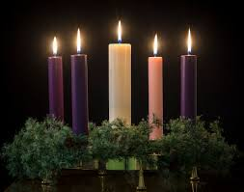

The Advent wreath, four candles in a wreath of evergreen, is shaped in a perfect circle to symbolize the eternity of God. In some churches, four purple candles, one for each week in Advent, are used with one larger white candle in the middle as the Christ candle. Other churches prefer three purple or blue candles with one candle being rose or pink, to represent joy.
The Advent wreath symbolizes the coming of Christ. During each Sunday of the Advent season, we focus on one of the four virtues Jesus brings us: Hope, Love, Joy and Peace. Others consider the lighting of the first candle to symbolize expectation, while the second symbolizes hope, the third joy and the fourth purity. The Christ candle is lit on Christmas Eve reminding us that Jesus is the light of the world.

Advent Family Activities

Make an Advent prayer chain. Use red and green construction paper and cut twenty-two strips. Write a prayer concern on each strip. Use tape to tape the first strip into a circle. Take the second strip and insert it into the first strip before taping it into a circle. Continue until you have a chain. Each day of Advent, open your one strip and pray together as a family for what is on the strip.

Make a family blessing jar. Place an empty jar on your dining table. Each day during Advent, state one blessing for which you are thankful. Write the blessing on a slip of paper and put it in the jar. On Christmas Day, pour out the blessings. Read together and give thanks to God for the blessings you have enjoyed during Advent.

Christmas Wreath
After the fourth week, Advent is over and the rejoicing of the Christmas Season is at hand. The Advent wreath may be transformed into a Christmas wreath. Candles are replaced with long red or white tapers (to be lighted at breakfast on Christmas morning) and, if desired, other festive decorations can be added.



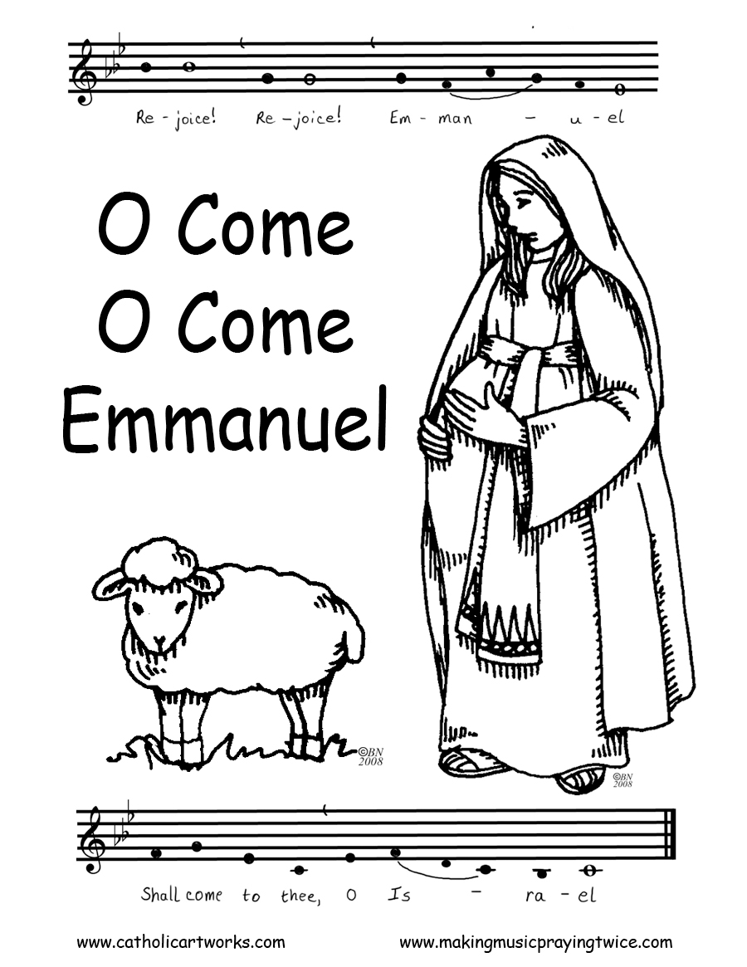

The O Antiphons

The O Antiphons developed during the Church's very first centuries for use in daily prayer. There are seven of these special antiphons, and their texts spring from the Old Testament Hebrew Scriptures, the Prophetic and Wisdom Books. The O Antiphons are short prayers traditionally sung during evening prayer before and after the Magnificat. The O Antiphons begin on 17 December, seven days before the Vigil of Christmas (24 December). The seventh and last antiphon is sung at Vespers on 23 December. The antiphons are, in fact, a collage of Old Testament types of Christ. Their predominant theme messianic, stressing the hope of the Savior's coming. They each address Jesus by one of His Old Testament titles. They are fervent prayers asking Our Lord to come to us.

O Wisdom, coming forth from the mouth of the Most High, reaching from one end to the other mightily, and sweetly ordering all things: Come and teach us the way of prudence.

O Adonai, and leader of the House of Israel, who appeared to Moses in the fire of the burning bush and gave him the law on Sinai: Come and redeem us with an outstretched arm.

O Root of Jesse, stand as a sign among the peoples; before you kings will shut their mouths, to you the nations will make their prayer: Come and deliver us, and delay no longer.

O Key of David and sceptre of the House of Israel you open and no one can shut; you shut and no one can open: Come and lead the prisoners from the prison house, those who dwell in darkness and the shadow of death.

O Splendour of light eternal and sun of righteousness: Come and enlighten those who dwell in darkness and the shadow of death.

O King of the nations, and their desire, the cornerstone making both one: Come and save the human race, which you fashioned from clay

O Emmanuel, our King and Lawgiver, the Desire of all nations, and their Salvation: Come and save us, O Lord our God.

A Series of Sonnets on the O Antiphons
by Malcom Guite

O Sapientia
I cannot think unless I have been thought
Nor can I speak unless I have been spoken
I cannot teach except as I am taught
Or break the bread except as I am broken.
O Mind behind the mind through which I seek,
O Light within the light by which I see,
O Word beneath the words with which I speak
O founding, unfound Wisdom, finding me
O sounding Song whose depth is sounding me
O Memory of time, reminding me
My Ground of Being, always grounding me
My Maker’s Bounding Line, defining me
Come, hidden Wisdom, come with all you bring
Come to me now, disguised as everything.

O Adonai
Unsayable, you chose to speak one tongue
Unseeable, you gave yourself away,
The Adonai, the Tetragramaton
Grew by a wayside in the light of day.
O you who dared to be a tribal
God, to own a language, people and a place,
Who chose to be exploited and betrayed,
If so you might be met with face to face,
Come to us here, who would not find you there,
Who chose to know the skin and not the pith,
Who heard no more than thunder in the air,
Who marked the mere events and not the myth.
Touch the bare branches of our unbelief
And blaze again like fire in every leaf.

O Radix
All of us sprung from one deep-hidden seed,
Rose from a root invisible to all.
We knew the virtues once of every weed,
But, severed from the roots of ritual,
We surf the surface of a wide-screen world
And find no virtue in the virtual.
We shrivel on the edges of a wood
Whose heart we once inhabited in love,
Now we have need of you, forgotten Root
The stock and stem of every living thing
Whom once we worshiped in the sacred grove,
For now is winter, now is withering
Unless we let you root us deep within,
Under the ground of being, graft us in.

O Clavis
Even in the darkness where I sit
And huddle in the midst of misery
I can remember freedom, but forget
That every lock must answer to a key
That each dark clasp, sharp and intricate,
Must find a counter-clasp to meet its guard.
Particular, exact and intimate,
The clutch and catch that meshes with its ward.
I cry out for the key I threw away
That turned and over turned with certain touch
And with the lovely lifting of a latch
Opened my darkness to the light of day.
O come again, come quickly, set me free
O Oriens Paradiso
First light and then first lines along the east
To touch and brush a sheen of light on water
As though behind the sky itself they traced
The shift and shimmer of another river
Flowing unbidden from its hidden source;
The Day-Spring, the eternal Prima Vera.
Blake saw it too. Dante and Beatrice
Are bathing in it now, away upstream…
So every trace of light begins a grace
In me, a beckoning. The smallest gleam
Is somehow a beginning and a calling;
“Sleeper awake, the darkness was a dream
For you will see the Dayspring at your waking,
Beyond your long last line the dawn is breaking”

O Rex Gentium
O King of our desire whom we despise,
King of the nations never on the throne,
Unfound foundation, cast-off cornerstone,
Rejected joiner, making many one,
You have no form or beauty for our eyes,
A King who comes to give away his crown,
A King within our rags of flesh and bone.
We pierce the flesh that pierces our disguise,
For we ourselves are found in you alone.
Come to us now and find in us your throne,
O King within the child within the clay,
O hidden King who shapes us in the play
Of all creation. Shape us for the day
Your coming Kingdom comes into its own.

An Advent Prayer

Lord Jesus,
Master of both the light and the darkness, send your Holy Spirit upon our preparations for Christmas.
We who have so much to do seek quiet spaces to hear your voice each day.
We who are anxious over many things look forward to your coming among us.
We who are blessed in so many ways long for the complete joy of your kingdom.
We whose hearts are heavy seek the joy of your presence.
We are your people, walking in darkness, yet seeking the light.
To you we say, "Come Lord Jesus!"
Amen.

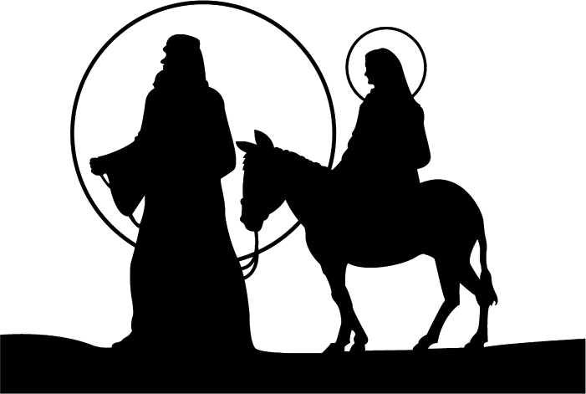

Advent Blessing:
May the Sun of Righteousness shine upon you and scatter the darkness from before your path; and the blessing of God Almighty, the Father, the Son, and the Holy Spirit, be among you, and remain with you always. Amen

www.saintthomasdenver.org ~ 2201 Dexter, Denver, CO 80207

