SPE-itTM Kit: Screening for Drugs of Abuse and Pesticides

Introduction
Urine has long been the sample of choice for drug screening of employers and law enforcement investigators. As more and more employers ask for the test, the sale of synthetic urine for individuals to supply to testers has risen. These synthetic urines often contain urea and creatinine, major components of urine, diluted in water. High quality synthetic urines also contain various metabolites and salts.

When urine is analyzed by either direct liquid injection LC/MS or DART-MS, significant matrix effects are encountered resulting in a mass spectrum dominated by the protonated urea and creatinine. In order to improve sensitivity for detection of drugs and minimize the matrix effect our solid phase micro-extraction fibers (SPE-itTM kit -C18 tips) were utilized to separate the metabolites and analytes of interest from the urine.

In a simplified sample handling process the sample laden SPE-it fiber is positioned in the ionization region of a Direct Analysis in Real-Time (DART) source for analysis. The desorption ionization generates protonated drugs of abuse and pesticides in seconds per sample facilitating rapid detection by the mass spectrometer.

While the extraction time is long at 1 hour or less the DART-MS analysis requires less than a minute per sample. Utilizing a 96-well plate and loading 12 SPE-it tips into the multi-tip holder the extraction can be completed in parallel followed by rapid analysis to improve sample throughput.

The SPE-itTM Kit consumables and hardware was used to isolate drugs of abuse and pesticides spiked into synthetic urines. Figure 1 shows the procedure that was followed while treating and sampling the fibers.

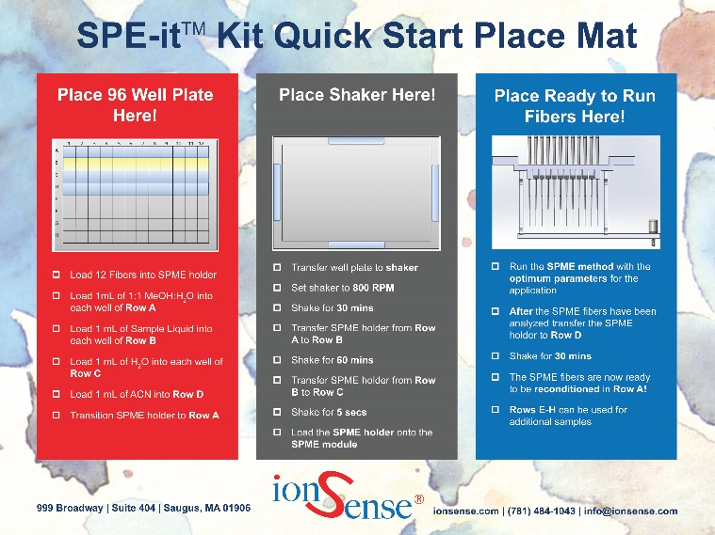
Figure 1: SPE-itTM Kit place mat showing sampling protocols

Experiment
Synthetic urines were spiked with heroin, LSD, and two pesticides; cyanazine and desmetryn. The analytes were spiked into the synthetic urines at 10 PPM. C18 fibers were utilized for the extraction. A DART-SVP coupled to a Waters Acquity® QDa was used to perform the analysis. The DART gas temperature was 300 °C with a rail speed of 0.5 mm/s used to push the fibers through the ionization region. The SPE-itTM module was used to complete all analyses.

Results

When urines are analyzed directly there is strong ion suppression that is associated with the sample matrix that makes detection of the analytes more challenging. Creatinine
and the urea dimer are two of the major ions that contribute to this suppression seen below in figure 2.

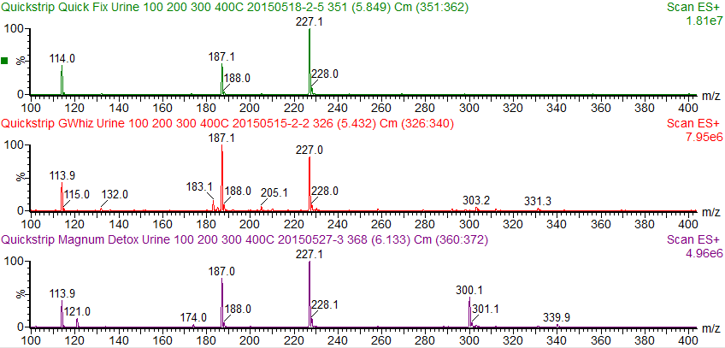
Urea Dimer
Creatinine and Dimer
Figure 2: Shows spectra of three synthetic urines Creatinine and its dimer can be detected at m/z 114 and 227 respectively. The urea dimer is detected at m/z 121.

The DART-MS of one of the urine samples after extraction with the SPE-itTM tip is shown below. In this case, the C18 coated fiber absorbed the analytes in the sample while leaving the urea and creatinine behind.

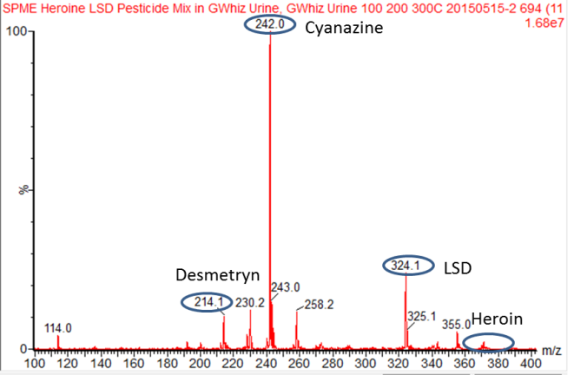
Figure 3: Shows the DART-MS results from direct desorption ionization of the C18 coated surface of the SPE-it tip. The drugs of abuse and pesticides are easily detected while the signal from creatinine at m/z 114 is greatly reduced.

Utilizing the C18 fiber successfully enabled detection of a mixture of drugs of abuse as well as various pesticides in a single

screening. The module allows for the desorption of twelve fibers in a single run, for rapid screening of urine samples.

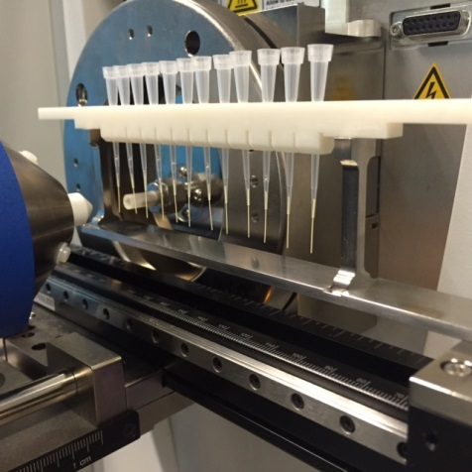
Figure 4: Shows the SPE-itTM module attached to the automated linear rail.

Conclusion

Screening urine samples can be simplified by eliminating matrix ion suppression by using the SPE-itTM tip and kit protocols. In this case, the C18 fibers, provided in the kit, readily enhanced the analyte signal for drugs of abuse and pesticides in synthetic urine. Parallel sample processing is used to make rapid and easy detection of these analytes possible.

Revision History
REV | DCR # | Description of Change | Effective Date
1 | 242 | Initial Release | 7/23/2015

