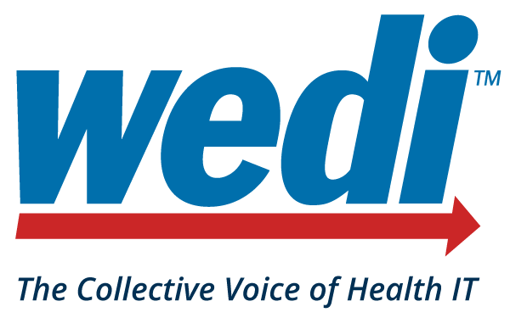

Federal Updates

CMS Reports ACOs Saved Medicare More Than $1.6 Billion in 2021. The Centers for Medicare & Medicaid Services (CMS) announced that the Medicare Shared Savings Program, through its work with Accountable Care Organizations (ACOs) – groups of doctors, hospitals and other health care providers -- saved Medicare money while continuing to deliver high-quality care. Specifically, the program saved Medicare $1.66 billion in 2021 compared to spending targets. This marks the fifth consecutive year the program has generated overall savings and high-quality performance results. As of January 2022, Shared Savings Programs include over 525,000 participating clinicians who provide care to more than 11 million people with Medicare. CMS has set a goal that 100 percent of people with Traditional Medicare will be part of an accountable care relationship by 2030. Go here for more information on the Medicare Shared Savings Program.
ONC and HRSA launch USCDI+ Initiative to support UDS Modernization. In a blog post, the Office of the National Coordinator for Health Information Technology (ONC) discussed how ONC and the Health Resources and Services Administration (HRSA) saw an opportunity to leverage USCDI+ and how the two agencies launched a new USCDI+ collaboration to support HRSA’s Uniform Data System (UDS) reporting through the UDS Modernization Initiative. ONC and HRSA are working together to align the UDS with interoperability standards and transition to patient-level reporting requirements with USCDI and other quality reporting efforts. We are also establishing a strategic direction aligned with ONC’s Cures Act Final Rule for HL7® Fast Healthcare Interoperability Resources (FHIR®)-based exchange to better support the needs of health centers across the country. The UDS is a standard data set submitted annually by health centers funded under the Health Center Program authorized by section 330 of the Public Health Service (PHS) Act (42 USC 254b). The UDS includes data on patient characteristics, services provided and used, clinical quality measures and health outcomes, staffing, costs, and revenues. Recently, HRSA launched its UDS Modernization Initiative to expand and improve the UDS data set, aligning with health information technology (IT) advancements, such as FHIR. A key pillar of the initiative is the transition from aggregate data submission at the health center level to disaggregated and de-identified UDS patient level submission (UDS+).
HRSA Announces $20 Million in Awards to Address Maternal Health Crisis; Reduce Disparities in Maternal and Infant Health. HRSA, announced investments of over $20 million to improve maternal and infant health and implement the White House Blueprint for addressing the maternal health crisis. The funding seeks to reduce disparities in maternal and birth outcomes, expand and diversify the workforce caring for pregnant and postpartum individuals, increase access to obstetrics care in rural communities, and support states in tackling inequities in maternal and infant health. The HRSA awards include: (i) Supporting State-led Maternal Health Innovation; (ii) Improving Maternal Care in Rural Communities; (iii) Increasing Access to Community-based Doulas; and (iv) Addressing Infant Mortality. Learn more about HHS’s efforts to strengthen maternal health here.
HHS Launches Website to Safeguard Information on Health and Rights for Patients and Providers. The Department of Health and Human Services (HHS) has launched the public awareness website, which includes information about reproductive health, including a Know-Your-Rights patient fact sheet to help patients and providers. Included on the website is a link to the Office for Civil Rights (OCR) should an individual believe their privacy rights have been violated. As well, guidance is provided for protecting the privacy and security of health information when using personal cell phones or tablets.
The Sequoia Project Publishes DUW IG for Review. The Sequoia Project, a non-profit advocate for nationwide health information exchange and the Recognized Coordinating Entity (RCE) for the Trusted Exchange Framework and Common Agreement (TEFCA) designated by ONC, announced the release of Data Usability Workgroup Implementation Guide, Version 0.1 and is seeking public feedback through Friday, October 14, 2022. This implementation guide covers the identified priority use cases that can be readily adopted within health information exchange vendors, implementers, networks, governance frameworks and testing programs and is built on existing work and in coordination with related standards development organizations and industry initiatives.
The Sequoia Project Releases Final QHIN Documents. The Sequoia Project has published final documents critical for the development of TEFCA. The final documents available on the RCE website include: (i) Qualified Health Information Network (QHIN) Application; (ii) QHIN Onboarding & Designation Standard Operating Procedure (SOP); (iii) Means To Demonstrate U.S. Ownership and Control of a QHIN SOP; and (iv) Means To Demonstrate U.S. Ownership and Control of a QHIN SOP Questionnaire. The Sequoia Project anticipates opening the QHIN application portal on October 3, 2022.
Research: Increased Telehealth Use for Opioid Use Disorder Services During Pandemic Associated with Reduced Risk of Overdose. According to a new study Published in JAMA Psychiatry, the expansion of telehealth services during the COVID-19 pandemic was associated with individuals staying in treatment longer and reducing their risk of medically treated overdose. The research, a collaborative effort that included the Centers for Disease Control and Prevention (CDC); the National Institutes of Health (NIH); and the Centers for Medicare & Medicaid Services (CMS), analyzed data among 175,778 Medicare beneficiaries from September 2018 to February 2021. The analysis examined the receipt of telehealth services, medications for opioid use disorder (MOUD), and experiencing a medically treated overdose among individuals with opioid use disorder (OUD) starting a new episode of care prior to the pandemic compared to those during the pandemic. Highlights from the study included: (i) those in the COVID-19 pandemic group were more likely to receive OUD-related telehealth services compared to the pre-pandemic group; and (ii) receipt of OUD-related telehealth services were associated with significantly better MOUD treatment retention and lower risk of medically treated overdose compared to those not receiving OUD-related telehealth services.

