First jobs Fund
Application Guide

Workforce Training and Employment

Economic Development, Investment and Trade

Contents
First Jobs Fund - Application Guide 1
Section 1: Company/Organization Information 2
Section 2: Company/Organization Profile 2
Section 3: Project Description 3
Section 3B: Project Evaluation 6
Section 4. Project Budget 6
Activity/Service Definitions 7
Appendix B 10
Project offers job focused employment preparation activities 10
Appendix C 11
Project offers employment specific training to address labor force development needs 11
Appendix D 12
Project offers employment specific training to address labor force development needs and includes a work experience component 12
Appendix E 13
Project assists participants in creating self-employment opportunities 13
Appendix F 14
Project offers on-the-job training 14
Appendix G 15
Eligible and ineligible expenses 15
Appendix H 16
Required documentation 16
Appendix I 17
Reporting requirements 17

First Jobs Fund - Application Guide

This guide has been prepared to assist service providers to complete the application for funding provided by Workforce Training and Employment (WTE) – Economic Development, Training and Trade.

The First Jobs Fund (FJF) is available for projects, up to $300,000, providing activities for NEW EMPLOYEES. Eligible applicants are registered non-profit or non-government organization.

Eligible organizations/service providers may apply for funding to support:
- Job readiness programs that will deliver employability skills, mentorship, job coaching and life skills
- Wage subsidy programs that will provide a minimum of 7 hours of employment/week and at least 150 hours of total employment

PLEASE NOTE:
- Funding is not guaranteed and is contingent upon eligibility and availability.
Troubleshooting Adobe

If you have any issues opening the application document and/or inputting information, check the following:
- Ensure you have the latest version of Adobe downloaded
- Make sure you have Enable All Features chosen (upper right hand side)
- The application must be submitted on behalf of the Board of Directors/organization by an individual who has legal signing authority and /or is authorized to act on behalf of the Board/organization.
- You will be contacted by a government staff member to set up a phone or in-person appointment to review your application and discuss next steps.
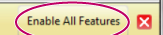
- If the application is approved, the organization will be required to sign an agreement with the Government of Manitoba which stipulates how the funds are to be spent and the reporting requirements.
- Applications are considered part of the agreement and therefore you may be asked to make revisions.
- Organizations must have either Workers Compensation or Third Party Liability Insurance in place before Manitoba can enter into an agreement.
When your application is complete (including the Project Budget)
Save it as:
Agency Name and Project Title
Email it back to: youthpartnerships@gov.mb.ca

Ensure that you complete all data fields in each section of the application
Failure to do so will cause a delay in processing the request

Section 1: Company/Organization Information

- Enter the name of the company/organization, Business Number obtained from the Government of Canada, operating name, mailing address, telephone, fax and email address.
- Provide the name, job title and direct telephone phone number of the individual who should be contacted by Manitoba to provide additional information and answer questions about your application.
- Provide the name, telephone, fax, and email address of the person with legal financial signing authority. ONLY complete if different from the previous contact information.

Section 2: Company/Organization Profile

Provide a general description of the organization | This should include the following:  - Description of the organization – who does the organization serve (population/age/demographics/area in province/etc)?  - What products/services does it produce?  - Mission/vision statement  - Community partners – does the organization work with partners on program development and/or delivery
Indicated if the organization has Worker’s Compensation and/or 3rd Party Liability Insurance | Organizations must have 3rd part Liability Insurance to be under contract with the province
Provide the number of years the organization has been in business
Indicate full time and part time employees attached to the project | Definitions:  - Full time employee: regularly works a minimum of 30 hours per week  - Part time employee: regularly works less than 30 hours per week
Indicate whether or not employees are unionized and whether or not the organization has union concurrence for the project, and the name of the union (or association).

Section 3: Project Description

This section requests information on the need or issue your organization is addressing, the actions to be taken to solve the problem, the results expected to achieve, and how the organization will measure those results.
Project Title and Dates | - Enter the project title: e.g.: Digital Training for Employment  - Enter the dates when the project will start and end
Provide an overview of the project | - Provide a high level description of the project and how the organization will ensure project success.  - As part of the project overview, projects must show how they will address the following:  - Barriers to Employment:  - What barriers to employment are faced by the target participant(s)? How does your organization plan to address these barriers to ensure a successful outcome?  - Truth and Reconciliation Activities:  - What activities will the project provide to participants and/or employers to advance reconciliation?
Provide an overview of the project | Barriers to Employment  Include but not limited to | - Mental Health challenges  - Homelessness  - Poverty  - Involved in the child welfare system  - Addictions  - Disabilities – physical and mental  - Low educational attainment  - Black, Indigenous and people of colour who may have experienced systemic barriers to engage in the labour market
Provide an overview of the project | Truth and Reconciliation Activities  Include but not limited to | - Presentations on the history and impacts of residential schools  - Consult on program development  - Invite an elder to work with participants  - Include sharing circles for reconciliation
What is the key issue the organization is addressing? | - Outline the need(s) or gap(s) is the project filling?  - First Jobs Fund projects should be addressing youth unemployment  - For example: The project title is Digital Training for Employment  - The key issue could be:  - Lack of youth represented within the Digital Media industry  - Youth will be filling a skill gap within the industry in Manitoba, which is expected to have 55% vacancy rate within 5 years.
Project Objectives  What will the project do? What is the project expected to achieve? | - Describe what the project is expected to achieve by the end date.  - Outline of how the organization will achieve project objectives and goals. Are the objectives measureable, achievable and realistic?  Example:  - Goal: Youth Employment  - Objective:  - Increase the number of youth successfully maintaining their first job experience.  - Decrease the skill gaps within the digital media industry  - Outcomes:  - Youth are returning to further education to pursue digital media as career option  - Youth are choosing digital media for employment  - The digital media industry has an expanded talent pool of future employees
Has the organization delivered similar programs in the past? | - Choose Yes or No  - If YES - Provide an example(s) of any similar programs delivered by the organization. Briefly outline the outcomes/results of this initiative(s).
Project Activities | - Your organization will be asked if there are participants for this project  ALL FIRST JOB FUNDS PROJECTS MUST CHOOSE YES  - A chart (see below) will appear based on your selection  - Click on Plus Sign to add more rows  - Add each service your organization will be delivering  - Complete the chart.

For ALL FIRST JOB FUND projects:
- Complete the Training/Activity Plan
  - See Appendix A for Activity/Service drop down menu explanations and definitions
- To add additional activities choose +

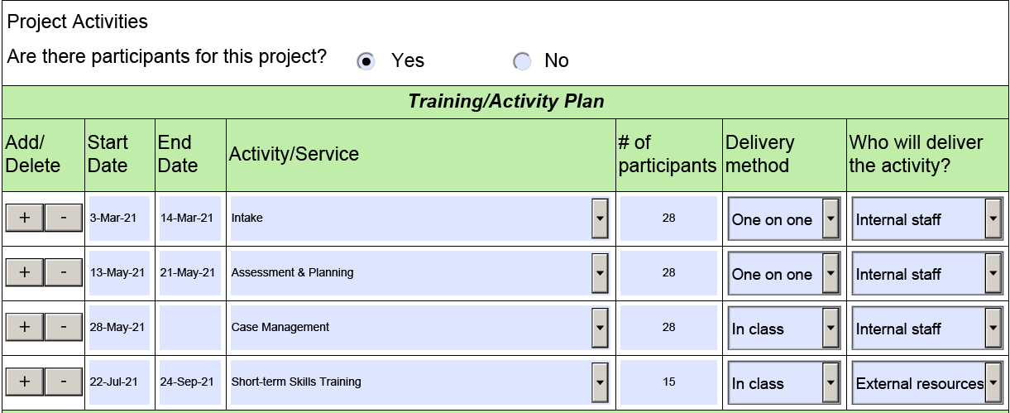
Additionally, a project with “participants” will generate a new Section (3A), with the following options:
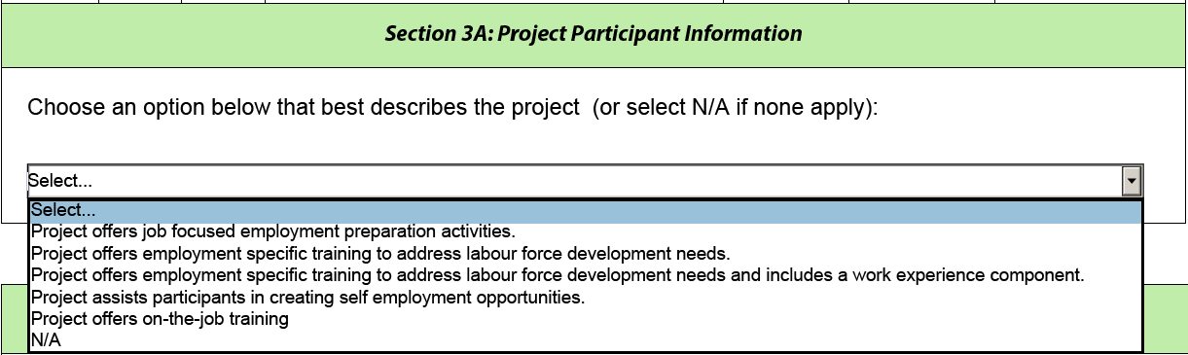
NOTE: First Jobs Fund project will choose one of the following options:
- Project offers job focused employment preparation activities
- Project offers employment specific training to address labour force development needs and includes a work experience component.

See Appendix B – F for full explanations and definitions for Project Participant Information

For projects with NO Participants complete the Activity Plan
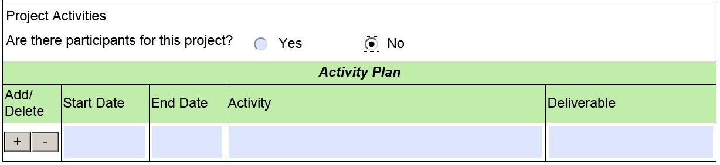
Not applicable to FIRST JOBS FUND projects

Section 3B: Project Evaluation

Project Evaluation | - What are the outcomes and results that will occur from the project? Examples could include:  - How many clients does the organization expect to successfully complete the program?  - How many clients will continue to further education and/or training?  - How many clients will drop out due to life circumstances?  - How will the organization collect client information?  - Telephone interviews; one-on-one sessions; survey  - Outline how the organization will determine if the project is successful  - What benefits are expected from the project?  - Outline how the organization will report these outcomes, how often and when the organization will submit the final report  - See Appendix I for reporting requirements

Section 4. Project Budget

NOTE: The project budget is completed using an Excel spreadsheet. This is a separate document from the application form and must be submitted with the application.
- Indicate if your organization is presently receiving money from WTE and indicate the reason why. If Yes, please complete the Service Provider Project Asset List
- Indicate if your organization has applied for funding from any other source for this project. This information is used to avoid duplication of funding for the same project.
- Indicate if there are any other organizations involved with the project and resources they will provide in-kind (free of charge).The in-kind amount can be included in the Source of Funding table
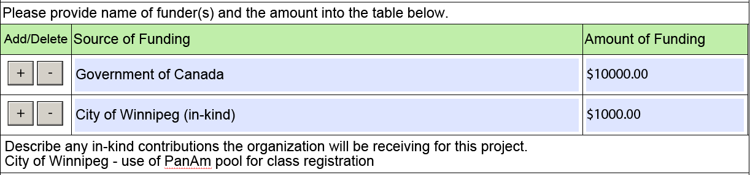
- Indicate how this project will be financially monitored and what checks and balances are in place to ensure that the project stays on budget.
Important to note:
- Workforce Training and Employment reimburses on actual expenditures only.
- Funding must not be used to offset reductions in funding received from other sources or to subsidize other operations or programs delivered by the organization.
- Project activities must not commence until an agreement is signed. Any costs incurred prior to both parties signing the agreement will not be reimbursed.
See Appendix G for a list of eligible and ineligible expenses.
Appendix A

Activity/Service Definitions

- Intake | Review of the service offerings by the organization  Each participant will be required to complete an intake form
- Assessment and Planning | Determination of which services clients should receive based on a range of factors (assessment results, client interests/goals) through a collaborative development of an individualized career development plan.
- Case Management | This service should remain open for the entire duration of the client’s intervention.  Individualized case management and counselling supports provided to a client as they progress in their action/service plan to achieve their employment goals.  - On-going career development  - Supporting development of a career plan (includes goal setting, planning and motivation)  - Working with the client to navigate services  - Providing on-going supports and referrals  - Monitoring progress and providing case coordination with other staff and services  - Exploring, identification and clarifying values, interests, education, experience, strengths and abilities in relation to career and employment goals  - Exploration of career paths, jobs, sector work environment, culture, occupational and training requirements related to career and employment goals, including trades and apprenticeship  - Support, mentoring (mentor) and coaching (coach) during the job search process  - Frequent monitoring and follow-up  - Referral to other community resources and supports  - Assisting the client in the implementation of the agreed upon activities through co-ordination of services in support of the career goal  - Assisting the client in identifying suitable employment opportunities and establishing necessary employer contacts  - Closure - to determine the appropriate timing for case closure and to refer to other more appropriate services, if required
- Job Search Assistance | Client or workshop-based support to help client clarify their employment goals and expectations, assess their skills and interests, prepare resumes and build interview skills so they can conduct a successful job search. These include:  - Cover Letter  - Interview Skills  - Labour Market Information and Assistance  - Resume Writing
- Job Development Matching & Placement | WAGE SUBSIDY COMPONENT - Assists clients who are facing labour market access barriers to find and connect with appropriate employment opportunities that are reflective of their skills and strengths as well as employer needs. The purpose is to help clients connect with a permanent job opportunity by providing the employer with employer Incentives
- Short Term Skills Training  NOTE: includes TRC activities | Courses, or seminars offered by professional institutes to help clients change careers. This could include the following:  - Computer software or project management short course  - First Aid, CPR, WHIMIS etc. that provide a certificate upon completion  - Life skills training such as time management, critical thinking, self-assessment, etc.  - Truth and Reconciliation Commission Calls to Action activities including workshops to raise the awareness of the history and creation of the residential school system, its ongoing legacy, and how it has shaped the country we live in today, as well as offering culturally relevant programming and supports to Indigenous youth through the FJF.
- Foundation Skills/High School | Training in adult education courses or programs to prepare and/or qualify for further higher education (i.e. upgrading high school credits) an/or leading to a Grade 12 diploma. Selected when a client is taking secondary school courses/credits to meet requirements for a post secondary program to meet requirement for a high school diploma.
- Foundation Skills/Literacy Training | Training to improve literacy skills for purpose of accessing education and training, improving employment potential, and/or addressing personal literacy needs.
- Foundation Skills/Language | Training to improve English or French language training
- Foundation Skills/Prior Learning and Essential Skills | The assessment and training in essential skills. Essential Skills include reading, writing, digital technology, document use, oral communications, thinking skills, numeracy, working with others, continuous learning
- Long Term Skills Training | Higher education and training courses or programs that lead to post secondary credential. Includes formal learning only.
- Employability Skills Workshops | Employability skills workshops are intensive sessions designed to assist clients to better prepare for the world of work. Typically, a client will attend a series of workshops dependent on their individual need. There are 4 unique categories available:  - Essential Skills  - Pre-employment preparation  - Career Decision Making  - Life Skills
- Retention and Advancement Supports | Follow-up/wrap around supports for up to six months to assist a client once they have become employed for longer-term attachment to the labour market or advancement in the labour market. Provide support to clients in a Job Matching & Placement service where additional supports may be needed to ensure success or provide to clients who have secured employment independently but are at risk of not being able to maintain the job without additional supports. Activities may include:  - Monitoring and follow up  - Referral to other community resources and supports  - Arranging on-site job accommodations to support clients  - Assisting the client to resolve workplace issues  - Working with employers to identify and address employee performance issues
- Customized Employment and Coaching | Designed for clients with complex needs, the service is customized to the needs of the client, and designed to address immediate barriers in the client's path to employment. The project will support the relationship between a client and an employer to ensure the needs of both are met. This program allows time for a client to participate in the workforce temporarily, to assess their ability to do the job in a more formal way. Extra time is allowed for the client to learn the job, typically with a job coach on site. This placement can be paid or unpaid. Activities may include:  - Job Coaching on the job to assist employers in training clients in new employment or volunteer positions  - Work with employers to negotiate unique employment opportunities  - Identify, initiate, or create new jobs, crafting existing jobs by re-arranging work tasks or creating self employment opportunities  - Creating or modifying a job to fit a client’s capabilities and the needs of the employer, supporting clients and employers to prepare for the employment start date and regular monitoring of progress.  - Market and support clients and build a business case to employers for the creation of an employment opportunities that aligns with the clients’ skills and strengths.  - Guidance on employer expectation, workplace standards and orientation to the workplace.  - Identification of additional training opportunities or requirements  - Regular on-site visits to identify and address issues and challenges and regular coaching on workplace interactions and performance.  - Work with employers in assisting with the identification and coordination of on-the-job training for the client.  - Assist in evaluating and monitoring the clients’ job performance and progress.
- Self Employment | The Self Employment (SE) programs assist unemployed Manitobans to create a self-employment opportunities through the provision of business advice, planning, coaching and financial support. The ultimate goal of the SE program is for clients to achieve economic self-sufficiency by developing, launching and operating their own business.  Not available for FIRST JOBS FUND projects  Offered by Self-Employment Projects only

Appendix B

Project offers job focused employment preparation activities

Number of new participants | - The expected number of clients to be served
Number of carryover participants  FIRST JOBS FUND projects cannot have carry-over clients | - The number of expected carryover clients  - A carryover client is an individual who continues receiving service as of the end date of the service provider agreement and into a new agreement with WTE
Total number of participants to be served | - Total of new participants
Describe the recruitment process | - How will the organization recruit participants into the project? Examples could include:  - Newspaper ads, ads on social media, community outreach, community organizations etc
Describe project staff expertise | - What knowledge/skills will the project staff bring? What past experiences(s) do they have in this area? Do they have education that is relevant to the project?
Describe sub contracted staff expertise  (if applicable) | - What knowledge/skills does the contracted staff bring to the project? What past experiences(s) do they have in this area? Do they have education that is relevant to the project?
Describe the project site | - Give a brief description of the project site, the area it is located, is it on a bus route, disability access, access to computers, hours of operation etc

Appendix C

Project offers employment specific training to address labor force development needs

NOTE: For these projects, client eligibility must be determined by WTE Services

Total number of participants expected to start the program | - The number of participants that the organization expects to have participating in the project
Total number of participants expected to complete the program | - The number of participants expected to complete the program
Number of participants expected to secure employment within 90 days of completing the program | - The number of participants expected to secure employment because of the training offered  - Projects are evaluated on the number of clients employed within 90 days of project completion
Describe the recruitment process | - How will the organization recruit participants into the project? Examples could include:  - Newspaper ads, ads on social media, community outreach, community organizations etc  Not applicable to FIRST JOBS FUND projects
Describe the selection process | - How will the organization determine whether or not a candidate will be a good fit with the program?  - Interviews?  - Will there be any testing?  - Will past experience in this field be taken into consideration?
Describe project staff expertise | - What knowledge/skills will the project staff bring? What past experiences(s) do they have in this area? Do they have education that is relevant to the project?
Describe sub contracted staff expertise (if applicable) | - What knowledge/skills does the contracted staff bring to the project? What past experiences(s) do they have in this area? Do they have education that is relevant to the project?
What organizations/companies have stated that they will hire the participants at the end of the training? | - Indicate which organizations/companies have expressed an interest in this training and would be willing to hire a participant afterwards  - Projects must show that there is a labour market demand in order for this training to take place
Describe the project site | - Give a brief description of the project site, the area it is located, is it on a bus route, disability accessible, access to computers, hours of operation, etc.

Appendix D

Project offers employment specific training to address labor force development needs and includes a work experience component

NOTE: For these projects, client eligibility must be determined by WTE Services

Number of participants expected to start the program | - The number of participants that the organization expects to participate in the project.
Total number of participants expected to complete the program | - The number of participants expected to complete the program
Number of participants expected to secure employment within 90 days of completing the program | - The number of participants expected to secure employment because of the training offered  - Projects are evaluated on the number of clients employed within 90 days of project completion
Describe the recruitment process | - How will the organization recruit participants into the project? Examples could include:  - Newspaper ads, ads on social media, community outreach, community organizations etc
Describe the selection process | - How will the organization determine whether or not a candidate will be a good fit with the program?  - Interviews?  - Will there be any testing?  - Will past experience in this field be taken into consideration?
Describe project staff expertise | - What knowledge/skills will the project staff bring? What past experiences(s) do they have in this area? Do they have education that is relevant to the project?
Describe sub contracted staff expertise (if applicable) | - What knowledge/skills does the contracted staff bring to the project? What past experiences(s) do they have in this area? Do they have education that is relevant to the project?
What organizations/companies have stated that they will hire the participants at the end of the training | - Indicate which organizations/companies have expressed an interest in this training and would be willing to hire a participant afterwards  - Projects must show that there is a labour market demand in order for this training to take place
Describe the project site | - Give a brief description of the project site, the area it is located, is it on a bus route, disability accessible, access to computers, hours of operation etc
Work Experience | - Enter the work experience start and end dates  - Enter how many hours per day the participants will spend at the work experience
List the companies hosting the work placements or describe how companies will be recruited | - What companies/organizations have indicated that they would be willing to host a work experience?
Describe how the work experience will be supervised by the project staff | - Over the phone, on site monitoring
Describe how the work experience will be evaluated | - Show up every day, attitude, form for host organizations to complete etc.

Appendix E

Project assists participants in creating self-employment opportunities

NOTE: For these projects, client eligibility must be determined by WTE Services

Total number of participants expected to start the program | - The number of participants that the organization expects to have participating in the project
Total number of participants expected to complete the program | - The number of participants expected to complete the program
Number of participants expected to be operating a viable business one year after completing the program | - Indicate the number of participants expected to secure employment because of the training offered  - Self-employment projects are evaluated on the number of clients employed within 90 days of project completion.  Not applicable to FIRST JOBS FUND projects
Describe the recruitment process | - How will the organization recruit participants into the project? Examples could include:  - Newspaper ads, ads on social media, community outreach, community organizations etc
Describe the selection process | - How will the organization determine whether or not a candidate will be a good fit with the program?  - Interviews?  - Will there be any testing?  - Will past experience in this field be taken into consideration?
How will a participant’s business idea be evaluated? | - Describe the methods/criteria/tools that will be used to assess the viability of a participant’s business idea
Describe project staff expertise | - What knowledge/skills will the project staff bring? What past experiences(s) do they have in this area? Do they have education that is relevant to the project?
What organizations/companies have stated that they will hire the participants at the end of the training? | - Indicate which organizations/companies have expressed an interest in this training and would be willing to hire a participant afterwards  - Projects must show that there is a labour market demand in order for this training to take place
Describe the project site | - Give a brief description of the project site, the area it is located, is it on a bus route, disability accessible, access to computers, hours of operation, etc.

Appendix F

Project offers on-the-job training

NOTE: For these projects:
- client eligibility must be determined by WTE Services
- Your organization may be required to provide job descriptions

Total Number of positions to be filled | - Enter the number of participants that the organization expects to have participating in the project
Choose either Yes or No for the next questions
- Is a driver’s license required
- Is this a new position for the organization
Position Title | - Name of the position(s)
List the job duties | - Indicate what the participant(s) will be expected to
List any tools/uniforms/protective clothing required for the position | - List any of the above that are needed and whether the organization will supply or if the client is to supply their own.
Hours/week | - Enter the number of hours the participant will be expected to work each week.  - To qualify for wage subsidy the position must be a minimum of 30 hours/week.
Salary | - Indicate the yearly amount or the amount per hour
Supervisors Name and Phone Number | - Enter the name of the person who will be supervising the participant and their direct phone number or cell phone number.

Appendix G

Eligible and ineligible expenses

ELIGIBLE EXPENSES (not a complete list)

Staff | - Salaries  - MERC’s (Mandatory Employer Related Costs)  - Insurance (Workers Compensation and/or Third Party Liability)
Operating/Overhead | - Board Insurance  - Rent  - Telephone and Internet  - Photocopying  - Office Supplies  - Travel
Client Assistance | - Criminal Record checks
Participant Costs | - Participant Wages
Persons with Disabilities | - Training Costs  - Personal Supports
Training Costs Subcontracted

INELIGIBLE EXPENSES | - Employee Benefits including  - Company pension plans  - Dental/medical plans  - Life insurance  - Parking  - Graduation ceremony costs  - Administration Fees – with the exception of universities and colleges  - GST on Service Provider Services

Appendix H

Required documentation

Organizations that have been approved, will be asked to show WTE the following documents (if applicable) at the first activity monitor:

- Conflict of Interest policy
- Nepotism policy
- Confidentiality of Participant Information Policy
- Electronic Media Disposal Policy
- Participant Policies
- Personnel policies for absenteeism, suspension, termination, statutory holidays
- Project staff resumes
- Project staff position descriptions
- Organization’s Personnel Policies
- Letter/Memo from Board stating organizations wish to submit this application
- Articles (ex Articles of Incorporation)
- Board Bylaws
- List of Board of Directors and Executive
- List of Board Delegated Signing Officers
- Current Annual Report
- Proof of Workers Compensation or Third Party Insurance
- Proof of Commercial General Liability
- Board Liability
- Written Union concurrence

Appendix I

Reporting requirements

Manitoba is required to report on the results of any project to which it provides funding. Reporting on results provides information on what worked, what didn’t work and needs to be changed. This can allow a program to evolve and change to meet client needs on a proactive basis. These reports are a requirement of receiving support through the province and consist of both narrative and financial reporting. The following can be expected:

Progress Reports  Completed through Service Provider Reporting Solution (SPRS) and/or narrative – or a combination of both | Progress reports allow project staff to identify if the project is on track to meet the following (but not limited to):  - Target number of participants  - Achievement of expected outcomes – are clients meeting expected outcomes?  - Delivery of activities – will activities take place within the expected timeframe of the contract? Are there new activities that have been identified?  - Are there project changes that need to occur  - Project expenditures  Projects reporting through SPRS will have predetermined headings which organizations will report against. These headings are set up by government staff and reflect the contractual agreement  Organizations work with their WTE staff member to determine the frequency of the reports
Final Report  Completed through Service Provider Reporting Solution (SPRS) and/or narrative – or a combination of both | The final report outlines the following:  - The activities that were delivered  - The total number of clients served (the outputs)  - The outcomes of the activities – (example: were the clients successful in completing the program? Did this close the labour market issue being addressed? Were clients successful in obtaining employment?  The final report must be submitted to Manitoba within 90 days of the project completion date.

