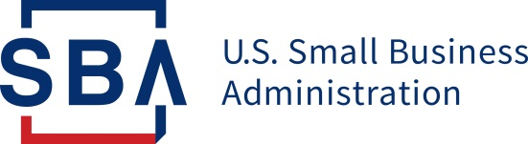
NEWS RELEASE

PRESS OFFICE

Release Date: May 15, 2020 Contact: Press_Office@sba.gov, (202) 205-7036
Release Number: 20-41 Follow us on Twitter, Facebook, Blogs & Instagram

SBA and Treasury Release Paycheck Protection Program

Loan Forgiveness Application

WASHINGTON—Today, the U.S. Small Business Administration, in consultation with the U.S Department of the Treasury, released the Paycheck Protection Program (PPP) Loan Forgiveness Application and detailed instructions for the application.
The form and instructions inform borrowers how to apply for forgiveness of their PPP loans, consistent with the Coronavirus Aid, Relief, and Economic Security Act (CARES Act). SBA will also soon issue regulations and guidance to further assist borrowers as they complete their applications, and to provide lenders with guidance on their responsibilities.
The form and instructions include several measures to reduce compliance burdens and simplify the process for borrowers, including:
- Options for borrowers to calculate payroll costs using an “alternative payroll covered period” that aligns with borrowers’ regular payroll cycles
- Flexibility to include eligible payroll and non-payroll expenses paid or incurred during the eight-week period after receiving their PPP loan
- Step-by-step instructions on how to perform the calculations required by the CARES Act to confirm eligibility for loan forgiveness
- Borrower-friendly implementation of statutory exemptions from loan forgiveness reduction based on rehiring by June 30
- Addition of a new exemption from the loan forgiveness reduction for borrowers who have made a good-faith, written offer to rehire workers that was declined
The PPP was created by the CARES Act to provide forgivable loans to eligible small businesses to keep American workers on the payroll during the COVID-19 pandemic. The documents released today will help small businesses seek forgiveness at the conclusion of the eight-week covered period, which begins with the disbursement of their loans.
Click here to view the application and instructions.

###

About the U.S. Small Business Administration
The U.S. Small Business Administration makes the American dream of business ownership a reality. As the only go-to resource and voice for small businesses backed by the strength of the federal government, the SBA empowers entrepreneurs and small business owners with the resources and support they need to start, grow or expand their businesses, or recover from a declared disaster. It delivers services through an extensive network of SBA field offices and partnerships with public and private organizations. To learn more, visit www.sba.gov.

