Board REport
  - December 2021
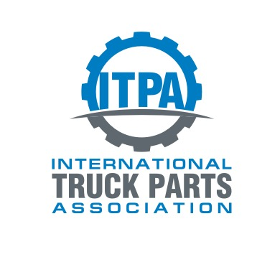
TAble of
Contents
Purpose of report 1
Latest board meeting 2
Operational Update 3
2020 Fall (Phoenix, AZ) 3
2021 Spring (Cincinnati, OH) 3
2022 Spring (Cincinnati, OH) 3
2022 Fall (Phoenix, AZ) 3
Membership Update 4
Current Membership 4
2021 Additions 5
2021 Cancellations 5
Financial Update 6
7
Sponsors 10
Governance 11
ITPA Board of Directors 11

Purpose
of report

The Board and the ITPA office provide transparency to the ITPA members. This report serves as an update to the Board and its members. The report will communicate the current status and projects as well as the association direction.

Latest
board meeting
Fall Board Meeting:
Chairman Rudy Niswanger opened by thanking the board and committees for enduring the pandemic through 2020 and most of 2021. He also expressed how great it was to see everyone again.
Executive Director Scott Tetz, explained the ITPA audit came back with no changes to the processes or procedures. There were a few small adjusting entries which will be amended in 2021. The board approved the audit and adjusting entries.
The board’s strategic planning meeting which is scheduled every 5 years was planned in 2020. The meeting was rescheduled to April 2022, prior to the Spring Meeting. Several operational changes have been suggested by members will be discussed, and equally as important, the association will plan for the next 5 years.
Vice Chair, Ryan Hochmiller, focused on getting the meetings back on track with the upcoming Spring Meeting. The fall meeting was about to get underway and there were no significant health changes due to Covid.

Operational
Update

2020 Fall (Phoenix, AZ)
Cancelled. The venue was postponed until October 6-8, 2022.

2021 Spring (Cincinnati, OH)
Cancelled. The venue was postponed until April 13-15, 2022.
Upcoming Meetings

2022 Spring (Cincinnati, OH)
Space has been reserved at The Netherland Hilton, Cincinnati, OH. Dates: April 13-15, 2022.

2022 Fall (Phoenix, AZ)
Space has been reserved at The Wigwam, Phoenix, AZ. Dates: October 6-8, 2022.

Membership
Update

Current Membership

*2021 as of Fall Meeting

2021 Additions
SRC Holdings
My Little Salesman
Trucktech Parts & Service Inc.

2021 Cancellations
Gear Wizzard – Not in business
Bray Truck and Parts – Isn’t in parts business anymore
Berryhill Auctioneers – Not renewing
Arthur Trovie – Not renewing
TriPower – Not in parts business anymore
Ohio Truck Parts – Not renewing

Financial
Update

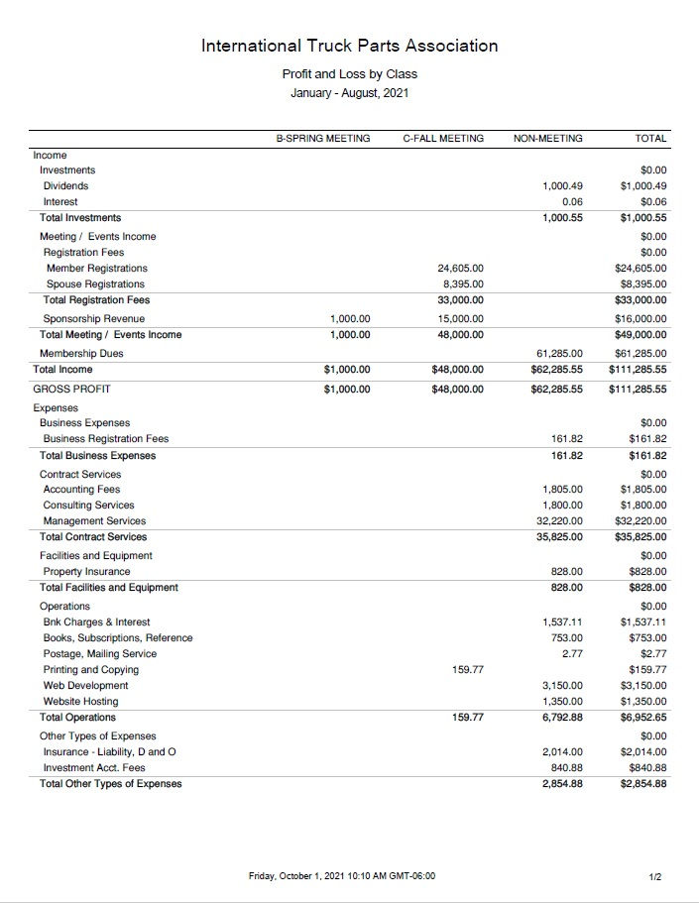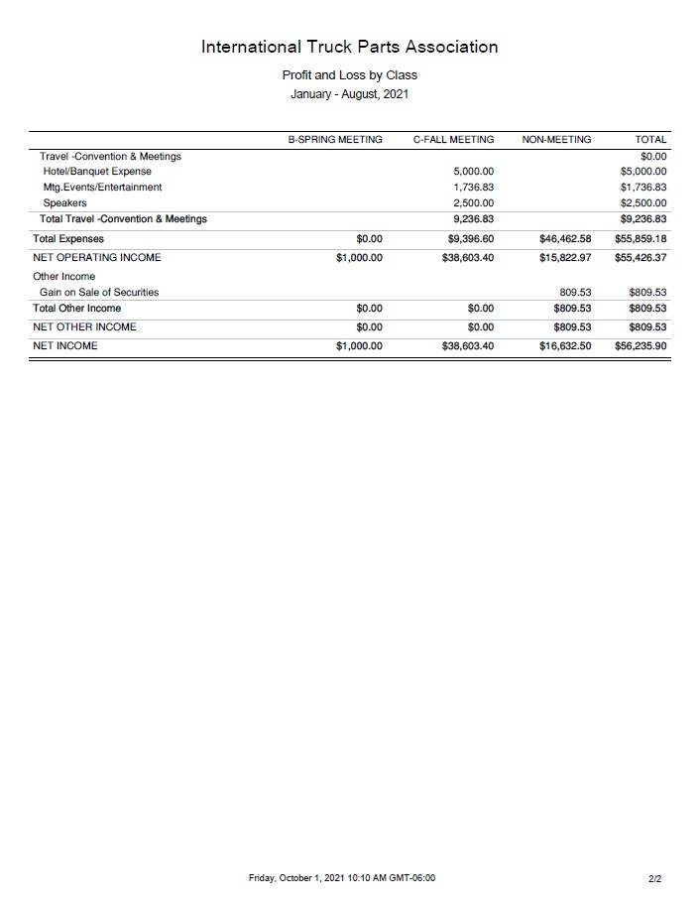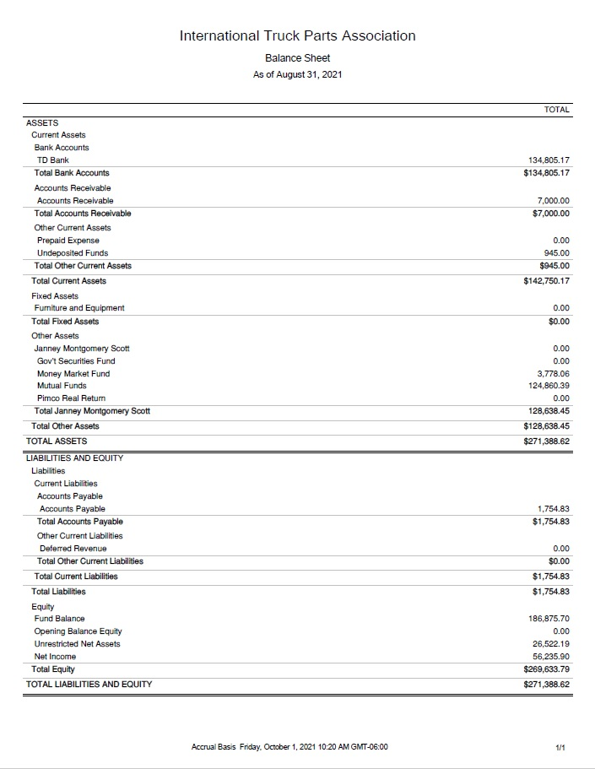

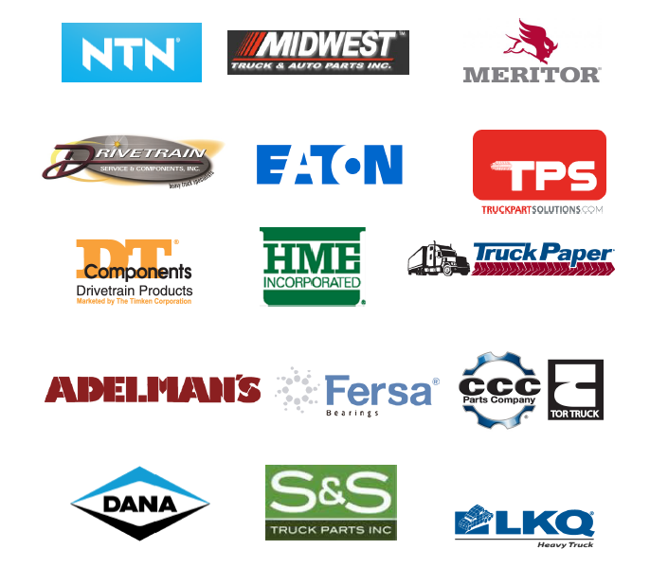
Sponsors

Sponsors are an important part of the ITPA budget. They contribute $1000 per meeting.

Governance

ITPA Board of Directors
Rudy Niswanger Second Term ending Oct 2023
Andy Mundy Second Term ending Oct 2022
Sarah Barber Second Term ending Oct 2023
Ryan Hochmiller First Term ending Oct 2022
Scott Liber First Term ending Oct 2022
Corey George (Filling Mark Harris Term)
First Term ending Oct 2023
Nick Comer First Term ending Oct 2023
CONVENTION COMMITTEE
Ryan Hochmiller - Comm. Chair; Michelle Walls, Andy Reichert, Mike Zakutny, Michael Chudacoff, Paresh Patel, Jordan Stein, Kyle Forster, Tommy deWildt, Jordan Adelman
INVESTMENT COMMITTEE
Ryan Hochmiller - Committee Chair; Matt Schmidt, Scott Liber
MEMBERSHIP COMMITTEE
Ryan Hochmiller - Committee Chair; Martin Mercer-Deadman, Andy Mundy
LEGISLATIVE COMMITTEE
Ryan Hochmiller - Committee Chair

