Board REport
  - November 2019
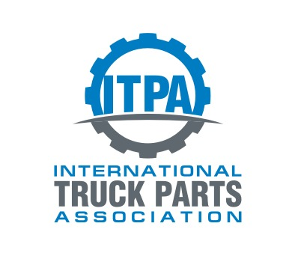
TAble of
Contents
Purpose of report 1
Latest board meeting 2
Operational Update 3
2019 Fall (Miami, FL) 3
2020 Spring 3
2020 Fall 3
2021 Spring 3
Membership Update 4
Current Membership 4
2018 Additions 5
2018 Cancellations 5
Financial Update 6
Sponsors 15
Governance 16
ITPA Board of directors 16
Convention Committee 16
Investment Committee 16
Membership Committee 16
Legislative Committee 16

Purpose
of report

The board and the ITPA office provide transparency to the ITPA members. This report serves as an update to the Board and its members. The report will communicate the current status and projects as well as the association direction.

Latest
board meeting
Fall Board Meeting:
Chairman Shawn Andringa opened discussions on Q&A session before board meetings.
The board is very accessible through phone and email, the board also has a 30 minute open session before the board meeting for all members to discuss issues. After the 30 minute session, all but the board members are excused for the board meeting. The open session with members and board members was standing room only.
At the official Board Meeting, the board discussed:
- the importance of Strategic Planning and the upcoming audit for 2015-2020 in 2021.
- the membership process. It is complex and time consuming for both the potential member and the ITPA. After a lengthy discussion, it was decided to deal with it at the strategic planning meeting in 2020.

Reliable Transmission and Quality Parts were voted into membership.

Operational
Update

2020 Spring (Philadelphia, PA)
Space has been reserved at the Crown Plaza Cherry Hill (Philadelphia), PA. Dates: April 15-17, 2020.

2020 Fall (Phoenix, AZ)
Space has been reserved at The Wigwam, Phoenix, AZ. Dates: October 8-10, 2020.

2021 Spring (Cincinnati, OH)
Space has been reserved at The Netherland Hilton, Cincinnati, OH. Dates: April 14-16, 2021.

2021 Fall (Destin, FL)
Space has been reserved at The Henderson. Dates: October 14-16, 2021.

Membership
Update

Current Membership

*2019 as of Fall Meeting

2019 Additions
Quality Parts Supply
Reliable Transmision

2019 Cancellations
Erickson Trucks N Parts – No response on collection
Kurt’s Truck Parts – No response on collection
Wayne Built & Son - No response on collection
P&S Trucks & Parts – Business is up for sale
Margala & Sons – Cancelled
Heavy Truck Salvage – Removed as under new ownership

Financial
Update

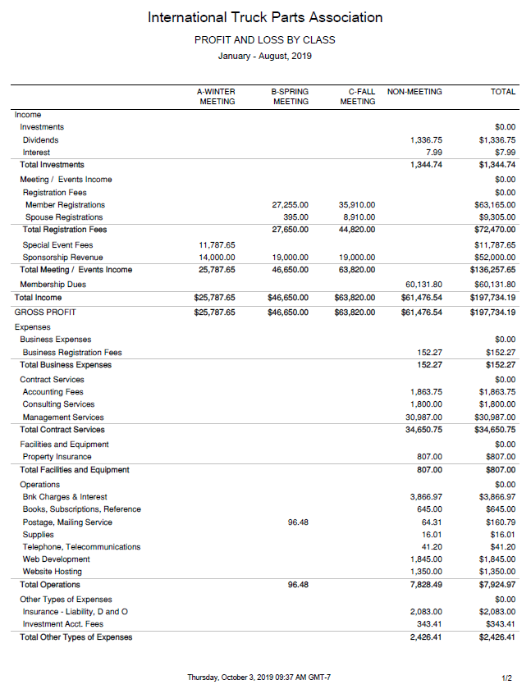
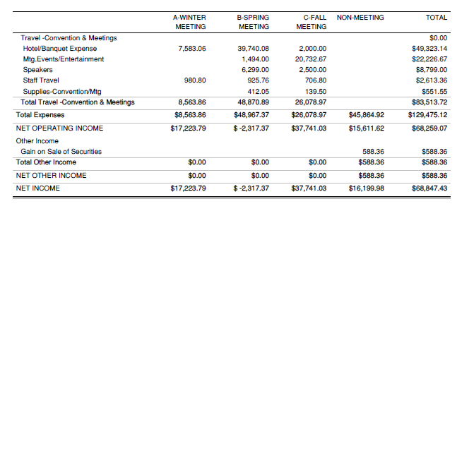

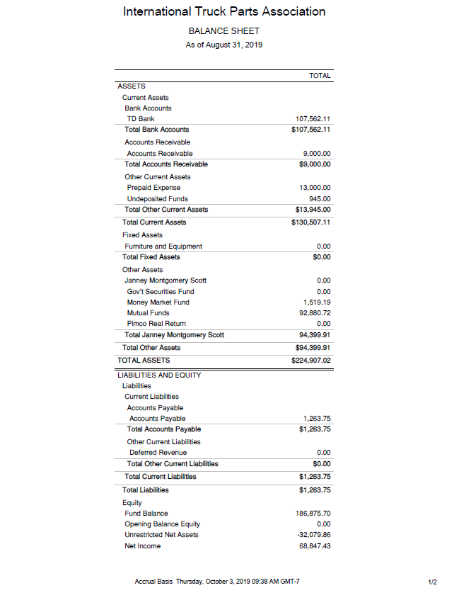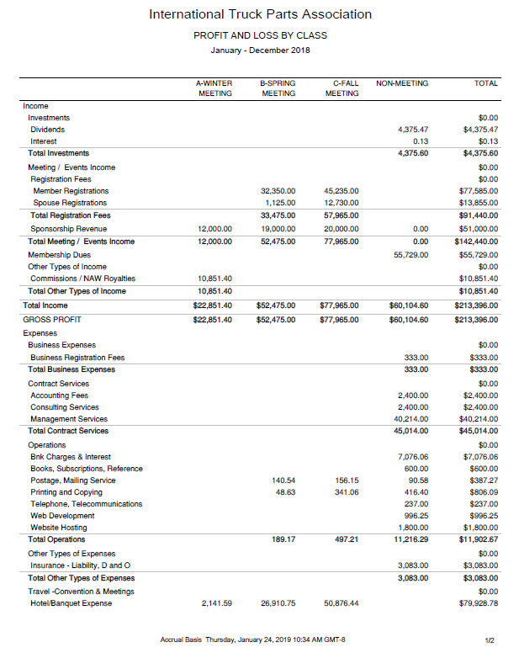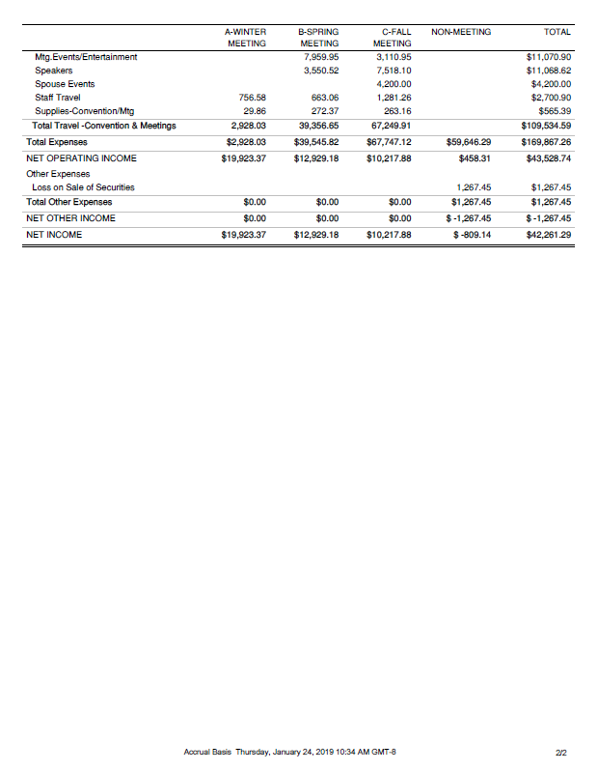 Sponsors
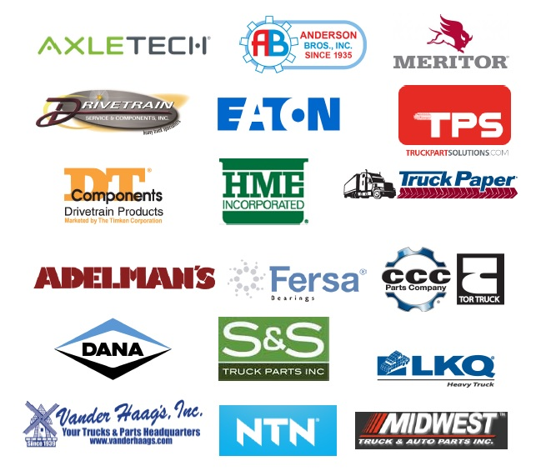

Sponsors are an important part of the ITPA budget. They contribute $1000 per meeting.

Governance

ITPA Board of directors
Rudy Niswanger - Chair Second Term ending Oct 2021
Ryan Hochmiller – Vice Chair First Term ending Oct 2020
Scott Liber First Term ending Oct 2020
Andy Mundy Second Term ending Oct 2020
Sarah Barber Second Term ending Oct 2021
Mark Harris First Term ending Oct 2021
Nick Comer First Term ending Oct 2021

Convention Committee
Ryan Hochmiller - Committee Chair, Michelle Walls, Andy Reichert, Mike Zakutny, Michael Chudacoff, Kyle Forster, Paresh Patel, Jordan Stein, Kevin Payne, and Tommy deWildt.

Investment Committee
Ryan Hochmiller - Committee Chair, Matt Schmidt, Scott Liber

Membership Committee
Ryan Hochmiller - Committee Chair, Andy Mundy, Martin Mercer-Deadman

Legislative Committee
Ryan Hochmiller - Committee Chair

