Board REport
  - May 2019
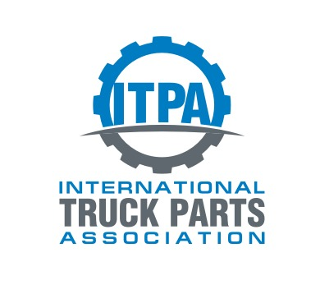
TAble of
Contents
Purpose of report 1
Latest board meeting 2
Operational Update 3
2019 Fall (Miami, FL) 3
2020 Spring 3
2020 Fall 3
2021 Spring 3
Membership Update 4
Current Membership 4
2018 Additions 5
2018 Cancellations 5
Financial Update 6
Sponsors 15
Governance 16
ITPA Board of directors 16
Convention Committee 16
Investment Committee 16
Membership Committee 16
Legislative Committee 16

Purpose
of report

The board and the ITPA office provide transparency to the ITPA members. This report serves as an update to the Board and its members. The report will communicate the current status and projects as well as the association direction.

Latest
board meeting
Spring Board Meeting:
Chairman Shawn Andringa opened discussions on Q&A session before board meetings.
The board is very accessible through phone and email, the board also has a 30 minute open session before the board meeting for all members to discuss issues. After the 30 minute session, all but the board members are excused for the board meeting. The open session with members and board members produced some good suggestions and some suggestions the ITPA was already doing.
The Board discussed the drastic turnaround from 2017 to 2018 revenue and expenditures of the ITPA. (Financials below.) 2019 is on track for similar results. The continued plan of action is:
- We are going to stick to convention expenditure thresholds.
- Dues will be raised from $545 to $595 in 2020. Interestingly, at 2% inflation from 1998, ITPA dues would be at $668.
- Small cost cutting measures have been instituted for hotel expenses.
Membership criteria was discussed at length. The value of potential members is paramount but the board questioned the value of 3 years in business before joining the ITPA. Particularly in the case of prior members. Andringa tasked the board with digging into member criteria to clarify requirements.
Northwest Drivetrain and Red Fox Resources was voted into membership.

Operational
Update

2019 Fall (Miami, FL)
Space has been reserved at The Palms Hotel & Spa. Dates: October 10-12, 2019.

2020 Spring (Philadelphia, PA)
Space has been reserved at the Crown Plaza Cherry Hill (Philadelphia), PA. Dates: April 15-17, 2020.

2020 Fall (Phoenix, AZ)
Space has been reserved at The Wigwam, Phoenix, AZ. Dates: October 8-10, 2020.

2021 Spring (Cincinnati, OH)
Space has been reserved at The Netherland Hilton, Cincinnati, OH. Dates: April 14-16, 2021.

Membership
Update

Current Membership

*2019 as of Spring Meeting

2019 Additions
Northwest Drive Train Inc.
Red Fox Resources

2019 Cancellations
Erickson Trucks N Parts – No response on collection
Kurt’s Truck Parts – No response on collection
Wayne Built & Son - No response on collection
P&S Trucks & Parts – Business is up for sale
Margala & Sons – Cancelled
Heavy Truck Salvage – Removed as under new ownership

Financial
Update

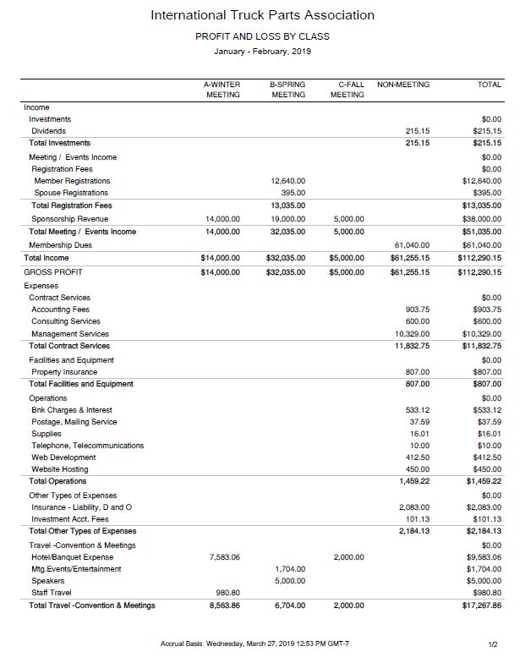

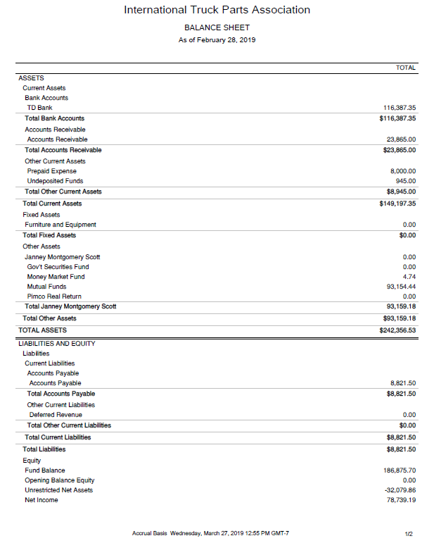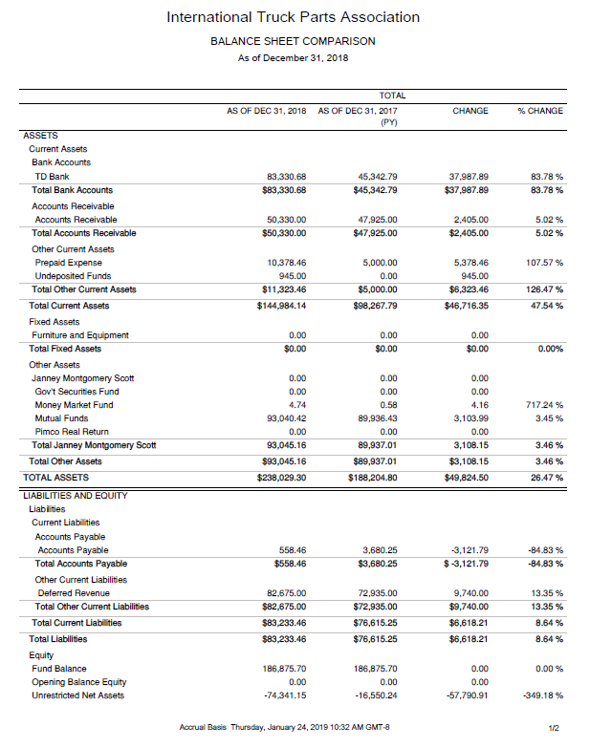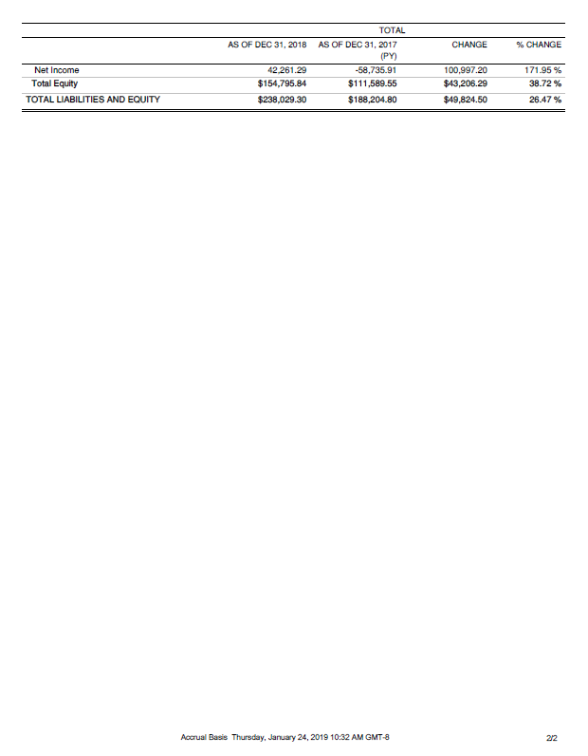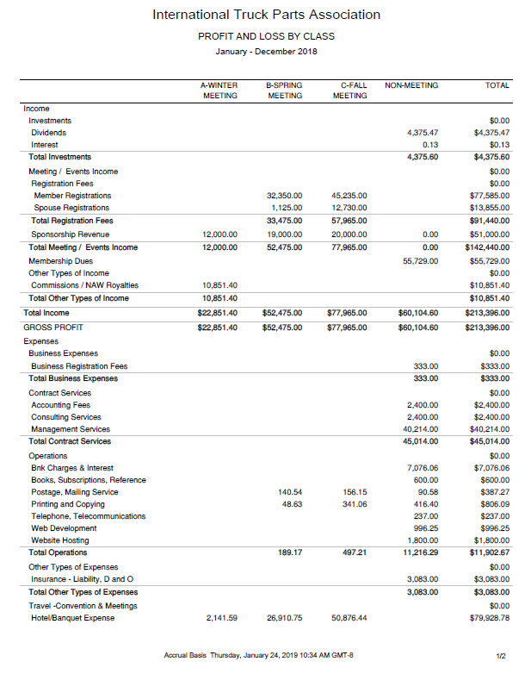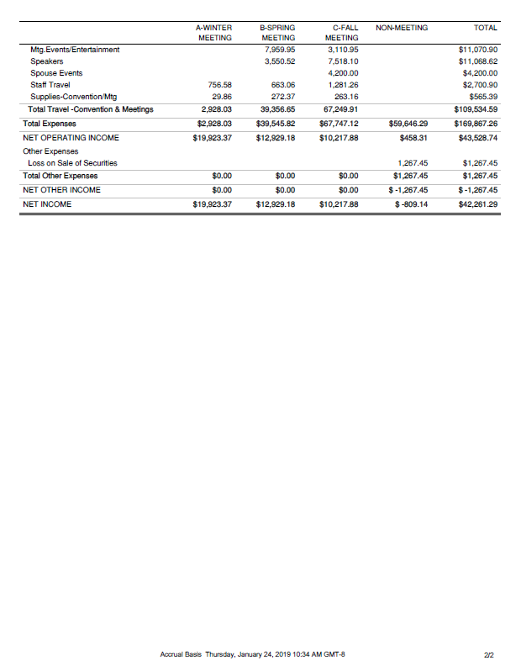 Sponsors
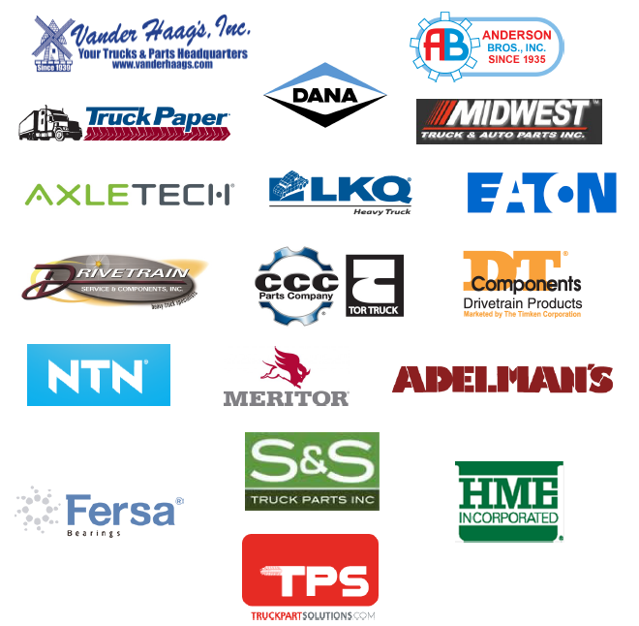

Sponsors are an important part of the ITPA budget. They contribute $1000 per meeting.

Governance

ITPA Board of directors
Shawn Andringa – Chairman Second Term ending Oct 2019
Rudy Niswanger - Vice Chair Second Term ending Oct 2021
Scott Liber First Term ending Oct 2020
Andy Mundy Second Term ending Oct 2020
Sarah Barber Second Term ending Oct 2021
Mark Harris First Term ending Oct 2021
Ryan Hochmiller First Term ending Oct 2020
Nick Comer First Term ending Oct 2021

Convention Committee
Rudy Niswanger - Committee Chair, Michelle Walls, Andy Reichert, Mike Zakutny, Michael Chudacoff, Kyle Forster, and Paresh Patel

Investment Committee
Rudy Niswanger - Committee Chair, Matt Schmidt, Scott Liber

Membership Committee
Rudy Niswanger - Committee Chair, Andy Mundy, Martin Mercer-Deadman

Legislative Committee
Ryan Hochmiller - Committee Chair

