The Diary of a Prodigal Parishioner 5: The Big Clothes Disposal

Sue Young
‘Truly, I say to you, as you did to one of the least of my brothers, you did it to me.’
Matthew 25:40
These words from Jesus continue to hit me hard each time I see a Bangladeshi label on my clothes, and I remember the harrowing sweat shop images of mostly women, slaving for long hours for a pitiful wage, so I can enjoy cheap fast fashion (truecostmovie.com see on Netflix and Prime TV). Last month, whilst writing, I was preoccupied searching for the mouse, which my cat Misty had presented me with, during my clothing audit. This month, with thankfully no repeat presentation, my unwanted clothes are now in bags, destined now for greener pastures.
Most of us are familiar with the idea of our throw away clothes finding a new home in a local charity shop, but how many of us know that only about 20% of these clothes are ultimately sold. The alarming result is a staggering volume of unwanted clothes stockpiled worldwide, but particularly in the western world. My research tells me to create fresh, additional ideas for the reuse of my cast-off, yet good quality garments, other than sending them to toxic landfill sites. Always keeping in mind that reusing a ton of textiles saves twice as much carbon as recycling a ton of plastics.
Did you know that ‘swapping’ or ‘swishing’ parties are now popular? Meeting with others, people of our own age, size and possibly gender, to barter or exchange any unwanted clothing. However, our Mothers Union opting to hold regular ‘Swishing’ events seems a less likely proposition than, for example, their usual fund raising faith teas. Perhaps I should suggest it for a future Mother’s Union event, in support of our green church endeavours? My mischievous nature imagines that it would be more attractive to interchange, not unwanted clothes, but our relatives long since past their sell by date, swapping them with others for less high maintenance ones?
As a more socially acceptable version, I can see that in future borrowing, renting or interchanging all kinds of household and garden items (as well as clothing) could be a way to both save money and reduce our planetary footprint. Multiple use shops to rent/borrow all kinds of domestic and garden implements are now in existence, though sadly I am told that the manpower to perform such DIY tasks is not included in the cost of the rental. That would be a bonus, especially to those of us living alone. As this goes to press I see that the brilliant ‘Zero Waste Leeds’ are advertising several such venues in several parts of Leeds where you can rent/borrow household equipment.
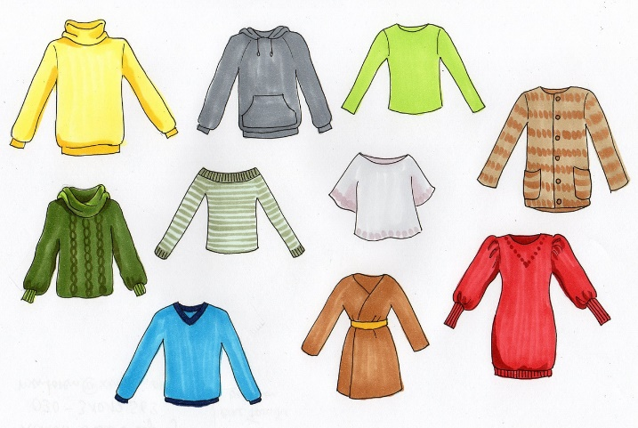
Repairing our well-worn clothes is an obvious way to extend the life of them, especially those items we are particularly fond of. Again, Zero Waste Leeds will help us to find places where we can actually learn to repair/restore clothing, or they will do it for us for a nominal cost. My failed attempt to darn my sock some weeks ago, suggests that repairing will not be my forte, though I see there is a current trend to convert old duvet covers into summer dresses. My bags destined for charity shops contain my grandchildren's discarded duvet covers (Spider-Man and dinosaurs), but I fear these may make less than pretty summer frocks. However, people’s tastes vary and one never knows….
Reuse of old favourite clothes by customising them, could also be a sustainable way forward, but I suspect I am a little past-it to appear in church in a jacket adorned with ribbons, tassels, pom-poms and patches. I could have adopted this look in the 70’s, but I suspect my family would fear my descent into madness should I take up that particular creative baton today. As an add on to this ghastly image, I read that Doc Martins have a significantly strong ethical and environmental policy, should I choose to add sustainable footwear to my bohemian look. Nike and Adidas I understand, have some considerable way to go to ‘get green’.
Bearing in mind the shortfall in charity shop sales, whilst hoping fervently that Misty’s mouse friend is not resident in any of my black bags, I set off to tour the shops in our area. Some places were more pleased to see this hobbling parishioner than others. I expected, rather foolishly, to be greeted with an element of gratitude, but it was a sobering experience to find most are bursting at the seams with our cast-offs. Less than 20% of the clothes from these shops are actually sold and reused by new owners. Millions of tons of the rest make their way across the globe, ending up in squalid dumps, some of which can take over a hundred years to decompose into often previously virgin environments. One island in the beautiful Maldives is used entirely for this appalling purpose.
Having balanced the heavy bags precariously on my inherited rollator (a four wheeled disability aid) I arrived in one shop to find they refused to take the clothes unless I was registered with them for gift aid. I was Informed that my ‘late husband was indeed registered but as he is deceased it no longer applied.’ Leaving feeling rather exasperated with this response, my prodigal nature having been somewhat irritated, I wondered if I should sneak the odd bag of quality clothing into one of these many local textile bins. (Note here to the reader, look up ‘Zero Waste Leeds’ www.zerowasteleeds.org.uk for up to date information and maps to locate these) Thankfully I didn’t succumb to the temptation to let good clothes go for rags, just to save my time and effort, and I found alternative greener homes for them.
Another temptation soon reared its head in an upmarket charity shop in Ilkley, tempting me to break my ongoing fast from buying new clothes. A rather attractive cashmere jumper took my eye.
Instead I did succumb to buying a dinosaur sweatshirt, with a John Lewis label, for grandson Charlie. However, I resisted the temptation to buy for the other eight little ones and myself. Instead, keeping the option of reuse and customisation in mind, I had kept back two white-ish T-shirts from the original clothing purge. The idea being to follow suggestions from my ‘Conscious Closet’ eco bible, to respond a creative urge, and attempt to tie-dye the garments. I was wondering if this ‘new look’ would help update Grandma in her twilight years. I opted to use natural products for this adventure (note, no chemicals for this eco-giant-in-training) settling on an avocado rinse, to apparently produce a blush pink hue. As an adventurous alternative, try using red onions to create a vibrant orange.
However, I must add a warning that the process for me wasn’t entirely successful, but I had enjoyed eating the avocado beforehand and I have planted the remaining stone. The latter was more in the prayerful hope of ultimately producing more avocados to repeat the process, mostly for consumption purposes. The notable aspect of the revamp venture was the discovery, somewhat later, of the promised pink blush shade on Misty cat’s paw, suggesting that she had dipped it into the pot used for the dyeing process. I was relieved that she had not tipped the entire container onto my newly power-washed patio. I know the latter is profligate in the context of the world drinking water shortage, but I intend to hopefully tackle my domestic cleaning footprint in the near future, so watch this space!
(To be continued next month)

