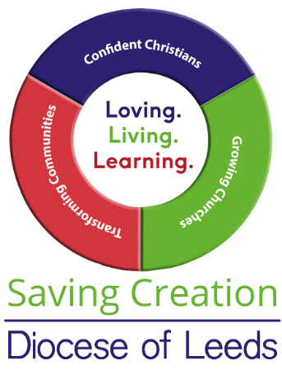
Diocesan Environment Group Advisors
A number of volunteer advisors and staff are available to assist parishes with environmental concerns and particularly to assist with the transition to carbon net zero.
The Area Environment Champions will be able to help you with general enquires. Please contact diocesan staff members directly if you have a specific enquiry.
If you would like advice from one of the other advisors please contact Jemima Parker, Diocesan Environment Officer, in the first instance and she will direct your enquiry to the appropriate advisor. jemima.parker@leeds.angilcan.org 01423 569121

Area Environment Champions (AEC):
Bradford: Ian Fletcher ijf@fgco.com
Huddersfield: Debby Plummer debby.plummer@leeds.anglican.org
Bev Playle bev@holytrinityhuddersfield.com
Leeds: Jan Goodair jan.goodair@leeds.anglican.org
Ripon: N - Jeff Payne jeff.payne@leeds.anglican.org
S - Ros Swaney roslyn.swaney@leeds.anglican.org
W – Vacant
Wakefield: Vacant

Biodiversity Advisor Mike Willison mike.willison@leeds.anglican.org
Carbon Conversations Coordinator Paul Magnall paul.magnall@leeds.anglican.org
Children and Youth Advisor Jo Young jo.young@leeds.anglican.org
Civic Partnerships Advisor Vacant
Climate Resilience Advisor Dave Cherry dave.cherry@leeds.anglican.org
Communications Advisor Jack Bacon jack.bacon@leeds.anglican.org
Community Engagement Advisor Sarah Hinton sarah.hinton@leeds.anglican.org
DAC Link Lisa McIntyre lisa.mcintyre@leeds.anglican.org
Funding Advisor Janet Edmond janet.edmond@leeds.anglican.org
Interfaith Advisor David Midgely david.midgley@leeds.anglican.org
Project Management Advisor Vacant
Technical Advisor Vacant
Theology/ Spirituality Advisor James Allison james.allison@leeds.anglican.org
Training Advisor Ruth Newton ruth.newton@leeds.anglican.org
Travel Advisor Vacant

