St Barnabas’ Speaks Up

Over recent months our attention has been drawn to how we at St Barnabas may help take a lead in playing our part in caring for the environment.

In line with the Diocesan Policy, we are encouraged to live more simply and thoughtfully as we use the earth's resources and consider the needs of others, especially the World's poor.
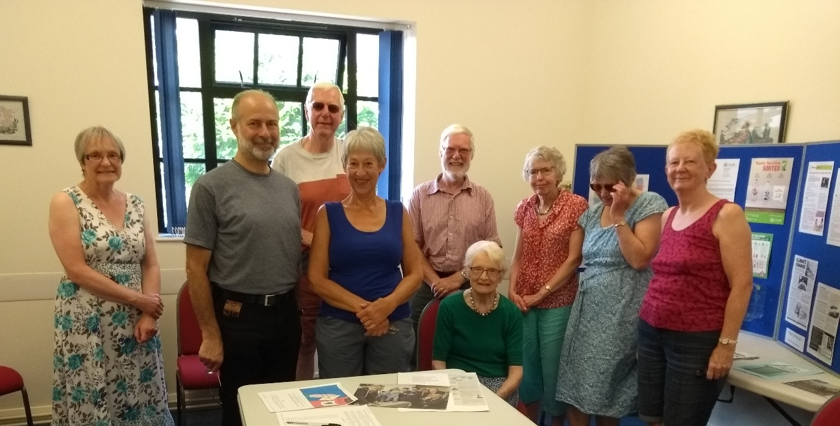
MP Fabian Hamilton with visitors to the Climate Coalition exhibition

On a summer Saturday St Barnabas opened its grounds and Church Centre to the community as part of the Speak Up Climate Coalition campaign. We encouraged as many people as possible, including local MP Fabian Hamilton, to become more aware of the effects of climate change on landscapes across the globe and the need to reduce our own carbon footprints.

The exhibition detailed how our climate has changed over the post-industrial period and especially in recent years. It highlighted the effects of a warming earth on the world's landscapes. Practical ways of being less wasteful of resources used in our daily lives were detailed. New ways of considering how we might alter our life-styles in order to help the less fortunate were suggested.

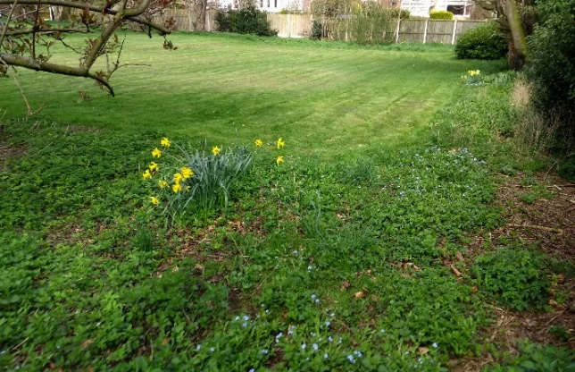
The need and responsibility we each have to God to help protect wild-life, resources, and to support all people around the world was stressed. Small-scale changes to ways we live and what we do in our church and grounds were recorded and people were invited to suggest their own ways of reducing our global footprint and impact on the environment by living more simply.

Caring for our church environment by encouraging natural wild-life and animal habitats through careful management of grounds.

Nigel Craddock, St Barnabas, Alwoodley

