Growing number of Parishes register with the PGS
The Parish Giving Scheme was launched across the Diocese of Leeds in January 2020, just before the Covid 19 struck. Despite the barriers presented by the pandemic lockdown 25% of our parishes have now registered for the PGS and that number is steadily increasing. Parishes report that regular giving through the PGS has brought them increased financial resilience and our PGS statistics for the Diocese also reflect this with 60% of regular givers opting in to an annual inflationary increase in their giving. This generosity is helping our parishes to continue their mission and face the financial challenges presented by the ever rising costs.
The table below shows the latest PGS figures for March 2022 in the Diocese of Leeds
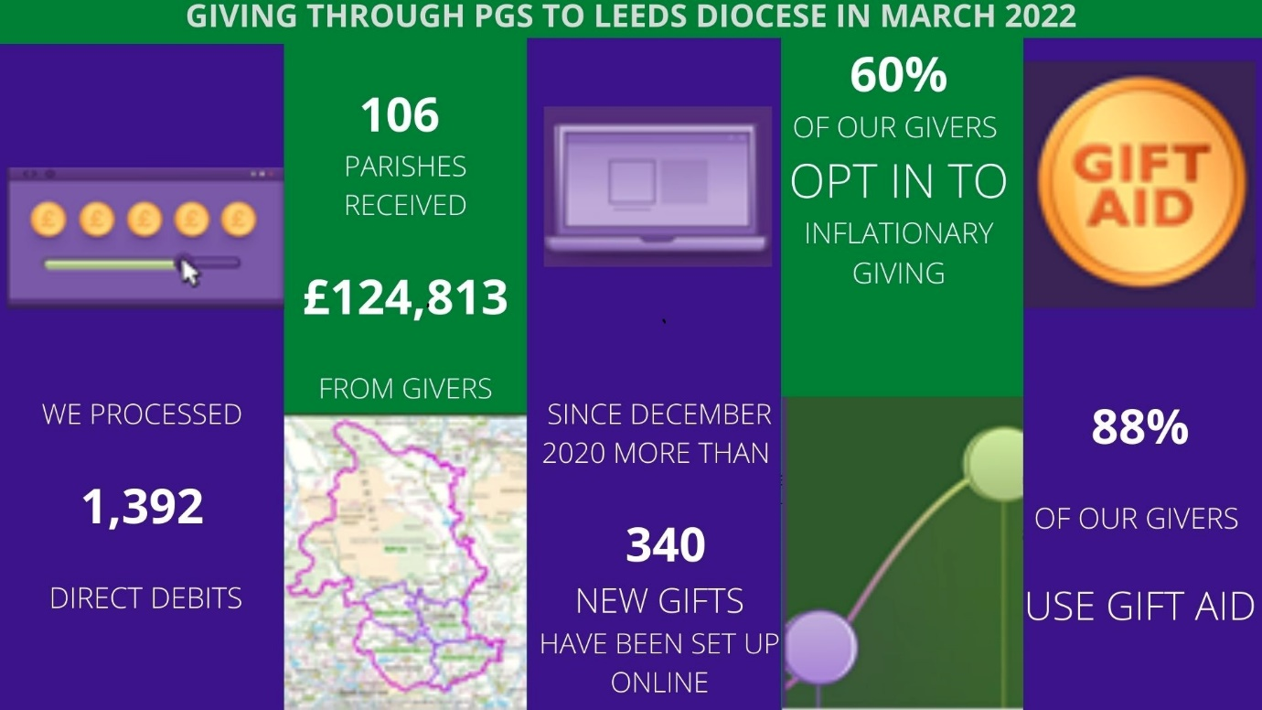
If you would like more information to share with your PCC members on the benefits that the PGS can bring to your parish email Stewardship Officer Janet Edmond at janet.edmond@leeds.anglican.org or telephone: 07376 525684 to request a pack of “Parish Giving Scheme Explained” leaflets to be posted to you.

