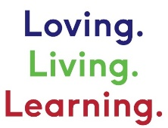
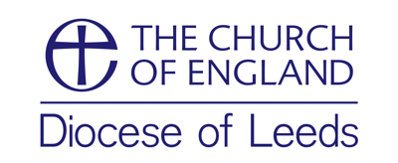

Study Courses on Christian Care for Creation

There are a variety of bible study resources available on the theme of caring for creation, protecting the environment and a biblical response to climate change. Some have a practical emphasis giving plenty of opportunities for your group to respond to the Word, while others focus more on the theology of our stewardship of creation or Christ’s renewal of all the earth. You will need to discern which would be most appropriate for your group(s). While each is written with groups in mind, they could also be used for personal study. Listed alphabetically below.

Consumer Detox
Seven weeks to detox from consumerism. This course from St George’s Leeds is based on the ideas explored in the book Consumer Detox by Mark Powley.
7 group sessions. 2012

Creation Matters
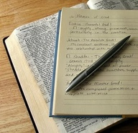
These seven sessions focus on how we can better care for God's creation. They are a mix of bible studies and practical reflections on our lifestyle, so may be a little different from the small group sessions we normally do. 2018

Let there be… stuff?
A spirit-filled response to a consumer-crazed world. A faith-based program for Christian teens from A Rocha UK.
6 group sessions for teenagers. 2016

Mission and Creation Care for Christian Disciples: John Ray Institute (scroll down the page)
5 Group Studies The focused on mobilising congregations and churches in living out the mission of God and to see individual lives, communities, and the environment flourish. A core feature of this is to challenge congregations and communities in the UK to change their values from individual consumerism to justice and sustainability both locally and globally.

Plenty!
A six session small group discussion resource for churches on the economic drivers of the current ecological crises has been produced by Green Christian’s Joy in Enough programme.

Saying Yes to Life
Six session study course based on the Archbishop of Canterbury’s 2020 Lent Book written by Ruth Valerio. Using the six days of creation as a theme the book and discussion questions explore God’s relationship with creation, our place in the natural world and our Christian response. Each session has an accompanying video to stimulate discussion. Book details, accompanying notes, youth resources and course videos here.

Tenants of the King: Operation Noah study course
Tenants of the King is a Bible-based, Jesus-centred resource from Operation Noah. Four-part study series. Through interactive group sessions, video interviews with leading Christian thinkers and insightful Bible commentary, this resource will help you and your church to reflect on the challenges of a changing climate, and how Christians can respond with hope to one of today’s greatest challenges.

