Giving Nature A Home
For those of us privileged to live in this glorious area, we only need to open our eyes to see nature all around us – mountains, fields, woods, rivers, marshes, lakes and, not far away, the coast, cliffs and the sea - and all of it filled with countless treasures.
There is however one other place that is literally on our doorstep – our gardens and they are our very own nature reserves. One of the objectives of Caring for Creation is to encourage those who have gardens to make them wildlife friendly. It doesn’t mean we want them to be totally overgrown but just to have wildlife in mind. There are many ways to do this.
To set the scene let me give you two illustrations of how gardening with wildlife in mind can make a real difference to wildlife and to us. In the 1970s and early 1980s the numbers of Goldfinches in Britain declined substantially, largely due to dwindling natural food supplies. But, since the mid-1990s, a wider range of bird food has become available and two of them, sunflower hearts and nyjer seed, have attracted the Goldfinches into many gardens and, as a result, their numbers have grown substantially. It is indeed ‘a charm’ to have these beautiful little birds around us.
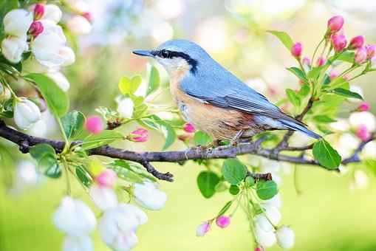
Feeding the birds is as good for us as it is for the birds. Recent research by Exeter University and the British Trust for Ornithology found that people living in neighbourhoods with more birds, shrubs and trees are less likely to suffer from depression, anxiety and stress. In the study, common types of birds including blackbirds, robins, blue tits and crows were seen, but the main benefit for mental health and well-being came from people simply interacting with birds, making them feel more relaxed and being more connected with nature.
Jesus said the same thing: “Look at the birds of the air; they do not sow or reap or store away in barns, and yet your heavenly Father feeds them. Are you not much more valuable than they? Who of you by worrying can add a single hour to his life?” (Matt.5.26-27).
Go on, look at the birds of the air, be a birdwatcher and relax!

David Mann, Treasurer and Membership Secretary, RSPB Lancaster Local Group.

