The Carbon Conversation Course: Tools for change
By Lizzie Pell, Course Participant Autumn 2019

I was feeling frustrated and exhausted from climate crisis activism, which was taking huge amounts of my energy and returning very little tangible results. Carbon Conversations gave me something different.
Focussed on reducing each participant’s individual footprint, it led me to look at my own life and choices with a magnifying glass, and iron out conflicts within myself, allowing time to figure out creative solutions both practically and emotionally.
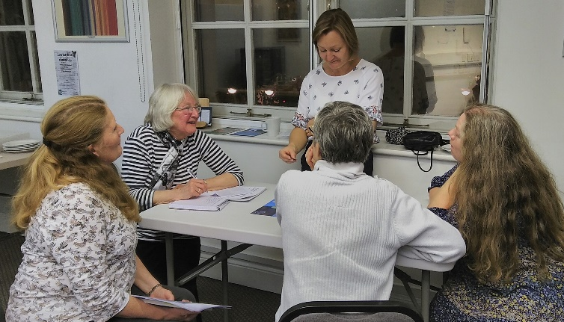
A refreshing approach that connected me to like-minded neighbours of my local city, together we began to delve into the reasons why as a society we struggle to adopt a low carbon lifestyle.
With a mixture of thoughtful discussions, games and activities, we explored 4 areas of high carbon expenditure: the home, travel, diet and purchases and waste. Each chapter in the book is accompanied by a section in the workbook with related exercises and a space to make a plan including goals for the short and long term.
The books are filled to the brim with contextualised facts and figures, making it interesting and comprehensive. It encouragingly evidences the impact that making even small changes can make. The specialised spreadsheet allows you to track your spending in each of the 4 areas and monitor as your carbon footprint reduces.
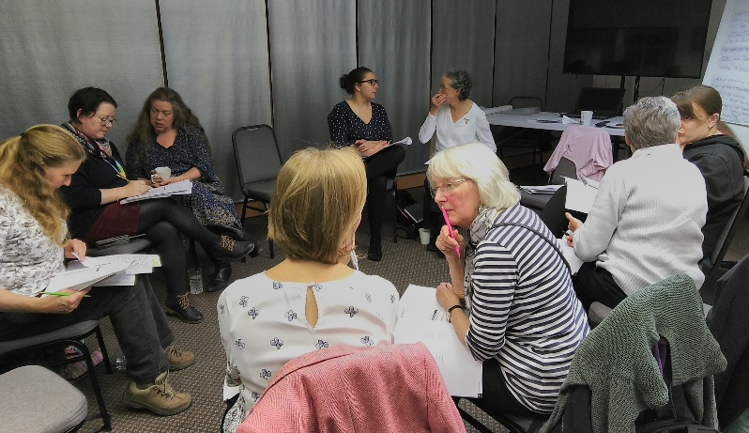
The journey as a society in to a low carbon future is an urgent, yet gradual, process, and therefore needs immediate action on many levels. It requires system change from the top down from governments and corporations, simultaneous with individual and community changes from grass roots up. One will not work without the other and I believe that this course gives a systematic overview of why we need to change and how we can start implementing these changes as individuals. It equips the group with tools to visualise and come to terms with what low carbon life may look like in the future.
I have enjoyed the course and am greatly looking forward to becoming a facilitator and delivering it to a wider community in Leeds. I am hopeful that it will incite positive change for all those that take part.

