Looking back at the long hot summer

By Rev Stephen Treasure, St Oswald's and All Saints, Little Horton, Inner Bradford Deanery

Our long hot summer was lovely looking back, but worrying; is sub-Saharan Africa going to become a desert? If we found it hot, spare a thought for Spain and Portugal with temperatures of 40°C and higher. In Japan at least 80 people died from the excessive heat, and California had the biggest wildfires in its history; even chilly Sweden had 80 of them. In Greece fires drove people into the sea.
Our Diocesan Environment Officer recently came to speak to Deanery Synod, and told us how we are making things worse. She told us that each person in the UK on average creates 15 tons of carbon a year – compared to around 2.5 tons in poorer countries: and one long haul flight (there and back) gives off a massive 3.4 tons for each individual passenger.
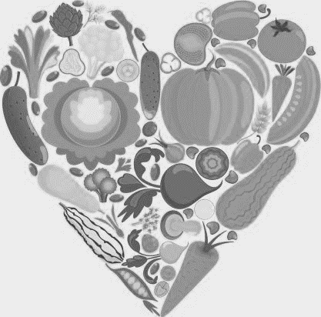
She added another worrying set of statistics about our carbon footprint generated by the food we eat. A kilogram of baked beans generates a moderate 2.3kg of CO2 equivalent in being produced and brought to the shops. For chicken that’s 6kg of C02; pork and cheese 13 kg; beef and lamb a massive 25kg per kg of meat. She advocates Meat-Free Mondays, as one small step we can all take to start to combat climate change.

Recently an international report warned of the need to limit global warming to 1.5°C above pre-industrial levels by 2030. If not, the climate reaches a tipping point when oceans and forests cease to absorb carbon dioxide and instead release it. The effects would be catastrophic. Although we enjoy hot summers, we are less keen on drought or floods such as we have seen in recent years. And to ignore the needs of the global south would be selfish in the extreme.

