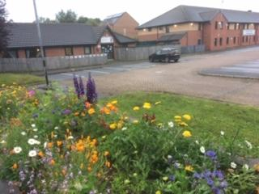
St Luke’s Church Gardening and Environmental Report
Sue Kaye

The project was started in April 2020 following a successful grant application of £3000 from the Inner South Community Committee. Sue Kaye and Jo Brook were then interviewed and recruited to do the work by Councillor Paul Wray, Alaric Hall and John Hardy.

Dewsbury Rd Raised bed after planting

The funding was to be split between 2 wards 50/50 and was to run as a pilot project, with a view to future development. The two wards were Beeston and Holbeck and Hunslet and Riverside.
In Beeston and Holbeck the plan was to plant pictorial meadow flowers, info@pictorialmeadows.co.uk on green sites the Malvern Rd, specifically with local young people in the area, working through contacts with youth leaders. This was in response to the community survey in 2018 which showed that young people felt that the area is dirty and are particularly concerned about their environment. It was hoped that we could teach them skills and attract pollinator insects which are so important to the ecosystem.
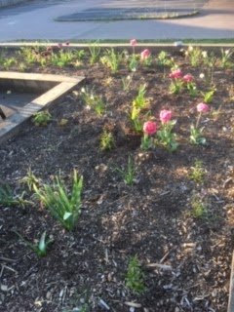
In Holbeck and Riverside the plan was to work with the Community Hub on Dewsbury Rd to help establish their raised beds at the rear of the building and neglected raised bed at the front of the building. Again, it was hoped that we would be able to teach skills to the local community and local school children.

Bulbs, spring 2020

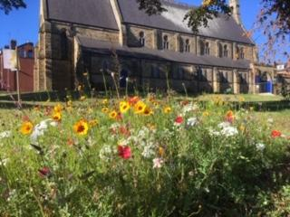
Covid 19 severely impacted the plans, meaning that we were unable to engage with the community as hoped. Dewsbury Rd Hub closed and youth workers were furloughed; schools closed. The council agreed that we could do the work ourselves with a view to working with the public once restrictions were lifted.

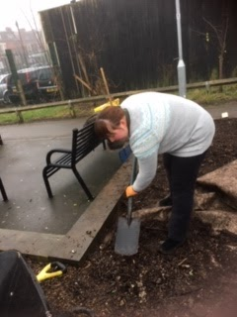
Dewsbury Rd Hub
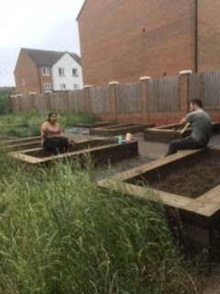

Justyna digging over the Front Hub at Dewsbury Rd with Sue, Steph and Kiro. Work done voluntarily in December 2019. Bulbs planted.

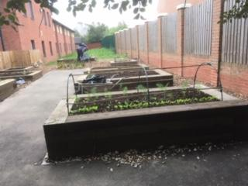
Malvern Rd sites Pictorial Meadow flowers

Pictorial Meadow seedlings coming up
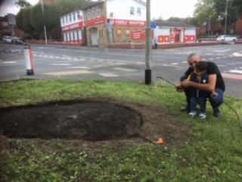
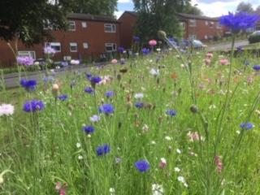
Pictorial Meadow flowers, summer 2020

