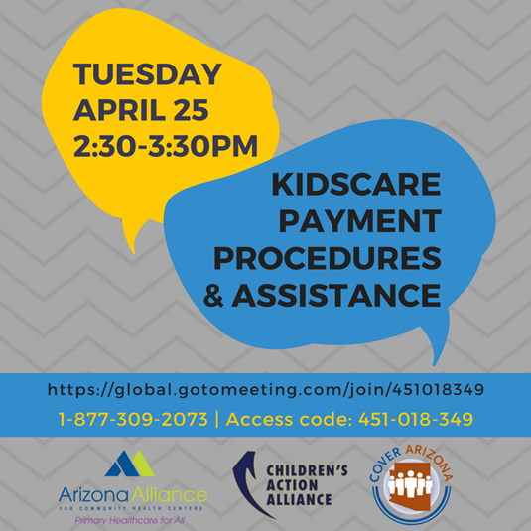

Topic: KidsCare Payment Procedures and Best Practices

Tuesday, Apr 25, 2017 2:30 PM - 3:30 PM MST

It appears that families are losing KidsCare coverage due to lack of payment. Recent meetings and research has uncovered some problems with the invoicing and payment process. This Webinar will focus on how assisters can better assist consumers when they enroll or seek assistance after enrollment. The goal is to reduce unnecessary loss of coverage by making Assisters across Arizona aware of what to look out for and how best to deal with barriers.

No RSVP needed. Only 100 lines will be available so watching in groups will allow more to join. The Webinar will be recorded and the slides will be made available after the presentation so it can be easily shared with those who are not available on the 25th.

Please join my meeting from your computer, tablet or smartphone.
https://global.gotomeeting.com/join/451018349

You can also dial in using your phone.
United States (Toll Free): 1 877 309 2073
United States: +1 (646) 749-3129

Access Code: 451-018-349

First GoToMeeting? Try a test session: http://help.citrix.com/getready

