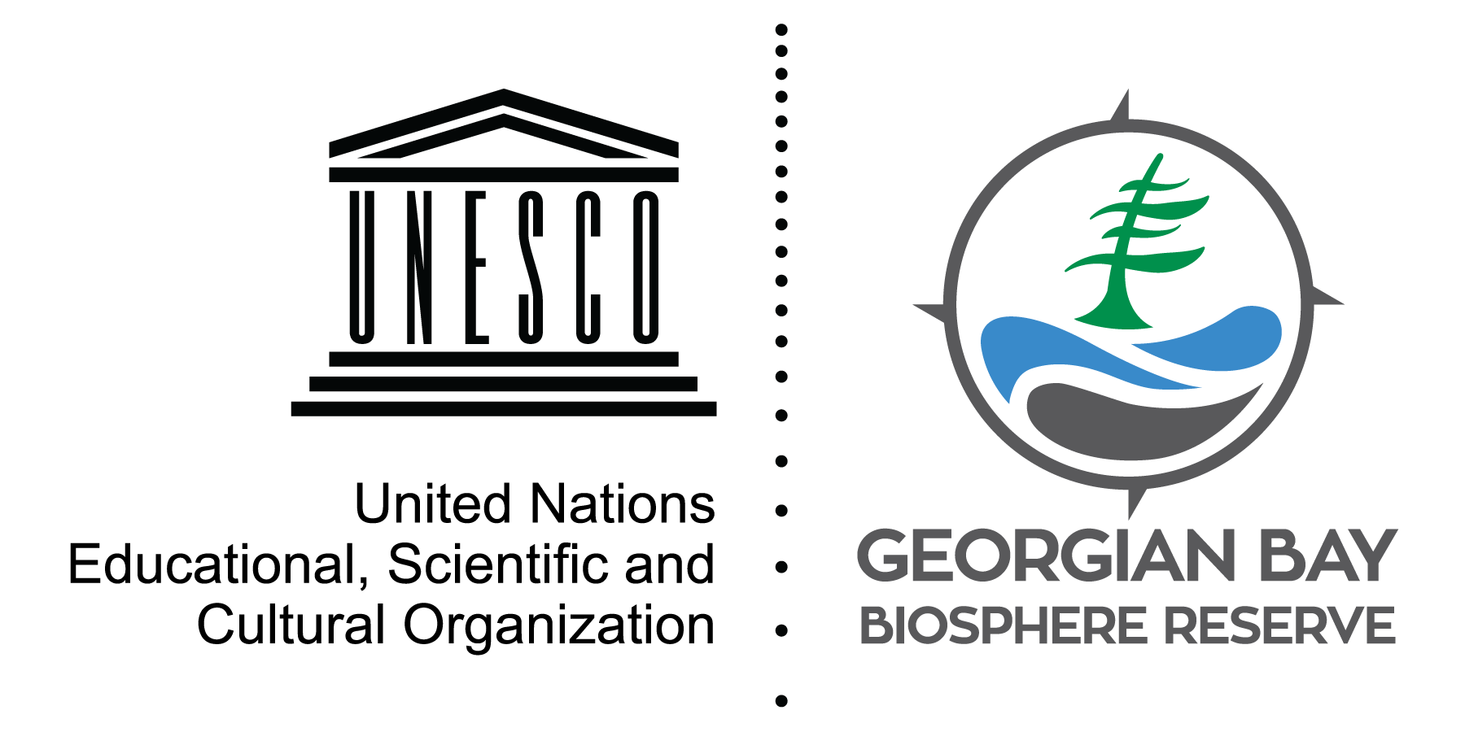
State of the Bay: Species at Risk

Monarch butterfly. Eastern Fox snake. Massasauga rattlesnake. Bald eagle. Blanding’s turtle. Little brown bat. Lake Sturgeon. These are all iconic species of Georgian Bay and species at risk of extinction.

Eastern Georgian Bay is home to over 1,100 native plant and animal species. 50 of these species are experiencing significant population declines, causing them to be classified as a species at risk. Little brown bats have seen a population decline of 94% since 2010 alone, due to white-nosed syndrome, caused by a fungus.

Each species plays a crucial role in our ecosystem. The loss of species results in the loss of biodiversity, reducing our natural environment’s ability to be resilient to disturbances — such as natural disasters and increases of disease and pests. Many of the ecosystem services that we depend on, rely on having a healthy, resilient ecosystem.

Many factors contribute to declines within Georgian Bay, including, habitat loss, development, road mortality, invasive species, harvesting, poaching and pollution. GBBR aims to teach people about how to reduce these pressures on wildlife. Visit stateofthebay.ca to see how you can help with species at risk conservation.

David Bywater is the State of the Bay Project Manager for the Georgian Bay Biosphere Reserve, a not-for-profit dedicated to environmental and community well-being. He can be reached at conservation@gbbr.ca

